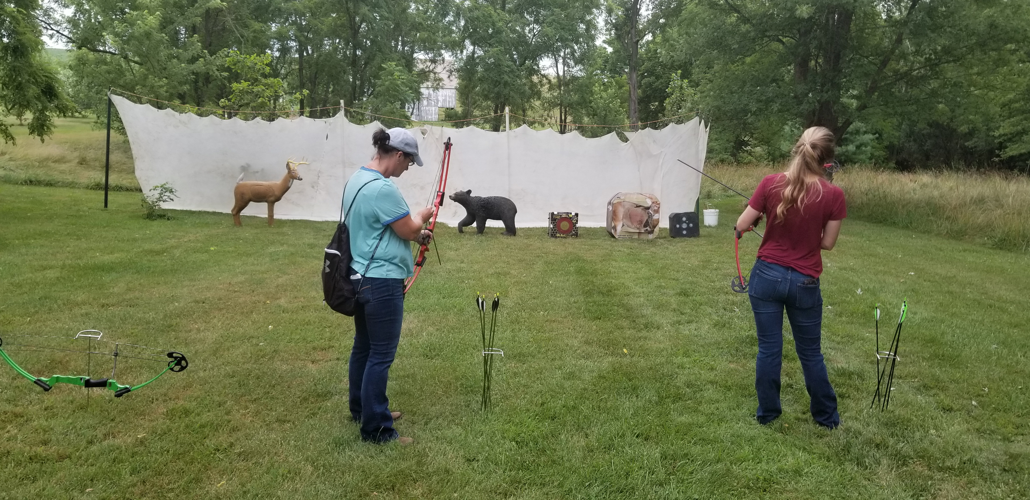  June 15, 2019  Ladies Day Out  Ladies would you like to learn skills to help you become more self-sufficient in the outdoors? Then this hands-on workshop is for you! Learn skills such as basic archery, gun handling and safety, basic trapping, field safety, tree stand safety, basic field aid, decoy placement, taxidermy and more. Lunch will be served, and all equipment provided. Live entertainment by Haley Keffer. Register by emailing countrycamooutdoors@gmail.com  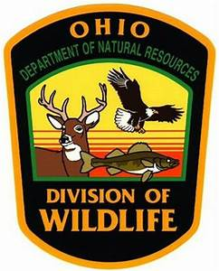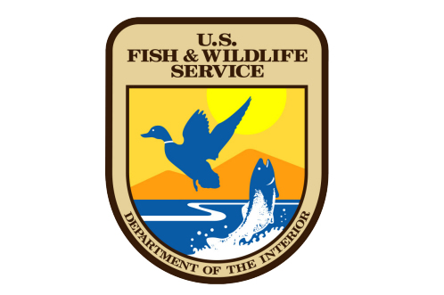 | Ladies Day Out  ────  Ladies Only!!!!  ────  Hands on workshop teaching ladies skills to be more self-sufficient in the outdoors  ────  Pre Register before May 1 and get free t shirt the day of event  ────  Free Event!!  Country Camo Outdoors  3510 County Line RD NE Rushville, OH 43150  740-550-1366  www.countrycamooutdoors.org  countrycamooutdoors@gmail.com

