Bremen Community Days
(car, truck, & motorcycle show)
Tractor Parade hosted by Bremen Area Historical Society*
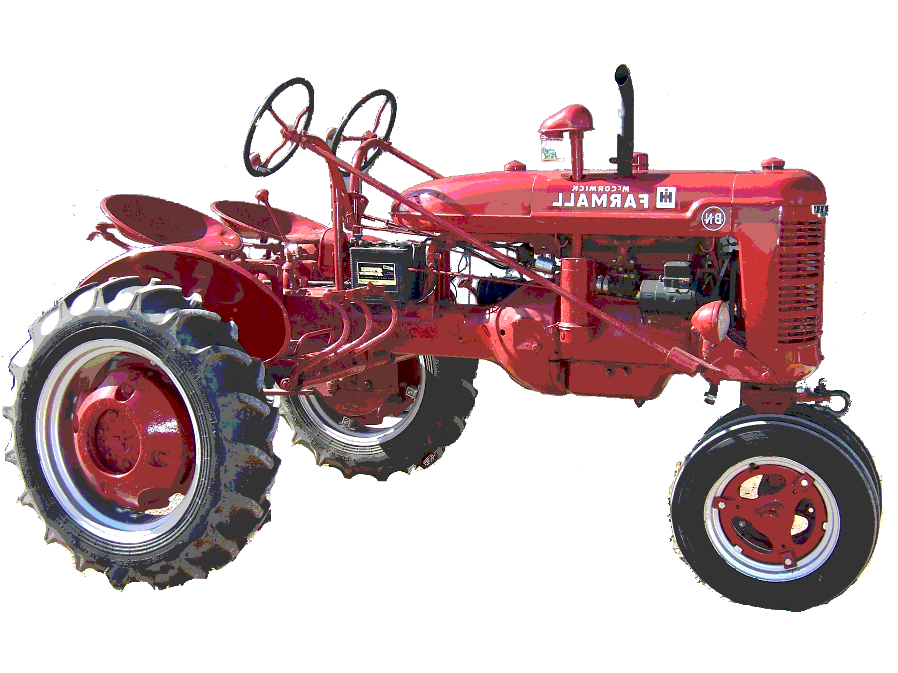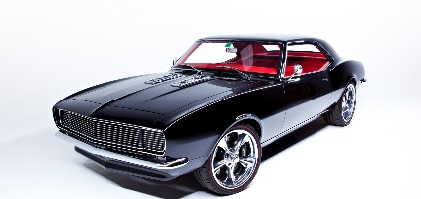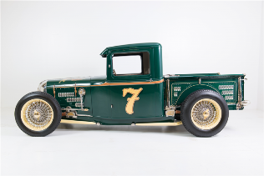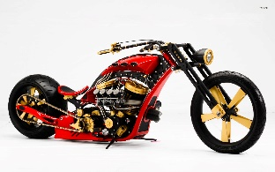
September 14, 2019 (10am-6pm)
Bremen, OH
$10 Donation Entry Fee – Pre-Register
$12 – Day of Event
Free to Public
Prizes Awarded Kids Bike Parade 50/50 Raffle
Craft Bazaar Kids Activities Food/Drink/Prizes
Bounce House vendors Raffles
*Live Entertainment
*Matthew Linkous will be performing

*Entry for participation in tractor parade is free of charge – contact BAHS for more info

Craft Vendors may set up for a Fee of $10 Per table- 8ft (Pre-registration Required) Chairs available $2/each – these are inside booths

Vendor Booths Available $10 Each (Pre-Registration required) (food vendors – retail, etc.)- Food Vendors must have own power source, canopy, ) Early set up Friday 14th from 6-8:30 pm

To Pre-Register (motor show or vendor) send check or money order with your Donation, Name, Address, and entry Made payable to American Legion Post #20 c/o Jeana Mitchell 3510 County Line RD NE Rushville, OH 43150

