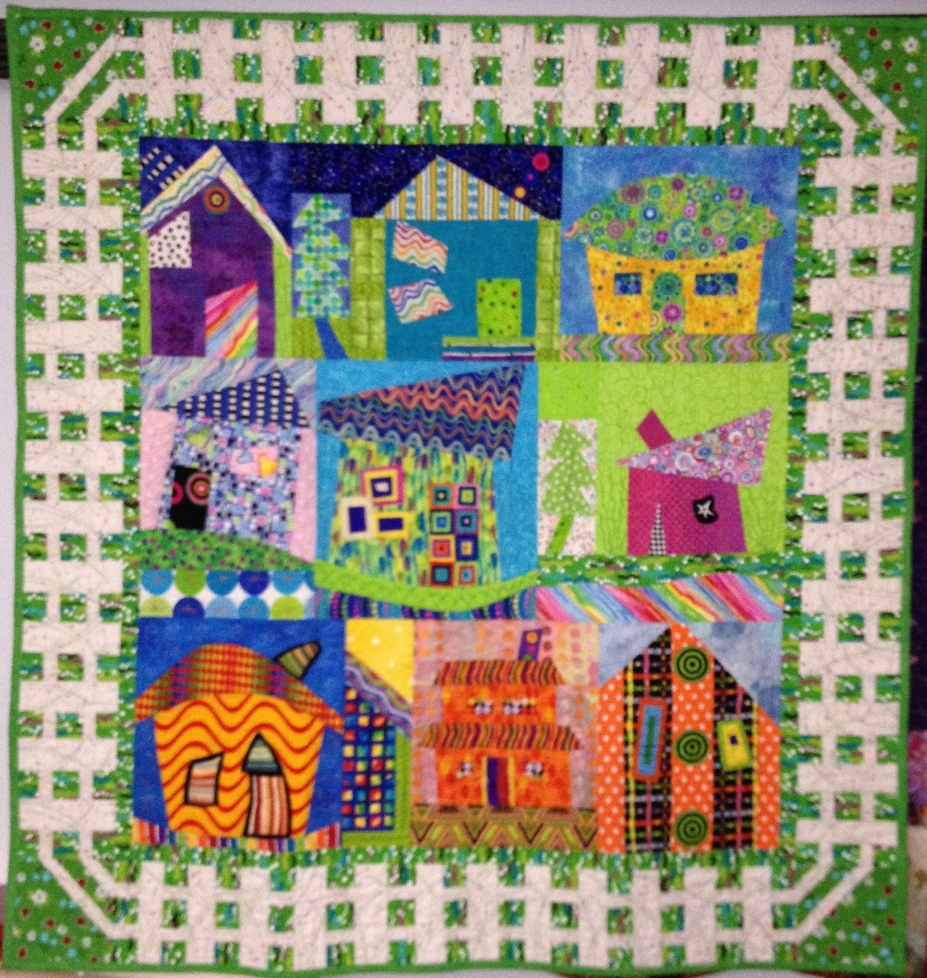
“It’s a Beautiful Day in My Neighborhood”
Supply List
Dianne Kane
DianneKane1@gmail.com
www.DianneKane.com
360-693-3994 (c)

Class Description
Wouldn’t it be nice to create your own neighborhood? It could be funky, colorful, sophisticated, wonky, architectural, or whimsical. Mmm . . . doesn’t that sound like fun? Use your fabrics to create houses with varying shapes, colors, and designs. We’ll spend time making houses, then combining your creations to create your neighborhood, balancing color, design, and dimension.
If you’re wanting to finish a top, consider making a table runner or wall hanging with just 3-4 houses.

Supplies
- Basic sewing supplies
- Sewing machine
- Mat
- Ruler
- Square ruler, any size (optional)
- Rotary cutter
- Fusible web (optional)
- Design wall (can use flannel or batting—something you can pin onto and take with you)

Fabrics
Bring 12-15 fat quarters or equivalent of fabrics that you like. Include a mix of light, medium, and dark and a range of near-solids and small prints. You may want green (for grass) and blue (for sky) but this is not a requirement for your neighborhood. And you may want a few fabrics that resemble trees, flowers, or rocks. Geometrics work well for chimneys, walkways, and windows.

If you have any questions about fabric selection, please call or email me.

