# Round & Round & Round We Go

# Dianne Kane [DianneKane1@gmail.com](mailto:DianneKane1@gmail.com) [www.DianneKane.com](http://www.DianneKane.com) 360-693-3994

## Description

Learn to make circles using a wedge ruler. Pick a fun fabric with mirror images and be delighted with the surprise result. In this full-day session, you can design, cut, and assemble your circle. Learn how to create the finished inner circle. You may have time to get your piece quilted and bound. Fabrics by Paula Nadelstern are suggested, but interesting results can be had with lots of choices. Both of the circles above were made from the same piece of fabric.

|  |  |
| --- | --- |
| Supplies Matt  Rotary cutter (consider a new blade)  Ruler (at least 4 x 12")  Sewing machine (only need straight stitch)  Thread for piecing  Scissors, seam ripper  Pencil & paper for taking notes  Flat head pins  Backing and facing fabric ¾ yard  A piece of batting 30x30"  Quilting thread  Safety pins  Wedge ruler if you have one. Will be available for purchase on class day. | *Optional* *A folding mirror*  *Design wall*  *extension cord* |

## Fabrics

This technique works best with a fabric that mirrors itself vertically and/or horizontally. A Paula Nadelstern fabric will usually give you this result. Because there are so many options in the cutting and layout of the fabrics, it’s hard to provide specific fabric requirements.

You will be using a wedge ruler to cut your pieces. The rulers are about 7x3" and you will need to have 20 repeats of the same design in your fabric.

The rulers will be available for purchase in class for $8 each. If you have another wedge ruler, bring it along with you. They come in multiple sizes/degrees that will create different final results.

A few other fabric choices are shown on the next page. It would also be fun to create with a stripe fabric. Or a piece with 1-2” swaths of color. It’s also fun to create your circle with two complementary fabrics.

If you have questions, please call or send an email to me.

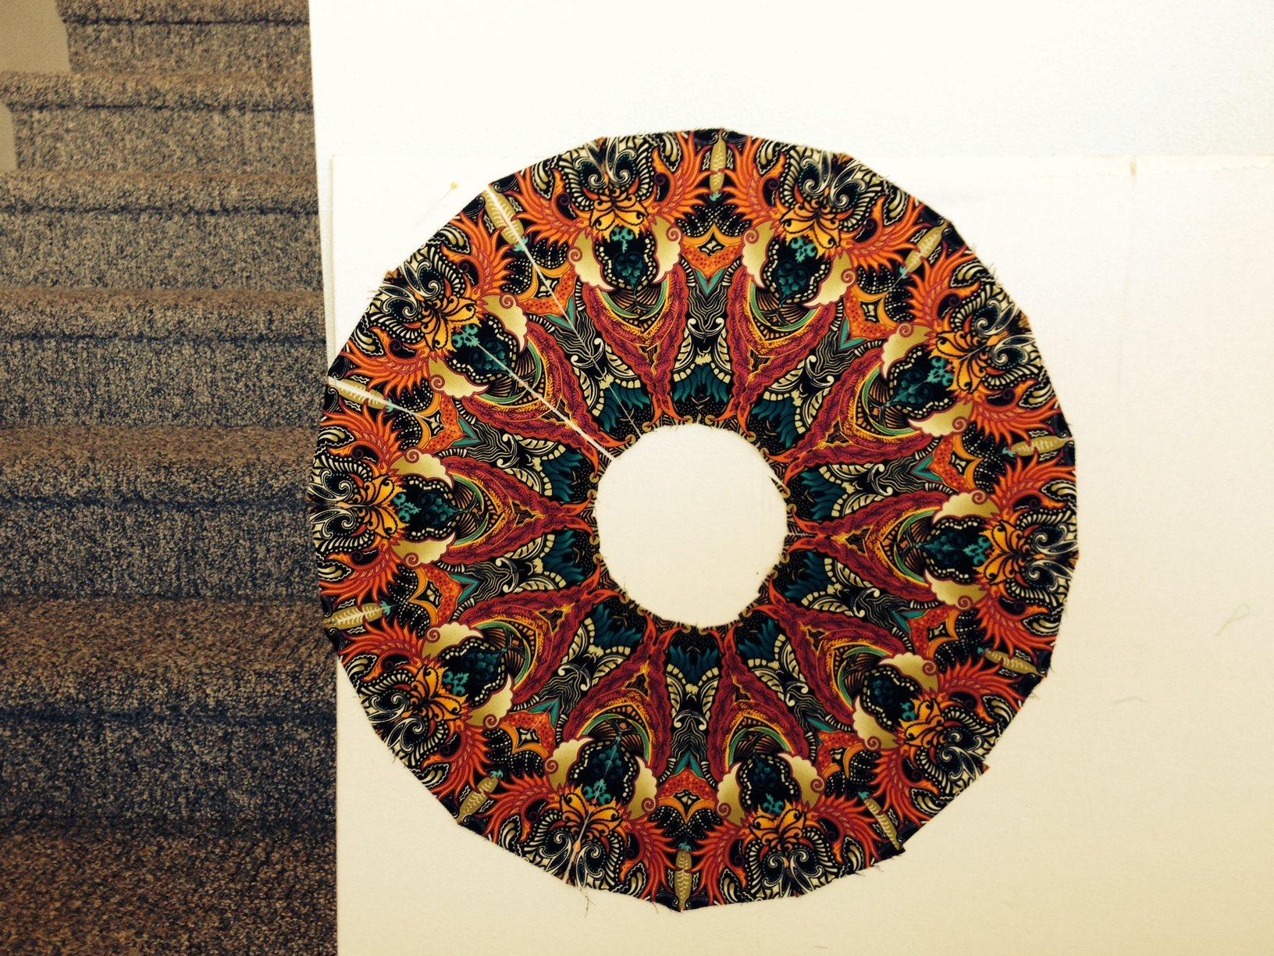 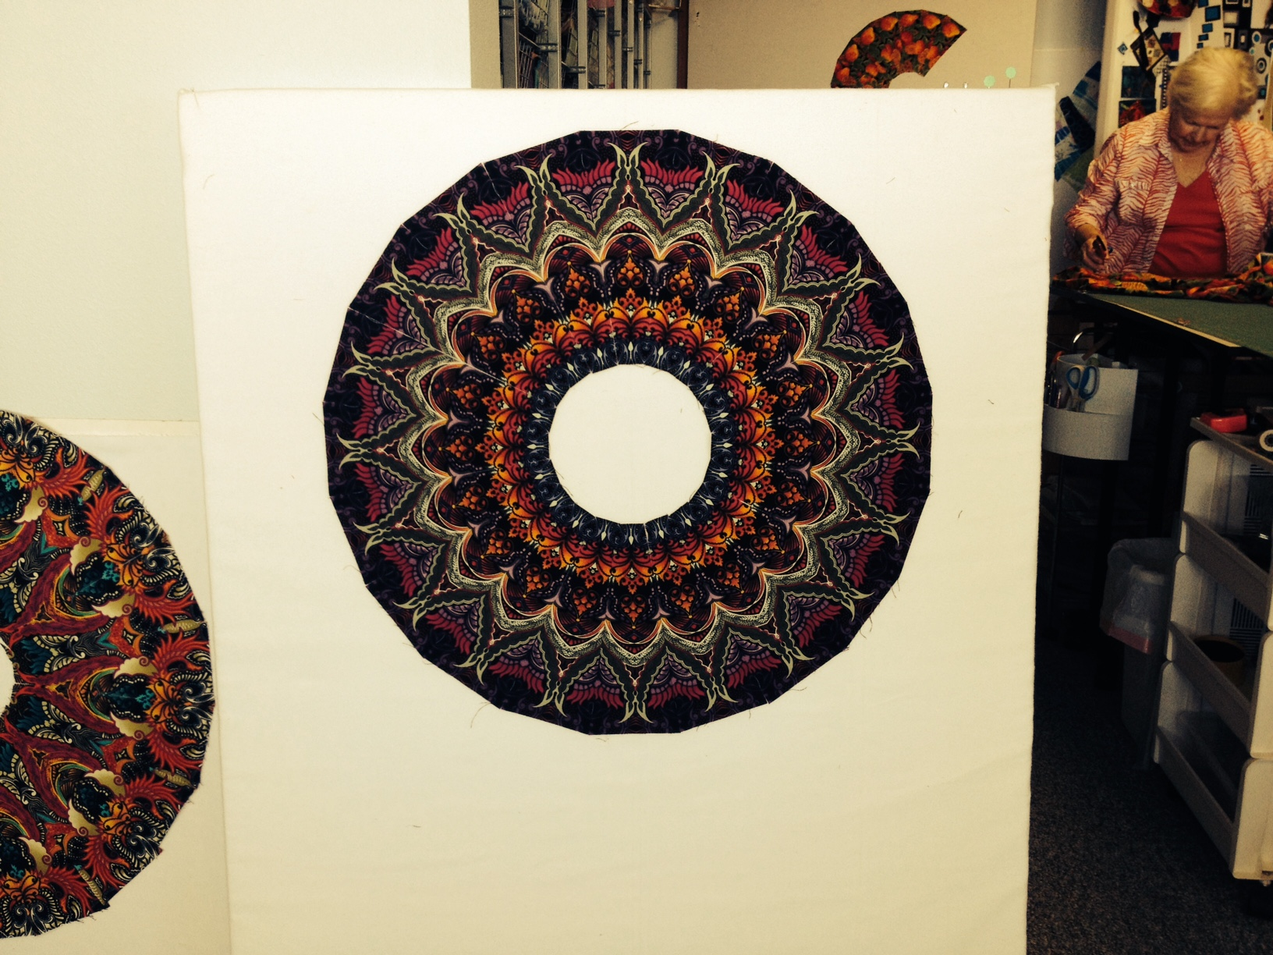 These are Paula Nadelstern fabrics

Another Paula Nadelstern fabric

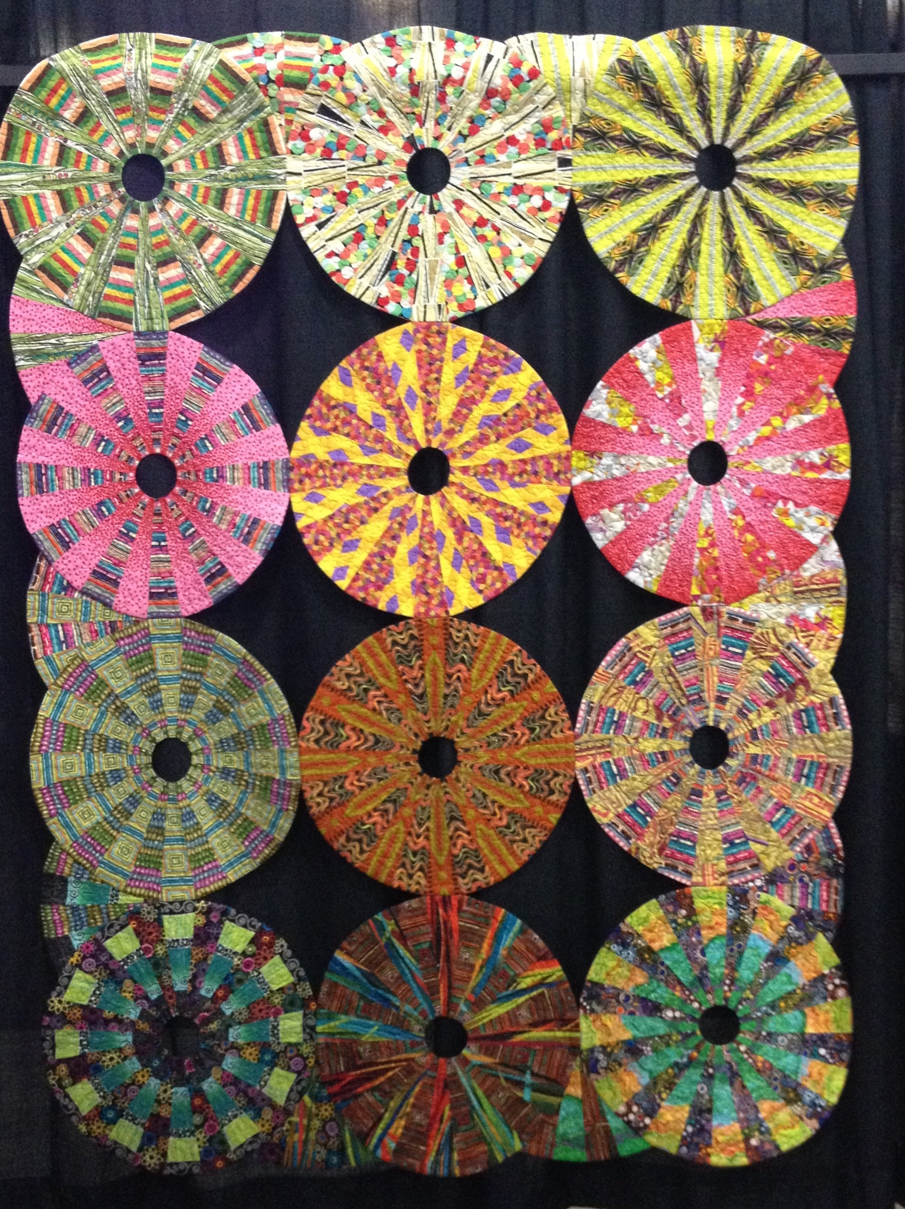  
  
These circles were fussy cut with complementary fabrics.

Here are a few sample fabrics that would create interesting pieces.

