Name: _______________________________________________________________
Address: _______________________________________________________________
City: ___________________ State: ________ Zip: ________
Phone: ___________________ E-Mail: __________________________

EMERGENCY CONTACT
Name: ________________________________________________________________
Relationship: __________________
Phone: ___________________
Please list any medical concerns we should be aware of: _____________________________
.__________________________________________________________________________
Have you ever been convicted of a crime? YES NO
Are you Completing hours to fulfill probation? YES NO
If “YES”, please provide details of conviction: ___________________________________
Are you under the age of 18? YES NO
IF “YES” what is your age? ___________
OVER
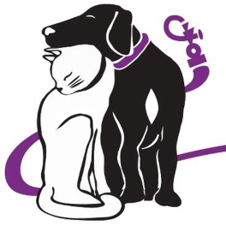
VOLUNTEER AGREEMENT

As a volunteer, you will be required to abide by the terms of this volunteer aggreement. The aggreement below details what the organization will expect of you and what you can expect from the organization.
As accepted as a volunteer, my signature below indicates that I have read, understand, and agree to the following:
- I will abide by all organization policies and procedures
- I agree to be supervised by organization management or a designee and will report directly to them.
- I authorize the organization to seek emergency medical treatment for me in the case of accident, injury, or illness.
- If I fail to abide by the terms of this aggreement or are otherwise unable to meet the program requirements I will be terminated from this program. I understand that I may, at anytime,with or without cause, be removed from my position of volunteer at the sole descretion of the organization’s management.
- I herby agree to release, imdemdify and hold harmless the organization, its officers, directors, employees, and agents from any and all claims, damages and liability arising from or relating to my activities as a Dessin volunteer under this aggreement or for any negligent act or omission by the organization, its officers, directors, employees, and agents from any and all claims, damages and liability arising from my riding as a passanger in any motor vehicle owned or leased by the organization and operated by an employee or authorized agent of the organization.

Signature: _____________________________________ Date: _______________
Parent/ Guardian: ______________________________ Date: _______________
Printed Name: ______________________________ Date: _______________
Signature: ______________________________________ Date: _______________
Please return to Dessin Animal Shelter, 138 Miller Drive, Honesdale, PA 18431

