**Piedmont Area Service Committee Minutes**

July 13th , 2025 - Hybrid Meeting

**I. Call to Order and Serenity Prayer:**  4:01: Kyle W. **Twelve Traditions:** 4:02: Anthony M.

**Twelve Concepts:** 4:05: Tracy A. **Purpose of ASC:** 4:06: Matt S.

**II. Roll Call**

Group Service Representatives:

Addicts From the Belfry Kermit O. Absent

Changing Perspectives Patsy G. Present

New Attitudes Chris K. Present

New Life Group Matt S. Present

No Matter What Adam S Present Off the Tracks Owen E. Present

SOS Anthony M. Present

Serene in Greene Tracy A. Present

Spiritual Solutions Jordan D. Present

We Choose Recovery Lawrence E. Present

Without Parallel Madeline H. Present

Steppin’ to Freedom Jerrica H. Absent

Trusted Servants

Chair: Kyle W. Present

Vice Chair: Pete T. Present

Secretary: Azaria B. Present

Alternate Secretary: *Vacant*

Treasurer: Brendan Present

Vice Treasurer: Vacant

RCM: Dana R. Present

RCM II: *Vacant*

Literature Chair Hamish B. Absent

Alt Literature Chair *Vacant*

Public Relations Chair: Melissa Spi.  Present

Public Relations Vice Chair: Michelle R. Present

H&I Chair: Adam W. Absent

H&I Vice Chair: *Vacant*

Special Events Chair: Anand H. Present

Special Events Vice Chair: Madeline H.

VRCC Director: *Vacant*

Alternate VRCC Director: *Vacant*

***Quorum was met.***

Other members present: Chris G. , John Th.

Groups to be removed from roll call:

Groups to be added:

**III. Approval of Minutes –** 4:15

We will not be voting on these minutes due to revisions needed.

**IV. Open Forum** – 4:10

**V. Reports** – 4:12

Chair Report: (*Kyle L.)* No Report

Vice Chair Report (*Pete T.* ) No Report

Secretary Report: (*Azaria B*): Just wanted to relay a friendly reminder to those in ASC that announcements should be given three days after area service is concluded and for service reports, two weeks before area service. Thank you!

4:14 Regional Committee Member (RCM) Report: (*Dana R.*):

The Regional Service Committee meeting for August will take place on 8/16/25 at the Louisa County Library. Since we haven’t met since the last meeting I do not have a full report. I will take our vote on the regional motion out to groups back to the meeting this month.

In loving service,

Dana R

4:16 H&I Report: (*Melissa Spi.)*

H&I Subcommittee Meeting Report

August 3rd 2025

Subcommittee Meeting Members

Adam W. – Subcommittee Chair (absent, Pete T. filled in for Adam)

Kyle W.– Men’s ACRJ Panel Leader (present)

Connie P. – Women’s ACRJ Panel Leader (present)

Azaria B. – Boxwood Panel Leader (absent)

Chris G.– Mohr Center Panel Leader (present)

Melissa Spi. – Wellness Center Panel Leader (present)

Troy P. – Five East Panel Leader (absent)

Brendan F. – Subcommittee Secretary (present)

Viewers – Patsy G.

Minutes

14:36 – Opened the meeting with the Serenity Prayer

14:37 – Read the 12 traditions of NA

14:39 – Read the 12 concepts of NA

14:38 – Conducted attendance

14:43 – Motion to approve the minutes for the previous month with revisions was passed

14:44 – Kyle W. presented the panel report for the Men’s ACRJ meeting group

14:45 – Connie P. presented the panel report for the Women’s ACRJ meeting group

14:47 – Brendan F. presented Troy P.’s panel report for the Five East meeting group, Troy P. is

stepping down as the Five East panel leader

14:49 – Pete T. presented Azaria B.’s panel report for the Boxwood meeting group

14:50 – Melissa Spi. presented the panel report for the Wellness Center meeting group

14:51 – Chris G. presented the panel report for the Mohr Center meeting group

14:54 – Patsy G. discussed plans for carrying in meetings to the Women’s Recovery Center

14:55 – Motion to create Women’s Recovery Center H&I group was passed

14:56 – Brendan F. and Melissa Spi. discussed considerations for the Women’s Recovery Center

15:00 – Discussed the monthly budget for the H&I subcommittee

15:02 – Melissa Spi. discussed a request from the She-Shelter to conduct H&I meetings

15:13 – Discussed formatting for panel leader reports

15:17 – Melissa Spi. nominated Patsy G. to be the panel leader for the Women’s Recovery Center

15:18 – Patsy G. was voted in as the panel leader for the Women’s Recovery Center

15:19 – Discussed how the next meeting should be on September 7th

15:20 – Motion to close the meeting was passed

15:21 – Closed the meeting with the Serenity Prayer

Panel Report – ACRJ (Kyle W.)

July activities

• No literature is needed

August plans

• On August 7th two volunteers are needed to conduct a meeting

• On August 14th Jason B. and Ky L. plan to conduct a meeting

• On August 21st two volunteers are needed to conduct a meeting

• On August 28th two volunteers are needed to conduct a meeting

Panel Report – ACRJ (Connie P.)

July activities

• On July 7th Melissa Spi. and Connie P. conducted a meeting.

• On July 21st Megan B. and Patsy G. conducted a meeting.

• There are four volunteers to bring in meetings and sometimes only one volunteer will bring

in a meeting.

August plans

• On August 4th a volunteer plans to conduct a meeting.

• On August 18th two volunteers are needed to conduct a meeting.

Panel Report – Boxwood (Azaria B.)

July activities

• Did not receive report, need to follow up on this

August plans

• TBD

Panel Report – Wellness Center (Melissa Spi.)

July activities

• On July 18th there was no meeting.

• On July 25th Tyler M. and Jacob W. conducted a meeting with one participant.

• On August 1st Patsy G. and Johnny N. conducted a meeting with one participant. The

participant was a member of AA and wanted information on NA as an additional resource.

August plans

• On August 8th Melissa Spi. and Melissa Spe. plan to conduct a meeting.

• On August 15th MK and Jacob W. plan to conduct a meeting.

• On August 22nd Tyler M. and an additional volunteer plan to conduct a meeting.

• On August 29th Melissa Spi. and Grace A. plan to conduct a meeting.

Panel Report – Mohr Center (Chris G.)

July activities

• Troy P. and Chris G. conducted a meeting.

• Melissa Spi. and Chris K. conducted a meeting.

• Hamish B. and Megan B. conducted a meeting.

August plans

• The Mohr Center subcommittee has their meetings booked for the month of August

Panel Report – Five East (Troy P.)

July activities

• On July 17th Jim W. and Roy C. conducted a meeting with one participant.

August plans

• TBD

4:21 Public Relations Report: (*Melissa Spi.)*

**Opening**

The virtual meeting opened with a moment of silence and the Serenity Prayer at 1:34p.m. led

by Melissa Spi.

12 Traditions read by Tracy A.

12 Concepts read by Jim W.

**Roll Call**

Chair Melissa Spi. (9/24) Present

Vice Chair Michelle R (1/25) Present

Secretary Lawrence E. (6/25) Present

Presentations Jim W. (3/23) Present

Meeting Lists Jim W. (10/24) Present

Literature Racks Tracy A. (9/23) Present

Web Servant Andy H. (8/24) Present

Phone Line Jodi D. (6/25) Present

Area Vice Pete T. Present

Also attending MK K. (8/25)

**Approval of Minutes**

June minutes approved Jim W. and Tracy A.

July minutes approved Jim W. Michelle R.

**Reports**

Chair

No Report

Vice Chair

Attended Westhaven Community Day

Interest shown:

S.H.E. H&amp;I interest shown

Rosewood Community Day neighborhood

**Literature Racks**

All is well.

**Web Servant**

We had 966 website visitors and 1 email from an addict that said they lived in a “rural area”

and are looking for a sponsor that can communicate via zoom or email. I responded and

asked them if they can make it to any meetings. Haven&#39;t heard back from them yet.

Thanks!

-Andy H.

• Removed Saturday meeting of Online Oasis from website, the Wednesday

meeting continues.

• Added Steppin’ to Freedom

• It was noted that the Web Servant was really on top of recent last-minute

changes from Tracks. Thank you.

**Presentations:**

We had the NA table at the July One-Stop event manned by Michelle and Roy.  We also had

the table at the Westhaven Community Day manned again by Michelle, along with Dennis

and Jerrica.

Michelle reported info about another upcoming Community Day in Rosewood where we can

have the table; more will be revealed re: this event.

One-Stop is going back to every other month, so there will be no event this month.

Many thanks to Michelle for her incredible willingness.  She volunteers for every

Presentation we’ve done since she’s been in the Area- except for one when she was in

California.

No printing scheduled yet; waiting to hear back from our Chair.  She says it’s likely we’ll print

either this month or next.  More will be revealed…

ILS,

Jim W

• At the meeting Pete reported that Area has several hundred copies of the current

meeting lists. We will request changes now and await future printing. Melissa and

Pete will inventory the stock of current meeting lists.

• We’re putting in a request at ASC for a supply of meeting lists and IPs for future

presentation purposes.

**Meeting Lists**

No printing scheduled yet; waiting to hear back from our Chair.  She says it’s likely we’ll print

either this month or next.  More will be revealed…Phone Line

**Phone Line Coordinator Report – July**

During the month of July, there was 1 phone call, which was marked as missed in the

tracking application.

Volunteer schedules are set, and there are no changes at this time.

Warmly,

Jodi D.

**Old Business**

None.

**New Business**

The Piedmont web site has a 1pm meeting time for PR.

**Open Positions & Elections**

MK K. stood for election to Alt Literature. Pete read the requirements for Literature.

MK was elected by acclamation.

**Closing**

Next virtual PR meeting is scheduled for September 7, 2025, 1:30pm.

The meeting was closed at 2:09p.m. with the Serenity Prayer led by Melissa Spi.

4:30 Special Events Report: (*Anand H.)*

Dear Family:

Having served my two year term, I am stepping down as Special Events Chair for PASCNA. Thank you for letting me be of service.

In loving service,

Anand

4:40 Literature Report: (*Pete T.*)

Hello family, I was unable to attend the August PASC and Pete ably stood in. Thank you Pete.   
I don’t have a precise amount of literature distributed at this time. However I did place an order.   
  
$297.50 literature ordered  
  
Order # 1048353  
  
ILS, Hamish

4:42 Treasurer Report: (*Brendan M.*)

Dear Area Service Members,

I have attached my Treasurer's Report for the month of August as well as a second draft for the budget for FY26. There was a mistake on my end where I had put $400 down as an annual amount for the Public Relations committee, when this value should be closer to $850. Given this increase, I have marked down a few other items to make sure that there are no instances of double counting for subcommittee budgeted amounts and line items as well as to ensure that our expenses are closer to a conservative estimate of how much in donation revenue we will receive. I plan on sending out a deeper analysis on Saturday based on the bank account transaction information and the check book stated expenses as supporting rationale for some of the budgeted amounts in this second draft.

Kind regards,

Brendan FitzPatrick

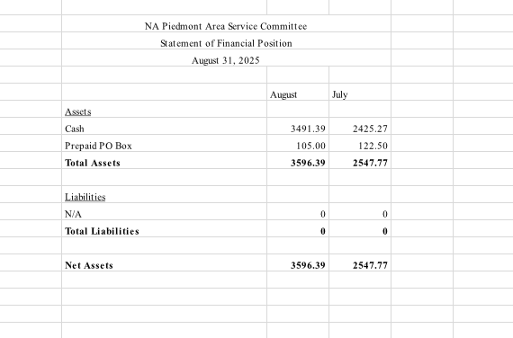

4:11 Director of VRCC Report: (*Tracy A.*)

Good Afternoon

We met on July 20,2025 by zoom.  We went over questions the Host Committee had about the 42nd Convention. All is going well with the 42nd convention to be held in Roanoke, Va on January 23-25, 2026. You can go to the website AVCNA.org to register and get a hotel room. We met again on Sept 21,2025 at UVA Hospital and on Zoom. We are in need of a Treasurer at this time if you are willing to serve. Today is my last day as VRCC Director and I thank you for letting me serve.

ILS,  Tracy A

|  |  |
| --- | --- |
|  |  |

4:39 GSR Reports:

None

**VI. Old Business**: 4:41

GSRs brought their votes from their homegroups concerning the CARNA Motion. We had 8 groups, 7 voted to approve and 1 abstained. Dana R. will bring our vote of approval to the next RSC.

**VII. Elections:** 4:35

Dana R. nominated John Th. to be VRCC director, seconded by Matt S. Requirements were read and accepted by John Th. John Th. was unanimously voted in.

A vote of confidence was taken to have Madeline H. step up to Special Events chair and was unanimously voted in.

**VIII. New Business**: 4:36

None

**IX. Back to Groups**: 4:59

Groups need to vote to accept the proposed budget effective immediately after voting in.

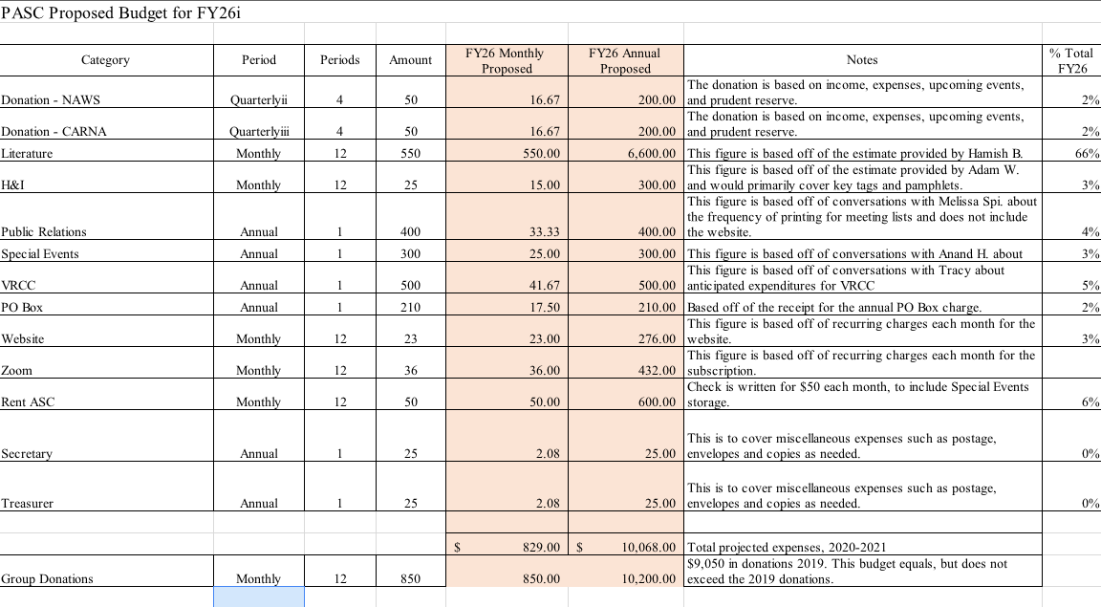

**X. Announcements and Anniversaries:**

***- MEETING CHANGE:*** **Off the Tracks** on **Wednesdays** will now be splitting up the meeting into **men's and women's groups**, same time, location, and format.

***- PARKING CHANGE:*** The parking lot at **Off the Tracks**and **No Matter What** on **August 8th and 9th** will be closed so please do not park in the parking lot. There is parking at the Amtrak station across the street.

***- MEETING LOCATION:*** Addicts From the Belfry is looking for a new location to hold their meetings- with ideas please contact Kermit O.

***-VOLUNTEERS NEEDED:***  H&I is looking for **volunteers** for the **men’s and women’s ACRJ and Boxwood.** If interested, please contact Kyle W, Connie P, Azaria B.

***-SPECIAL EVENTS MEETING:***  **Wednesday August 13th following Off the Tracks**, Special Events will be hosting a meeting recruiting members to join the special events committee and discussing upcoming events. All are welcome to join!

***- VACANT AREA POSITIONS:***

H&I Vice Chair

5 East H&I Panel Leader

Vice Treasurer

Alternate Literature Chair

RCM II

Alternate VRCC Director

With any questions regarding requirements/duties, please contact Kyle W, Pete T, Azaria B.

***ANNIVERSARIES***

Gilie G.                  10 years           8/4                   We Choose Recovery

Michelle R.             2 years            8/4                   Off the Tracks

Dale L.                    2 years            8/7                   New Life Group

Mary L.                 10 years            8/10                 TBD

Jason B.                 22 years            8/11                 We Choose Recovery

Jim W.                     7 years            8/16                 Changing Perspectives

Troy P.                    2 years            8/16                 Changing Perspectives

Tyler M.                  1 year              8/26                Off The Tracks

Tracy A.                  24 years            9/1                 TBD

Lauren F.                18 mo.             9/15                Off the Tracks

Adam W.                19 years          9/15                New Attitudes

Stuart S.                  42 years          9/15                New Attitudes

Keyler B.                  1 year             9/20                No Matter What

Grace A.                  4 years            9/29                Off The Tracks

**Next ASC will take place on September 7th .**

4:59 **Motion to Close:** Pete T. Seconded by: Azaria B.

5:00 Serenity Prayer said by all.