Piedmont Area Service Committee Minutes
September 7th , 2025 - Hybrid Meeting

I. Call to Order and Serenity Prayer: 4:01: Kyle W. Twelve Traditions: 4:02: Adam D.
Twelve Concepts: 4:05: Patsy G. Purpose of ASC: 4:06: Matt S.

II. Roll Call
Group Service Representatives:
Addicts From the Belfry Kermit O. Absent
Changing Perspectives Patsy G. Present
New Attitudes Adam D Present
New Life Group Matt S. Present
No Matter What Adam S Present Off the Tracks Owen E. Present
SOS Ky L. Present
Serene in Greene Tracy A. Present
Spiritual Solutions Jordan D. Present
We Choose Recovery Lawrence E. Absent
Without Parallel Nathaniel O. Present
Steppin’ to Freedom Jerrica H. Absent

Trusted Servants
Chair: Kyle W. Present
Vice Chair: Pete T. Present
Secretary: Azaria B. Present
Alternate Secretary: Vacant
Treasurer: Brendan Present
Vice Treasurer: Vacant
RCM: Dana R. Present
RCM II: Vacant
Literature Chair Hamish B. Absent
Alt Literature Chair Vacant
Public Relations Chair: Melissa Spi. Present
Public Relations Vice Chair: Michelle R. Present
H&I Chair: Adam W. Absent
H&I Vice Chair: Vacant
Special Events Chair: Madeline H. Present
Special Events Vice Chair: Vacant
VRCC Director: John Th. Present
Alternate VRCC Director: Vacant
Quorum was met.
Other members present: Addicts from the Belfrey, Steppin to Freedom
Groups to be removed from roll call:
Groups to be added:

III. Approval of Minutes – 4:13
Pete motioned to approve July minutes, seconded by Melissa Spi.
IV. Open Forum – 4:10

V. Reports – 4:12

Chair Report: (Kyle L.) No Report

Vice Chair Report (Pete T. ) No Report

Secretary Report: (Azaria B): No Report

4:13 Regional Committee Member (RCM) Report: (Dana R.):
No Report

4:14 H&I Report: (Adam W.)
The H&amp;I Subcommittee met at 2:31to3:15pm this afternoon with 8
people in attendance.
Men’s ACRJ – Kyle W.
Below is my report for Men’s ACRJ:
August:
8/7 - Brian K. &amp; Chris K. - 5 guys, good meeting
8/14 - Jason B. &amp; Ky L. - jail canceled programs
8/21 - Chris K. - 3 guys, good meeting
8/28 - Chris K. - 3 guys good meeting
9/4 - Chris K. - 4 guys, 1 newcomer.
9/11 - ? &amp; ?
9/18 - ? &amp; ?
9/25 - Kyle W. &amp; ?
HU2 is under construction and they have moved our meeting to HU3
Jail reached out to me about us doing twice a week. Thoughts? My thoughts are we do
not have enough volunteers right now.
Guys want literature. They do not have access to the library but can get literature on
their tablets. Thoughts?
Thanks,
Women’s ACRJ- Connie P
Women&#39;s ACRJ H&amp;I Meeting Report:
August 4: Megan B took a meeting in by herself as the rest of us were celebrating
anniversaries with sponsees. Megan reported that it was a good meeting with 3 in
attendance (2 of them new)
August 18: ACRJ cancelled all programs
September 1: Labor Day. ACRJ was closed to programs
Upcoming Meetings:
Sept. 15 Melissa Spi and Megan B
Oct. 6 Connie and Megan B
Oct 20 Patsy and Melissa Spi

ILS
Connie

BOXWOOD – Azaria B.
August Boxwood report-
August 21st-Owen and Azaria. Owen led the meeting and shared his story
August 28th-Anand and Azaria. Anand led the meeting and shared his story.
Next month:
September 18th: Owen and Maddie
September 26th: Kermit O and Jamise

Need 10 red, 10 white and 5 blue keytags
ILS,
Azaria B

5 EAST – Melissa Covering Troy stepped down last month.
8-7 Connie+ Chris G no meeting
8-14 Jacob W + Patsy G
3 attending. Good meeting.
8-21 Jim Michelle were scheduled but Jim was sick and Michelle had conflicts of
interest so I went with Grace A we had one attend good meeting.
8-28 Pete Melissa (Jim went for me)
No takers

9-4 Troy P Chris G
2 attended the meeting !The meeting was a very powerful gave out two white
bookmarks.

9-11 Patsy G + need one
9-18 Jim W + Michelle R
9-25 Melissa Spi + need 1
10-3 need 2

In loving service,
Melissa Spi

MOHR CENTER – Chris G.

WELLNESS CENTER – Melissa SPI
8-1 Patsy G Jonny N. 1 client was a member of the other fellowship and wanted
information on NA to have a resource for others.
8-8 Melissa Spi + Anand H
2 people great meeting 2 white tags handed out
8-15 MK + Jacob W no meeting
8-22 Tyler M + Chris
We had a good meeting tonight. 2 attendees and one welcome keytag was given.
8-29 Melissa Spi + Grace A

1 attended. Was previously a member of NA. Great Meeting.

9–5 Tyler M + Pete T
9-12 Melissa Spi + Anand H
9-19 Troy P + Chris G
9-26 Patsy G + MKK
10-3 need 2
In Loving Service,
Melissa Spi
Women’s Center: Patsy G
I have arranged with my contact at Region 10&#39;s Women&#39;s Center to start carrying our
H&amp;I meetings in there on Tuesdays, at 7:00 PM, beginning September 16th. As I have
told the women who might volunteer, each of us, when she first goes in, will be asked to
present her ID to be photocopied and to sign a confidentiality agreement.
Here is the schedule I have so far:
9/16:Patsy &amp; Megan B.
9/23:Melissa Spi &amp; MK
9/30:
10/7: Megan B. &amp; Dana.
10/14:
10/21: Grace A.
10/28:
In loving service,
Patsy

Old Business: budget for H&amp;I changed from 20 dollars to 5 dollars a month to account
for printing White bookmarks that can’t get from litic
New Business:

Downloding and how to get ebooks to jail of NA lititure. Truble shoot downloads from NA
lititure.
H&amp;I Open positions: Vice Chair H&amp;I 5 East
ACRJ needs volunteers, both men and women.
Elections: 1 new panel leaders! Pet shown interest in taking over the wellness
center and Melissa would do 5 east.
Next Meeting October 5th. 2:30pm
ILS,
Adam W. – H&amp;I Chair
4:21 Public Relations Report: (Melissa Spi.)
Public Relations Subcommittee of
Piedmont Area Service Committee Meeting Minutes
September 7 , 2025

Opening
The virtual meeting opened with a moment of silence and The Serenity Prayer at 1:34 p.m. led by Melissa Spi
12 Traditions read by Tracy A
12 Concepts read by Jim W

Roll Call
Chair Melissa Spi (9/24) Present
Vice Chair Michelle R (1/25) Present
Secretary Lawrence E (6/25) Absent
Presentations Jim W. (3/23) Present
LiterLiterature Racks Tracy A. ( 9/23) Present
Alt Literature Racks MK K ( 08/25) Absent
Meeting Lists Jim W. (10/24) Present
Web Servant Andy H. (8/24) Present
Phone Line Jodi D (6/25) Absent
Area Vice Chair Pete T. Present
Also attending:
Approval of Minutes
August minutes approved
Reports
Chair
No Report

Web Servant
Website had 924 visitors this month. No new emails.

Meeting Lists
Meeting Lists Report

Looks like we’re preparing for another printing this month. Our illustrious leader got printing quotes for numerous quantities and I assume will get the approved quantity and go-ahead from Area later today.

Phone Line
During the month of August, there were 0 phone calls recorded in the Piedmont Area.
Volunteer schedules are set, and there are no changes at this time.
Warmly,
Jodi D.

Literature Racks
No report, all is well.

ILS Tracy A

Presentations
Nothing going on last month other than restocking meeting lists for our supplies. The next One-Stop Shop is 9/18 from noon-3 and the table will be manned by myself and Melissa Spe.

ILS,

Jim W
Region 10 will be hosting a Recovery Day this Saturday 9-13 from 12-4 at the carver rec center. Roy C and Tonya will man the table.

Old Business
retrieving pamphlets for lit rack and presentations
New business
Discussed changing the amount of meeting lists to be printed. Referred to PR guidelines noting that the guidelines call for 1300 lists to be printed each quarter. After being in the chair position for the past year I think it would be a good idea to shoot for 750 each quarter. The 1200 printed in March have lasted over 6 months. I think having them updated quarterly is a good idea to make sure lists are up to date. Also discussed the color guidelines set forth in the PR guidelines.
Elections

Open Positions

Closing
Next meeting October 4th 2025 @ 1:30 p.m. via Zoom.

The meeting was closed at 2:15 p.m. with the Serenity Prayer led by Melissa Spi.

4:30 Special Events Report: (Maddie H.)
Maddie H stepped down from Special Events Chair and endorsed Grace A. to take over.

4:44 Literature Report: (Hamish B.)
Hello family,
$719.19 literature distributed
$733.76 literature ordered
Order # 1050053
ILS, Hamish
4:42 Treasurer Report: (Brendan M.)
Dear Area Service Members,

I have attached the revised budget after considering our discussion at the September Area Service Meeting. This includes $800 for the year allotted to the Special Events Subcommittee and $850 allotted for the year for meeting lists. The anticipated contributions have also been slightly revised to around $870 per month in contributions. Please send this to the GSRs so they can bring it to their groups and vote on its approval. Additionally, if you or any of the GSRs think there are any areas which need to be further revised, please contact me so that we can make necessary changes.

Kind regards,

Brendan FitzPatrick

11-6 vote of those in attendance of making a donation to WSC and RSC with our present reserves.

4:11 Director of VRCC Report: (Tracy A.)

4:39 GSR Reports:
None
VI. Old Business: 4:41

GSRs brought their votes from their homegroups concerning the PACNA Budget. All groups(8) voted to bring the amended budget back to groups to then approve the budget.

VII. Elections: 4:35
Maddie H., seconded by Melissa Spi. To have Grace A. voted in as special events chair. A vote was taken by all members and Grace A. was voted in unanimously!

VIII. New Business: 4:36

Motion by Hamish B, seconded by Nathaniel O. :
To allocate additional funds to literature in the amount of $733.76.
Purpose: To pay for the larger than average amount of literature orders in September.

A vote was taken by all members in attendance and was voted in unanimously.

Motion by Brendan F. seconded by Nathaniel O.
To date $200 to CARNA and $200 to NAWS

A vote was taken by all members in attendance and was voted in with all in favor besides 1 abstention

IX. Back to Groups: 4:59
Motion by Pete T., seconded by Nathaniel O. :
To amend the PASC guidelines to allow the PR subcommittee to print meeting lists quarterly in an amount to be decided by the PR committee
Purpose: To allow PR the discretion to print lists at different amount so we don’t have too many.

Groups need to vote to accept the revised proposed budget effective immediately after voting in.

I have attached the revised budget after considering our discussion at the September Area Service Meeting. This includes $800 for the year allotted to the Special Events Subcommittee and $850 allotted for the year for meeting lists. The anticipated contributions have also been slightly revised to around $870 per month in contributions.
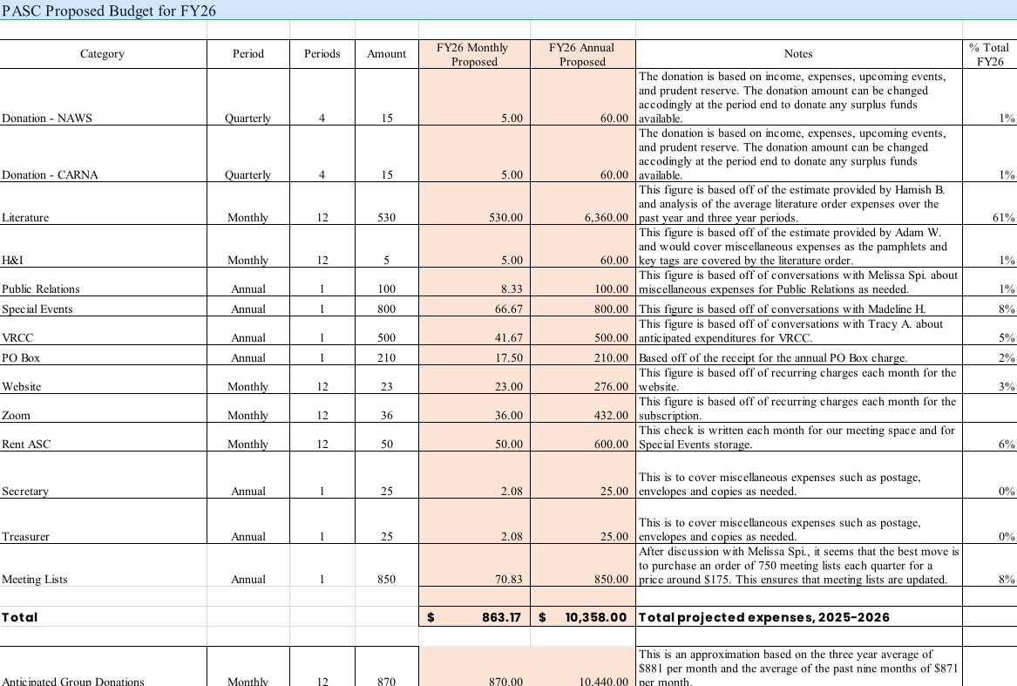

X. Announcements and Anniversaries:

- MEETING CHANGE: Off the Tracks on Wednesdays will now be splitting up the meeting into men's and women's groups, same time, location, and format.
- MEETING LOCATION: Addicts From the Belfry is looking for a new location to hold their meetings- with ideas please contact Kermit O.
-VOLUNTEERS NEEDED: H&I is looking for volunteers for the men’s and women’s ACRJ, The Women’s Center, and Boxwood. If interested, please contact Kyle W, Connie P, Azaria B.
-SPECIAL EVENTS COMMITTEE: Special events wants YOU! (yes, you!!) to be a part of the committee responsible for creating events for our area! If interested, please contact Grace A. or Maddie H.
- VACANT AREA POSITIONS:
H&I Vice Chair
5 East H&I Panel Leader
Vice Treasurer
Alternate Literature Chair
RCM II
Alternate VRCC Director
With any questions regarding requirements/duties, please contact Kyle W, Pete T, Azaria B.

ANNIVERSARIES
Adam W. 19 years 9/15 New Attitudes
Stuart S. 42 years 9/15 New Attitudes
Lauren F. 18 mo. 9/16 Off the Tracks
Terry D. 17 years 9/17 Together We Can
Keyler B. 1 year 9/20 No Matter What
Melissa Spe. 18 mo. 9/22 Off The Tracks
Grace A. 4 years 9/30 Off The Tracks
Vince S. 8 years 9/30 Off The Tracks
MK K. 18 mo. 10/6 We Choose Recovery
Mary L. 10 years 10/7 Serene in Greene
Dee Dee A. 24 years 10/7 Serene in Greene
Tracy A. 24 years 10/7 Serene in Greene
(^^Above 10/7 meeting has eating at 6pm, meeting starting at 7pm^^)

Next ASC will take place on October 5th .

4:59 Motion to Close: Azaria B. Seconded by: Pete T.
5:00 Serenity Prayer said by all.

