Piedmont Area Service Committee Minutes
January 3, 2021
Virtual Meeting

I. Call to Order and Serenity Prayer: 4:00 pm David H.

Twelve Traditions: Terry W
Twelve Concepts: Brian K
Definition of ASC: David H.

ROLL CALL
Trusted Servants

Chair:
Vice Chair: David H (October 2021)
Treasurer: Kurt S. (November 2021)
Vice Treasurer: None
Secretary: Dana R. (September 2021)
Alternate Secretary: Lawrence E (December 2021)
RCM: Chris P. (September 2020)
RCM II: None
Literature Chair: Jim W. (August 2020)
Alternate Literature Chair: Kyle W (September 2020)
Public Relations Chair: Ben C. (December 2021)
H&I Chair: Jake S. (October 2021)
Special Events Chair: John B. (Feb 2021)
VRCC Director: (absent) Tee T. (February 2021) (absent)
Alternate VRCC Director: None

Group Service Representatives
Quorum was met.

Addicts in the Belfry: Terry W.
Changing Perspectives: Erich H. (absent)
New Attitudes: Jodi D.
New Life Group: Kevin O.
SOS: Kyle W.
Serene in Green: Tracey A.
Sharing What We Have: Kim S
Spiritual Solutions: Anthony M.
Whatever It Takes: Jake B.
We Choose Recovery: David D
Where I’m At: Ann Mason

Groups removed from roll call:
None

Groups to be added:
None

Also attending:
Brian K

December Minutes: Out of order because of erroneous information, will be presented to be approved next month.

OPEN FORUM

Ben C-
- Suggestion to include email addresses specific to the position on the admin bodies associated with our website, ie chair@piedmontvana.org, etc. PR will work on this in the next month.
- Voicing concern over missing members due to the pandemic, seeking ideas for reaching out to homegroups that aren’t meeting currently or members who aren’t currently attending meetings in the area. GSRs shared means of keeping in touch with group members.
Ann Mason – After discussion with the group and the Friday night 7pm virtual meeting. Where
I’m At will be meeting Fridays at 6 pm on Zoom.

II. REPORTS

Chair Report: Vacant

Vice Chair Report: (David H)
Attended all scheduled subcommittee meetings today and they were held according to policy. Has a willingness to serve as Chair.

Secretary Report: (Dana R)

No report

Regional Committee Member Report (Chris P.)

CARNA held its 206th RSC on December 19th 2020.
I'm super excited to announce three members of the piedmont area attended and headway is being made on finding a willing RCM 2! The meeting very poorly attended by the region however, quorum was not met at first. A pro tem RCM was brought in from Almost Heaven Area to make quorum and we approved the minutes and heard reports. I spoke with the PR chair Richard and connected him with Ben about the phone line. An Ad Hoc was created to being organizing CARNAs H&I archives. After Lunch quorum was not met again, so we again tried to find a willing protem but failed and the RSC was Closed. The Autonomy Zonal Forum 2 day event is coming up January 30-31 and ill attach the flier to this email. The next meeting of CARNA will be February 20th starting at 10am.

VRCC/ECCNA Report: (Tee T.) (absent)

No report was sent to ASC, Tee was not present.

Special Events Report: (John B.)

Will present a motion regarding a Speaker Jam in May or June.

Public Relations Report: (Ben C)

The PR sub-committee met today at 1:30pm. There were 10 addicts in attendance including the Regional PR Chairperson, Richard S.
Website: In the last 30 days we have had 603 page visits, 0 file downloads, and 5 contact form submissions to the website. There were 65 Zoom meetings held with 530 participants which represented about a 14% increase in participants from the previous month. Issues reported regarding PayPal donations have been fixed on the website side of things.
Meeting Lists: The hybrid meeting list needs to be updated and reprinted. There were changes to in-person and Zoom meetings as a result from the most recent State Government mandate, so the committee was waiting until this Area Service meeting to update the list. There was also a conversation about updating the BMLT (Basic Meeting List Toolbox) so current meetings, both in-person and on Zoom, were accurately reflected on the Regional links. Richard made himself available to help members of the committee get that info updated and shared a Word doc on how to make those changes moving forward. This position does not currently have a written description in our PR Guidelines, so the current coordinator, Ky L., is going to work on putting some language together to update that document.
Literature Racks: Nothing new to report since no new meeting list has been published.
Phone Line: According to Richard, the YAP line went live on November 9th of last year. That was about a week after the November committee meeting where members tested the system unsuccessfully. There was a conversation about mechanics of the phone line with Kevin O., the new coordinator. The area PR Chair now has a login-in to the YAP system and can update volunteers which has been done. We are currently in need of more volunteers though, especially female members.
Presentations: We had a presentation on December 9th for OAR. It was only supposed to be a half hour presentation but ended up lasting an hour. Questions were fielded about the NA program, myths and/or rumors addressed, etc. The volunteers used an outline they had put together. Adam W., our presentations coordinator, is going to document the outline as well as put a volunteer and contacts spreadsheet together to have something that can be passed along to future volunteers.
Elections: Megan O. was elected as the Vice-Chair. In the coming month or so we have several positions that are coming to the end of their term. These include Meeting Lists Coordinator, Literature Racks Coordinator, and Secretary.
Next Meeting: February 7 at 1:30pm

H&I Report: (Jake S)

The H and I subcommittee met as planned today at 2:30pm. There were 8 members in attendance. Due to the new executive order concerning the congregating of 10 or more people, Boxwood is no longer able to allow us to volunteer at the facility. This was our last currently operating H and I meeting, so we are unable to bring in any meetings for the time being. Panel leaders continue to maintain contact with their respective facilities so we will be aware of any changes to these policies. We aim to be ready to restart meetings whenever facilities are able to open. There is no literature order this month. Open positions include secretary, men's ACRJ, 5 East, and women's center panel leaders.

Treasurer’s Report: (Kurt S.)

Kurt presented the balance and bank statement.

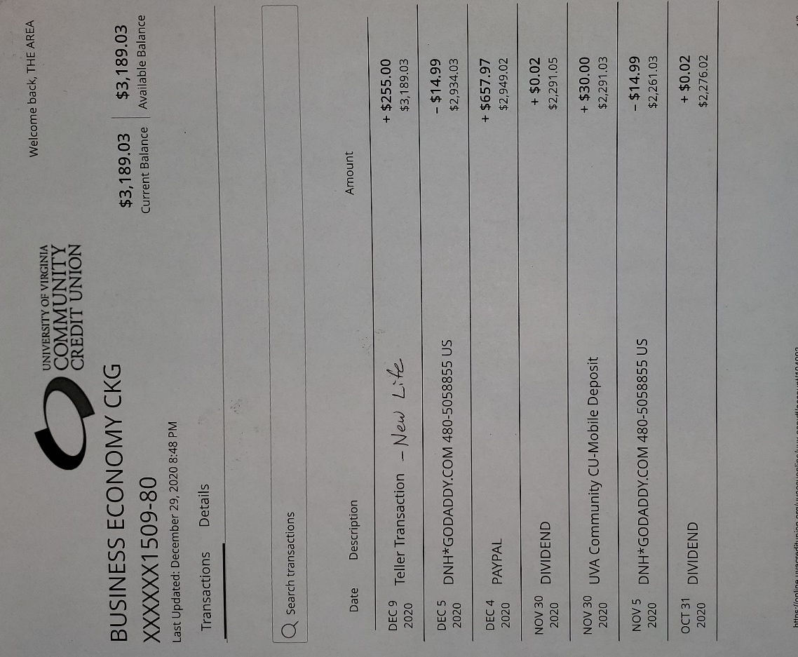

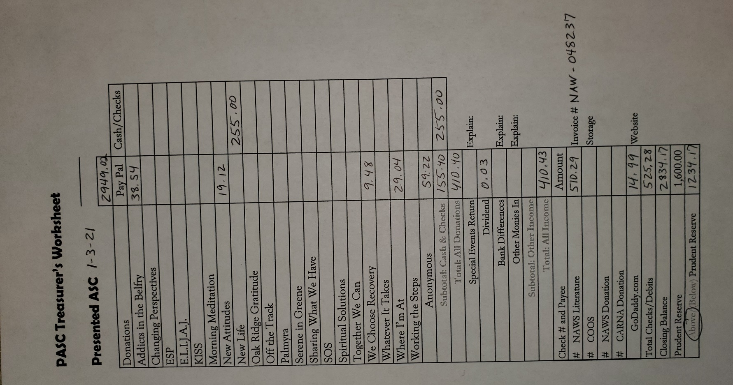

Literature Report: (Jim W.)

I handed out a grand total of $12.40 worth of literature. Obviously no need to order anything this month.

Ad-hoc Reports:
25th ECCNA Bid Committee Report: (Tee T)

The ECCNA bid committee meeting met on 11/22/2020. Unfortunately I was unable to attend. At this point no report has been sent by the secretary. The chair did text me and said we will contact the colleges in 1/2021.

Donations Adhoc committee: The paypal account was transitioned from a personal account to a business account, and included the PANA EIN. Then attempted to change the account to charitable organization status, which required classification as a subtype of non-profit for their purposes, “subordinated organization” was selected, and NAWS 501(C)3 designation was used as evidence. NAWS clarified that they are not a charitable organization, and are actually subordinate to groups so the committee is waiting to hear back from Paypal as they attempt to resolve this issue. Still working on removing Lawrence E’s name from the account.
RECESS
none

IV. OLD BUSINESS

none

V. NEW BUSINESS

none

VI. ELECTIONS

- Brian K was nominated as RCM II, seconded by Chris P. Brian stated that he met the qualifications of the position, and asked for clarification of the position from Chris P. Brian was elected with a unanimous vote of members present.
- David H was nominated as ASC Chair, David stated that he met the qualifications of the position. David was elected with a unanimous vote of members present.
- Ben C nominated as Vice Treasurer, stated that he met the qualifications of the position. Ben was elected with a unanimous vote of members present.

VII. ANNOUNCEMENTS AND ANNIVERSARIES

ANNOUNCEMENTS

In keeping with our 7th Tradition, a reminder that the Paypal app on our website: piedmontvana.org does have the ability to be set up with a recurring donation.

The following positions are open for those interested in serving the NA Community:
- VRCC Alternate Director please contact Tee T.
- H&I Secretary, Men’s ACRJ, Women’s Center, and 5 East panel leaders. Please contact Jake S.
- We have several positions available in the PR Subcommittee or are coming up very soon. These include Secretary, Meeting Lists Coordinator, and the Literature Racks Coordinator. Please contact Ben C.
- We especially need more volunteers for Presentations as well as the phone line, especially female volunteers. Please contact Ben C.
- Area Service Committee Vice Chair, please contact David H.

ANNIVERSARIES
- Richard P is celebrating 23 years on Monday 1/4/21 at 7 pm at Off the Tracks
- Alexa B. will be celebrating 3yrs on Monday, 1/11/21 6pm at We Choose Recovery
- Ruth Ellen W. will be celebrating 11 years on Monday, 1/11/21 6pm at We Choose Recovery virtual meeting
- Brian K. will be celebrating 15yrs on Monday, 1/11/21 at 8pm at New Attitudes virtual meeting
- Jennifer R. will be celebrating 39 yrs on Sunday 1/17/21 at 12 pm at Addicts in the Belfry meeting in person at First Baptist Church
- Terry W. will be celebrating 32 yrs on Sunday 1/24/21 at 12 pm at Addicts in the Belfry meeting in person at First Baptist Church
- James C is celebrating his first year in recovery Monday 1/25/21 at 7 pm at Off the Tracks
- Megan O. celebrating 11yrs on Monday, 1/25/21 at 8pm at New Attitudes virtual meeting
- Ben C. celebrating 17 years on Friday, 1/29/21 at 6 pm at Where I’m At virtual meeting

VIII. MOTIONS TO SEND BACK TO GROUPS

None
Next ASC: The next Area Service will be held on February 7, 2021 at 4:00pm
Motion to Close: 5:09pm
Made by: Terry W
2nd by: Brian K

Serenity prayer said by all.

ILS, Dana R.

