Piedmont Area Service Committee Minutes
November 3 2019
Church of our Saviour, Charlottesville, VA

I. Call to Order and Serenity Prayer: 4:00pm Gilie G.
Twelve Traditions: Dana
Twelve Concepts: Brian K.
Definition of ASC: David H.

ROLL CALL
Trusted Servants
Chair: Connie P. (November 2019) ABSENT
Vice Chair: ​ Gilie G. (November 2019) present – Chair in place of Connie P.
Treasurer: Lawrence E. (November 2019) present
Vice Treasurer: Kurt S. present
Secretary: Martha F. (August 2020) present
RCM: David H. (September 2020) present
RCM II: Chris P. (September 2020) present
Literature Chair: Deedee A. (June 2019) present
Literature Vice Chair: Jim W (August 2020) present
Public Relations Chair: Brian K. (December 2019) present
H&I Chair: Ky L. (December 2019) ABSENT
H&I Vice Chair: Dean N. present
Special Events Chair: Jake S. (August 2019) present
VRCC Director: Tee T (February 2021) present
Alternate VRCC Director: Erick H. ABSENT

Group Service Representatives
Quorum was met.

Addicts in the Belfry: present Terry
Sharing What We Have: present
We Choose Recovery: present Ruth Ellen
Where I’m At: present Dana R.
Whatever It Takes: JP
Serene in Green: present Tracey A.
SOS: present T. Tee
New Attitudes: present Mario B.
New Life: present Matt
Spiritual Solutions: present John Tr.
ELIJAH: present John C.
KISS: present Roy
Off the Tracks: present Clyde P.
Oak Ridge Gratitude: present Lynn
Changing perspectives: Ruth Ellen filling in for Eric
Together we can: Absent

Groups removed from roll call:
Groups to be added:
Minutes: Minutes cannot be approved until next month due to an out of order motion. October minutes will be approved at the December 2, 2019 meeting.

OPEN FORUM

Tee T. wants to submit motion that our area co-host ECC Convention of NA with New Dominion and Tidewater. Details to be attached to these minutes.

Terry suggested an additional printing of meeting lists with all of the new meetings listed. Lynne did say that she received updated meeting lists, but please update the website. Also, if GSR’s could announce at their meetings.

II. REPORTS

Secretary Report
Thank you to everyone for their love and support over the last month and a half.
I have received several reports already. Thank you. These are your minutes; the faster you get the reports to me, the faster I can get the minutes back out to you.
I received a notification on the Gmail account that the UVA Credit Union account had been changed on 11/1/2019. Note: Lawrence reported that it was he working on the account last Friday evening.

Regional Committee Member Report
David H.
RCM Report – November 2019 ASC

The Central Atlantic Region of NA it’s October two-day event and 199th RSC on October 19th and 20th in Fredericksburg.

- Our Region’s semi-annual two-day events include the GSR Assembly in April and a day in October where we focus in a regional project. This year’s special project has been the Regional Inventory. I have had the privilege of serving with the Regional Delegate team on the Planning Task Group. On Saturday the 19th, we presented the results of the Planning Survey and then broke into small groups to come up with approaches. Areas that will be focused on include:
  - public relations
  - inmate step writing
  - better communicating the function and benefits of the Autonomy Zonal Forum
  - Improving training and mentorship in service

The next phase of for the planning group will be to develop Action Plans to improve the Region’s work in these areas. More will be revealed!

- Regional Finances: Since the last RSC we had $1324.41 in income and $7081.99 in expenses. As of October 17th, we had $12722.43 in the bank.

  - Piedmont Area made did not make a donation to CARNA during this RSC due to being under prudent reserve. We have not made a donation to the Regional in six months.

- The 2020 Autonomy Zonal Forum will be held in Charlottesville January 24th and 25th. of 2020, at the Courtyard Marriot here in Charlottesville. The World Board will be in attendance, along with representative of the six regions that make up the Autonomy Zone. There will be a motion from Region regarding the funding of this event.
  - This is a big deal because the 2020 WSC cycle conference agenda report will come out in November and the world board will be in our town to discuss it with us and with members from around the zone. Come be a part of and contribute to the future direction of our fellowship.

- Regional Public Relations:

  - The new version of the website was presented to the RSC. You can expect that to go live sometime in the next quarter. I think it is much easier to use, more attractive, and more functional.

- Open Positions:
  - Regional Policy Chair is now open, after Antionette B was elected Regional Vice-Treasurer.
  - Regional Vice-Treasure remains open.

- New Business for ASC:

VRCC Report
Tee T.,
VRCC REPORT OCTOBER 2019
I attended the VRCC meeting at UVA hospital on 9/15/19. Prior to the official meeting and at the start of open forum the executive committee (Chair and Vice Chair) met with all the directors in attendance at the time in a closed door meeting. They made a statement about medical marijuana and asked us our opinion on whether a NA member on medical marijuana should serve on an executive board and what level of service. After each director gave an opinion, it was determined by the directors to take it back to their area and get their areas conscious. I am looking for our group’s conscious on the matter. I wish I could be there to talk in person about this matter, but I have a previous engagement that I am committed to. I will be glad to discuss this in further detail with anyone when I get back next week. You can contact me at teetucker@hotmail.com or 434-242-1970.

Three areas made donations to the 38th AVCNA. I turned in our partial donation. I would like to thank the two home groups that turned in their donation. There still is time. I would like to turn in the rest of the donation in at the next VRCC meeting in November. This is the LAST VRCC meeting prior to the convention. Please get your extra groups donation to the area treasure and let him know it is for the 38th AVCNA. Then in turn, he can write a check for all the groups’ donation to the 38th AVCNA.
As of this time the minutes haven’t been sent. The VRCC currently doesn’t have a secretary and the vice who is filling in is also filling in two other positions at the VRCC level. I will submit the VRCC minutes when I receive them.

30 Extra rooms for Friday and Saturday nights for the AVCNA Convention. Tee heard recently that we are almost out again. He will probably vote to keep adding 10 rooms at a time to the new block.

Discussion of whether people can serve on VRCC when they have been prescribed medical marijuana.

Special Events Report
Jake:
The Halloween Party took place as planned last Saturday from 5-8 pm. There were about 25 people in attendance. We took in $102 in donations and $31 from a raffle that was held, for a total of $133. We spent $225 on food and $75 on decorations, for a total of $300. I wrote a check for the leftover $100, from the $400 budget, to the treasurer. The $133 taken in from the party was also handed over to the treasurer following the event.

I am unaware of the exact figures, but I believe that is less money than we took in at the Halloween event last year. Without a doubt, there were fewer people in attendance this year compared to last year. Of the 25 people in attendance, I would guess about 7-10 of them were NA members, with the rest of the people in attendance consisting of their family members. It was fun having a lot of kids there, but I was disappointed to see the lack of attendance by actual NA members. Trying to figure out a way to get more people involved in the next event is going to be one of my top priorities. If anyone has any thoughts, I would love to hear them. Please get with me after area service or come to our next subcommittee meeting, which will be held November 23rd at 11:30 in the library at Church of Our Savior. The topic of the meeting will be planning the winter holiday party.

H&I Report
Ky L. –Absent Chaired by Dean N.
H&I held its regular meeting at 2:30pm on November 3, 2019
Wellness Center meeting moved to the Women’s Center as of first Friday of December 6, 2019. H&I always looking for volunteers. Contact Ky or Dean or any of the panel leaders.

Hospitals and Institutions Sub-Committee Meeting
DATE: November 3, 2019
Held at Church of Our Saviour

Call to Order and Serenity Prayer: Dean N.

Twelve Traditions: Mike R.
Twelve Concepts: Jim W.

Attendees

Chairperson: Ky L. (12/18-11/19) (ABSENT)
Vice Chair: Dean N. (01/19-12/19) Chair in Ky’s absence.
Secretary: Martha F. (01/19-12/19)
Men’s ACRJ: Mike R. (01/19 -12/19)
Women’s ACRJ: Patsy G. (01/19-12/19)
Wellness Recovery Center: John Tr. (02/19-02/20)
5 East: Melissa P. (01/19-12/19)
Boxwood: Jim W. (03/19-03/20)

Also Attending:

Minutes: Approved
Moved Patsy
2nd Jim

Panel Reports

Men’s ACRJ

For the month of October, we took a total of 8 meetings into the men’s jail out of 10 scheduled.

2 were cancelled by the jail, 1 of those a Thursday one cancelled last minute due to a power outage.

We have November mostly scheduled thanks to our devoted volunteers. Still an opening on Thanksgiving but the jail usually cancels that day anyway.

Kevin M. has now submitted his application and Kyle W. is interested. He has the application and will be filling it out.

As a reminder when volunteers enter a facility as part of the H&I subcommittee,
their sole purpose in being there is to share a clear message of recovery from the disease of addiction through the program of Narcotics Anonymous. We are essentially a "walking, talking Basic Text."

Literature needed:

15 White books- no staples
20 Meeting lists

Below is a list of completed meetings from October and the scheduled meetings for November:

ACRJ October 2019

Wednesday, 10/2 Robert P / Jon T meeting held
Thursday, 10/3 Ky L / Mike R meeting held

Wednesday, 10/9 Ky L / Mario meeting held
Thursday, 10/10 Dan C / Steve S meeting cancelled by jail

Wednesday, 10/16 Jason B / Mike R meeting held
Thursday, 10/17 Joe P / Mario meeting held

Wednesday, 10/23 Dean N / Kurt S meeting held
Thursday, 10/24 Jim W / Adam W meeting held

Wednesday, 10/30 Robert P / Mike R meeting held
Thursday, 10/31 Brian K / Bill C cancelled- power outage from a storm

ACRJ November 2019

Wednesday, 11/6 Ky / Mike R
Thursday, 11/7 Dan C / Steve S

Wednesday, 11/13 Jon T / Robert P
Thursday, 11/14 Jim W / Mario

Wednesday, 11/20 Jason B / Jon T
Thursday, 11/21 Brian K / Ky

Wednesday, 11/27 Mike R / Robert P
Thursday, 11/28 Jim W / _______

Women’s ACRJ:

Connie and I went to the Jail on the 14th and had a fine meeting.

Of the meeting in the 28th, Rachel says: "4 women came to the meeting on Monday. It was not a great experience as the staff said they had no idea I was coming; I arrived before 7 and no one came out front until 7:40. There was no roster and I couldn't find our literature; the women didn't come into the classroom until 7:55. We had a great meeting and then wrapped it up at 8:20 because one of the women had to use the bathroom."

I would like some meeting lists.

I have just sent a Jail application to Priscilla, who Connie started trying to recruit, and forwarded her email address to me.

It occurred to me that I could forward the lovely new simplified application to each of the rest of you and then you would have it to pass on to others, so here it is, attached. (see Addendum)

Wellness Recovery Center:

Oct 4 Fri, 8:56 PM
Ruth Ellen and I went to Wellness and we did not have a meeting. Beth Huntington
Oct 11th, 2019
Ky Lindsay to John Tr.: The meeting went famously. Clyde and I went with Alexa observing. We had about 6 women from the Women’s Center, no one from Wellness or the Mohr Center.
Friday Oct 18th : Gilie Garth reported
There were 10 women in attendance, 9 from the women’s center and 1 from Wellness. Ruth Ellen took Dean’s place and she and Gilie both shared a bit of our stories. That was followed by 3 of the women sharing. One woman requested a meeting list. Ruth Ellen and Gilie both agreed that it was one of the best meetings they’ve ever done there.
On Oct 25th the meeting was canceled due to Lawrence E. coming down with an illness at the last minute, a substitute was not able to be found in time.
Nov 1st: (no report yet)

Wellness Schedule for Oct. through Dec. 2019
updated 10/22/19 by (DN)

10/25: Jake S. & Lawrence
11/1: Dean & David D.
11/8: Lawrence & Kurt
11/15: John Tr & Connie (Alexa shadows)
11/22: Blane & Lawrence
11/29: Beth H. & Ruth Ellen
12/6: Jim W. & Alexa
12/13: Brian K. & Ky
12/20:
12/27:

5 East:
All meetings took place for October!
October 8 Beth H. And Erick H.
October 15 Ruth Ellen W. And Dean N.
October 22 Linda C. And Melissa P.
October 29 Gilie G. And Chris P.
All meetings went well. Currently we only need meeting lists.
Thanks again to all the wonderful volunteers. ️
So far this the November 5 east schedule.
November 5. ? And ?
November 12 Ruth Ellen and Dean.
November 19 Beth H. And Erick H.
November 26 David D. And Ruth Ellen W.

Boxwood:
There were four meetings scheduled for Oct. All meetings were held, all went smoothly and had around 20-25 clients present. Many key tags were handed out including, but not limited to, a lot of white key tags. One meeting handed out at least one of every color up to yellow!
The following trusted servants took in meetings:
10/10 Brian K and Joe P
10/17 John Tr and Jim W
10/24 David H and Jake S
10/31 John C and Jim W
Due to a death in the family Kermit O had to cancel last minute. Thanks to John C for going with me on a day's notice so we could still take a meeting in.
Below is the schedule for Nov and Dec:
11/14 Ky L and Steve P
11/21 John T and Jim W
11/28 Kermit and Jamise O
12/12 Brian K and Joe P
12/19 David H and Jake S
12/26 Kermit and Jamise O
Many thanks to our wonderful volunteers who keep sharing the message at Boxwood.

Open Forum:

Melissa is willing to stay on as 5East chair. Dean N. takes over for John C. as Wellness chair in December. Mike is willing to stay on for another year.

Old business:

New Business:

Bring up budget at the next meeting.

Elections: None

Literature Order:

Men’s ACRJ:

15 White books - no staples
20 Meeting Lists

Women’s ACRJ:

10 Meeting Lists

Wellness:

15 Current Meeting Lists
5 White Books
White Bookmarks

5E:

12 Meeting lists.

Boxwood:

15 meeting lists
10 Am I an addict?
10 For those in treatment
10 Recovery and relapse
10 Sponsorship
10 Welcome to NA
20 white tags
15 orange
5 green

Total literature order: $43.73

Volunteer Updates:

Motion to Close:
Made by: Patsy G.
2nd by: Melissa P.

Serenity Prayer: Said by all

Next Meeting: December 1, 2019 @ 2:30pm at Church of Our Saviour

ILS Martha F.

Public Relations Report
Brian K. –
PR Subcommittee Meeting
November 3, 2019
The meeting opened with the Serenity Prayer at 1:34.
The Traditions were read by Mario B.
Concepts were read by Lawrence E.
PR Subcommittee Structure were read by Mike R.
Roll Call
Brian K. Chair
Lawrence E. Secretary
Mike R. Presentation Director
Mario B. Interested party
Minutes from the October meeting were approved
Trusted Servant Reports
Webmaster Steve S.
720 page views in last 30 days
3 file downloads
1 contact form submission.
I looked into the tracking that David was asking about for unique IP addresses. Unfortunately, the way the GoDaddy site is formatted limits the coding that can be added, so I wasn't able to find a simple solution for this. There may be a solution out there but it would probably take a fair amount of time to research. If David or anyone wants to look into this I welcome the assistance, but as of right now I'm going to leave it as is.

Literature Rack Coordinator Mike R.
Dan C.’s many years of service were noted.
Brian will forward, to the committee members, a site list sent by Dan.
Panel Presentation Director Mike R.
No presentations in the month past.
Anthony will send his contact list to Mike.
Mike will stay on ACRJ and OAR.
Mike will also take on the phone line duties. He and Melissa G. reported no calls.
Lawrence will check with his rector about a Wednesday evening presentation at his church. He will also check with Tripp Martin, of his church, about a presentation for Albemarle County Police.
Old business
There was no old business.
New business
Look for presentation possibilities.

Election Rules & Regs were read.
Mike R. was nominated to be phone line point of contact. The duties of the position were read. Mike R. stated his qualifications and was elected by acclamation. Brian will forward the appropriate section of the PR Handbook to him.
Mario B. was nominated to be vice chair, the duties were read, and Mario was also elected by acclamation.
Literature-rack-coordinator-to-be Steve P. was not present.
Close
We closed with the Serenity Prayer at 2:20.

Literature Report
Jim W
Total literature order 496.86
Jim needs to be reimbursed for literature order copies.
Lawrence will provide monthly breakdown of literature orders for the last 12 months.

Treasurer’s Report – October 6, 2019
Lawrence –
Opening Bank Balance (A) | $1791.90 | Do Not Write
Donations | Cash | Check
Addicts in the Belfry | 52
Changing Perspectives
E.L.I.J.A.H.
ESP
KISS |  | 85
New Attitudes | 50
New Life |  | 248
Oak Ridge Gratitude | 10
Off the Track | 25
Palmyra
Serene in Greene
Sharing What We Have | 80
SOS
Spiritual Solutions | 5
Together We Can
We Choose Recovery |  | 86
Whatever It Takes | 24
Where I’m At | 57
Working the Steps |  | 20
Donations Subtotal | Cash $303 | Checks $439
Total Donations (A) | 742 | Sum of Cash & Checks
Special Events Return | 233
Other Monies In | 65 | Explain: AVCNA passthru
Other Monies In |  | Explain:
Total Other Income (B) | 298
Total All Income (A+B) | $1,040 | Sum of A + B
NAWS | 512.43 | Literature
Church of Our Saviour | 50 | Rent
AVCNA | 65 | Donation pass through
Jim W. | 89.51 | Literature Order Forms
ALC | 251.88 | Meeting Lists
(3) Checks Total | $968.82 | Do Not Write
(1+2-3) Closing Balance | $1,952.59 | Do Not Write

2019 Donations by Home Group
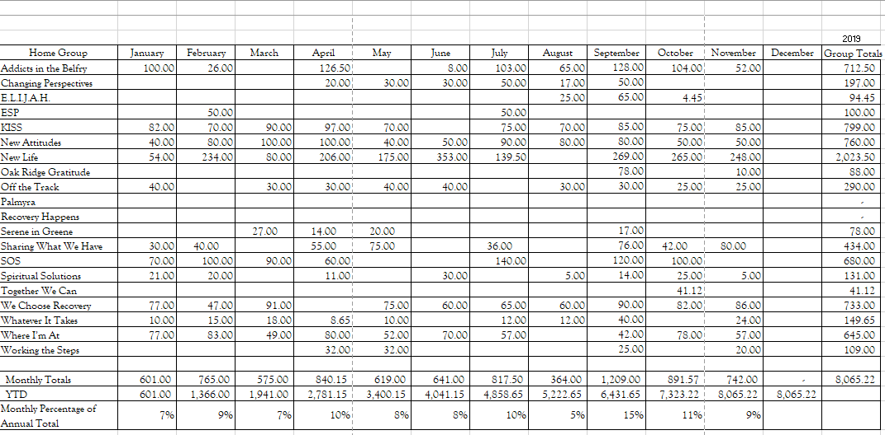

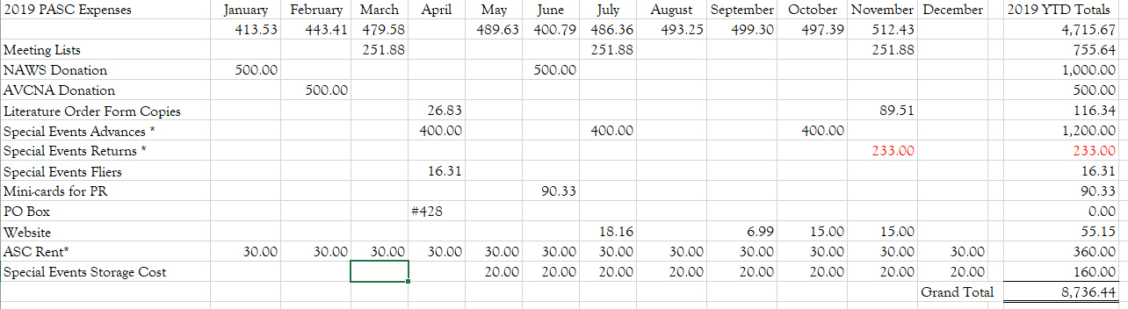
2019 PASC YTD Expenses

Ad-hoc Reports - None

RECESS​ – None

IV. OLD BUSINESS
October minutes will be approved/rejected according to the motion to amend after a group conscience is taken on the change in wordage. Motion was made out of order at the October meeting.

V. NEW BUSINESS
Motion to donate backlog gift editions to Special Events for fund generation.
Motion passed unanimously.
Motion by Jim W. 2nd by DeeDee A. to reimburse for making copies of literature order forms. $89.00
Motion passed unanimously.

VI. ELECTIONS

Nominate Gilie G. for PASC chair.
Elected unanimously.

VII. ANNOUNCEMENTS AND ANNIVERSARIES
Announcements:

-Public Relations is seeking a new secretary. See Brian K.
-Women’s ACRJ needs a new panel leader. See Patsy G.
-5 East always needs new volunteers. See Melissa P.
Special Events Subcommittee will be holding its next meeting on November 23, 2019 at -11:30am in the library of Church of Our Saviour on Rio Road. We will be planning the Winter holiday party and all are welcome to attend – ideas and feedback are greatly appreciated.

*Please come to the next Area Service meeting on December 1st at 4:00pm at Church of Our Saviour on Rio Road to find out more about service in Narcotics Anonymous! It’s fun.

-Please help support the Nelson County meeting, Oakridge Gratitude in Arrington on Tuesdays from 7-8pm.

- The 200th RSC will be in at University Hospital in Charlottesville on December 21st. Since it is the 200th, we are having a potluck celebration to mark the occasion.
All members, regardless of clean time or service experience, are welcome to attend this and any other Regional Service Conference.

Anniversaries:

Nov 4 Beth H, 6 years at We Choose Recovery
Nov 4 Lawrence E, 13 years at We Choose Recovery
Nov 10 Joe G, 10 years at SOS
Nov 16 Dan C, (xx years) at Together We Can, 10:00
Nov 18 Matt F. 3 years at New Life Group Monday, 12:15pm
Nov 18 Amalie D. 3 years at New Life Group, Monday, 12:15pm
Nov 18 Spencer S. 2 years at New Life Group, Monday, 12:15pm
Nov 21 Richard M. 26 years at Whatever It Takes Thursday, 9pm
Dec 3 Thom W. 27 years at ESP Tuesday, 6pm
Dec 6 Jake S. 3 years at Where I’m At

VIII. MOTIONS TO SEND BACK TO GROUPS
Motion 1: Motion by: Tee T. SOS GSR
2nd: John Tr. Spiritual Solutions Group GSR
Motion: That the Piedmont area take a group conscience to co-host and support the 25th East Coast Convention of NA in June 2021. New Dominion has invited the Piedmont area & other areas to co-host this convention.
Intent:
1. To fulfill our primary purpose by providing our Basic text to jails & prisons on the east coast.
2. To co-host a convention that is cost effective for our members
3. To have our area gain some experience in what it takes to host a convention.

Motion 2: Motion by Tee T. SOS GSR
2nd by John T. Spiritual Solutions GSR

Motion: To go back to groups to get a group conscience on whether someone on medical marijuana can serve on the VRCC executive committee. Please bring back a yes or no on whether they can serve.
Intent: To get a group conscience.

Motion 3:

Motion: 199-6

Mover: RD Team
2^{nd:} Michael L

Survey monkey was used to improve our ability to take the conscience of the members at the region directly and efficiently during the regional planning process.

Intent: To provide the funds necessary to allow multiuser use of Survey Monkey.

Motion: To budget $900.00 for the purchase of a one year 3 user subscription to survey monkey which will provide us with the technological capability to directly take the conscience of the of the CARNA region.

Pro: The money spent may allow better access to members not participating in service structure to get their conscience.

Motion 4:

Maker: David H.
2nd: Ky L

Motion: Any trusted servant making a report at the Area Service Conference will provide the Area Secretary a written report within 7 days of the Area Service Conference.

Intent: 1. To facilitate timely completion of the Area minutes. 2. To provide a mechanism of accountability for those trusted servants to whom the reporting responsibility has been delegated.

Motion to close: Terry W.
Seconded: Tee T.
Next ASC: The next Area Service will be held on December 1st, 2019 at 4 pm.
The Meeting was closed with the Serenity Prayer
ILS Martha F.

