Piedmont Area Service Committee Minutes
July 13th , 2025 - Hybrid Meeting

I. Call to Order and Serenity Prayer: 4:01: Pete T Twelve Traditions: 4:02: Anthony M.
Twelve Concepts: 4:05: Anand H. Purpose of ASC: 4:05: Pete T.

II. Roll Call
Group Service Representatives:
Addicts From the Belfry Kermit O. Present
Changing Perspectives Patsy G. Present
New Attitudes Chris K. Present
New Life Group Matt S. Present
No Matter What Adam S Present Off the Tracks Owen E. Present
SOS Anthony M. Present
Serene in Greene Tracy A. Present
Spiritual Solutions Dana R. Present
We Choose Recovery Lawrence E. Present
Without Parallel Madeline H. Present

Trusted Servants
Chair: Kyle W. Absent
Vice Chair: Pete T. Present
Secretary: Azaria B. Present
Alternate Secretary: Vacant
Treasurer: Brendan Present
Vice Treasurer: Vacant
RCM: Dana R. Present
RCM II: Vacant
Literature Chair Hamish B. Present
Alt Literature Chair Vacant
Public Relations Chair: Melissa Spi. Absent
Public Relations Vice Chair: Michelle R. Present
H&I Chair: Adam W. Present
H&I Vice Chair: Vacant
Special Events Chair: Anand H. Present
Special Events Vice Chair: Madeline H. Present
VRCC Director: Tracy A. Present
Alternate VRCC Director: Vacant
Quorum was met.
Other members present:
Groups to be removed from roll call:
Groups to be added: Step Into Freedom- Jerrica H.

III. Approval of Minutes – 4:15
Patsy H motioned to approve the minutes, Adam S seconded.
IV. Open Forum – 4:10

V. Reports – 4:12

Chair Report: (Kyle L.) No Report

Vice Chair Report (Pete T. ) No Report

Secretary Report: (Azaria B): No Report

4:32 Regional Committee Member (RCM) Report: (Dana R.):
No Report
4:14 H&I Report: (Adam W.)
4:21 Public Relations Report: (Melissa Spi.)
Opening
The virtual meeting opened with a moment of silence and the Serenity Prayer at 1:33p.m. led
by Michelle R.
12 Traditions read by Tracy A.
12 Concepts read by Tracy A.
Roll Call
Chair Melissa Spi. (9/24) Present
Vice Chair Michelle R (1/25) Present
Secretary Lawrence E. (6/25) Present
Presentations Jim W. (3/23) Present
Literature Racks Tracy A. ( 9/23) Present
Meeting Lists Jim W. (10/24) Present
Web Servant Andy H. (8/24) Absent
Phone Line Jodi D. (6/25) Absent
Area Vice Pete T. Present
Also attending
Approval of Minutes
June minutes approved Jim W. Lawrence E.
Reports
Chair
No Report
Vice Chair
No Report
Literature Racks
No Report
Web Servant
The website had 877 visitors this month. No emails were received.
Remove Online Oasis from website.
Add Steppin’ to Freedom (note spelling), Monday Step Working meeting, to website..

Presentations:
We were scheduled to do the One Stop Event last month, but Roy was in the hospital and our other volunteer- a relative newcomer who had never done it before- did not want to do it alone. Our usual stalwart Michelle was out of town; this was the first One Stop she didn’t do.
Our next One Stop event is this Thursday and Michelle will be there as usual, along with Roy. I signed up for a table at Westhaven Community Day Aug. 2 from 10-3 at 801 Hardy Drive. See attached flyer. We need to be there by 9:45 to set up, because at 10 am the access road will be closed. We need to bring our own table- which we have- but also our own chairs- which we don’t have, so we need to work something out. Old Faithful Michelle has offered to go. We need another volunteer. Let’s bring this up at Area and add it to the announcements.
There are no particular requirements for volunteers at this event. Will discuss the matter next month.
Meeting Lists
Chair will check with ASC about printing new meeting lists with changes:
Remove Online Oasis from meeting list.
Add Steppin’ to Freedom (note spelling), Monday Step Working meeting, to meeting list.
Phone Line
No report.
Jodi D. is setting up her access to the Regional Phone Line.
Old Business
None.
New Business
Check with ASC about printing new meeting lists with changes.
Open Positions
None.
Need new Literature Rack volunteer.
Closing
Next virtual PR meeting is scheduled for August 3, 2025, 1:30pm.
The meeting was closed at 1:51p.m. with the Serenity Prayer led by Melissa Spi.

4:30 Special Events Report: (Anand H.)
Hi Family,

The Special Events Committee is officially forming a subcommittee in order to plan the sponsorship event. Please contact me if you have any questions or would like to join.

In Loving Service,

Anand

4:40 Literature Report: (Hamish B.)
$366.29 literature distributed
$397.45 literature ordered
Order # 1046764
ILS, Hamish

4:43 Treasurer Report: (Brendan M.)
Dear Area Service Members,

I have attached my Treasurer's Report for the month of July as well as the proposed budget for FY26. We can discuss the budget further at the Area Service meeting shortly.

Kind regards,

Brendan FitzPatrick
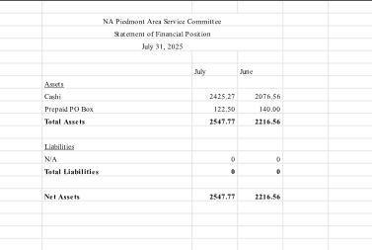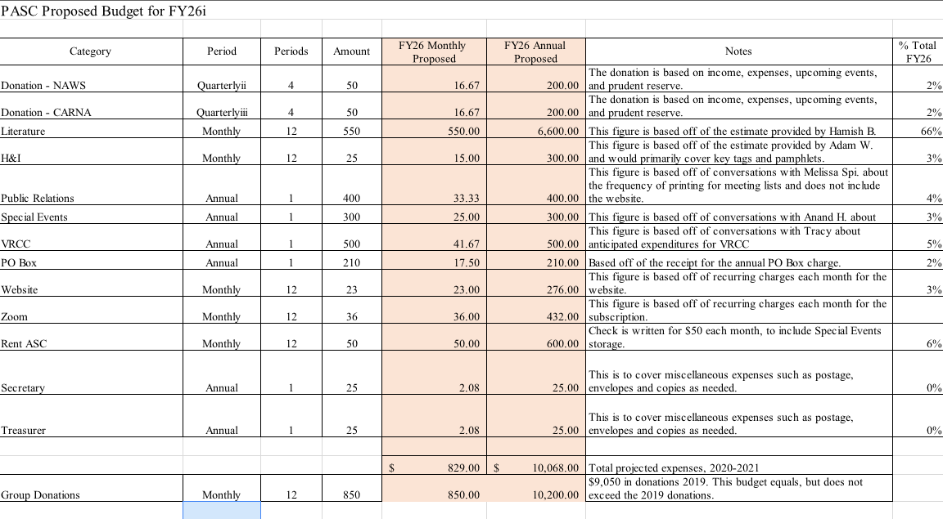

4:11 Director of VRCC Report: (Tracy A.)
Good Afternoon,

I was unable to attend the last VRCC meeting due to attending the memorial for the New Dominion Area Director Jeff. We are to meet on July 20,2025 by Zoom only. Everything is still going well with the planning of the 42nd Convention in Roanoke, VA January 23-25,2026. You will need to find a new VRCC Director because I will be stepping down as soon as possible.

ILS
Tracy A
4:39 GSR Reports:
None
VI. Old Business: 4:35
None

VII. Elections: 4:35
None
VIII. New Business: 4:36
None
IX. Back to Groups: 4:37
We have a motion that needs to be voted on by next area. It is as follows:
"
Date June 21, 2025
Name of Member Making
Motion Sherry V. Area RD Carna
Seconded by Heather R. Area Shevana
Description/Background
(optional)
World Services has paid for the Regional Delegate to attend
for many years after the conference voted for it. Then the
vote changed for NA world Services not to pay for RD unless
extenuating financial hardships of the region/zone
Intent To be fully self-supporting-
Motion: To Change: Section VIII: ADDITIONAL GUIDELINES
1. RSC will pay for transportation, lodging, and per diem for the RDA and
RDA2 to attend the biannual WSC, and for per diem for the RD to attend.
TO:
1. CARNA will cover the costs of transportation, lodging, and per diem for
the RD, RDA, and RDA2 to attend the World Service Conference (WSC). "

X. Announcements and Anniversaries:

- NEW MEETING: A new meeting titled “Steppin’ to Freedom” on Mondays at 5:15-6:30pm at the Downtown Library on the 3rd floor. For more information, please contact Jerrica H.
-VOLUNTEERS NEEDED: Public Relations is looking for volunteers to do PR presentations- One Stop Shop and the Westhaven Community Day (August 2nd)
-VOLUNTEERS NEEDED: H&I is looking for volunteers for the men’s and women’s ACRJ and boxwood. If interested, please contact Kyle W., Connie P.,
-CAMPOUT EVENT: 7/18-20 at Natural Chimneys Park, there is the BRANA campout. Several area NA members have campsites with open spots for more campers to join in on the fun. If you would like to attend, please reach out and we can guarantee you a spot for this wonderful, recovery-filled weekend. For more information on the campout, visit https://branacampout.org/

ANNIVERSARIES
Joe P. 18 years 7/21 New Attitudes
Grace H. 17 years 7/21 New Attitudes
Richie H. 9 years 7/21 New Attitudes
Dan K. 14 years 8/1 Off the Tracks
Michelle R. 2 years 8/4 Off the Tracks
Dale L. 2 years 8/7 New Life Group
Jim W. 7 years 8/16 Changing Perspectives
Troy P. 2 years 8/16 Changing Perspectives

Next ASC will take place on August 3rd .

4:59 Motion to Close: Pete T. Seconded by: Azaria B.
5:00 Serenity Prayer said by all.

