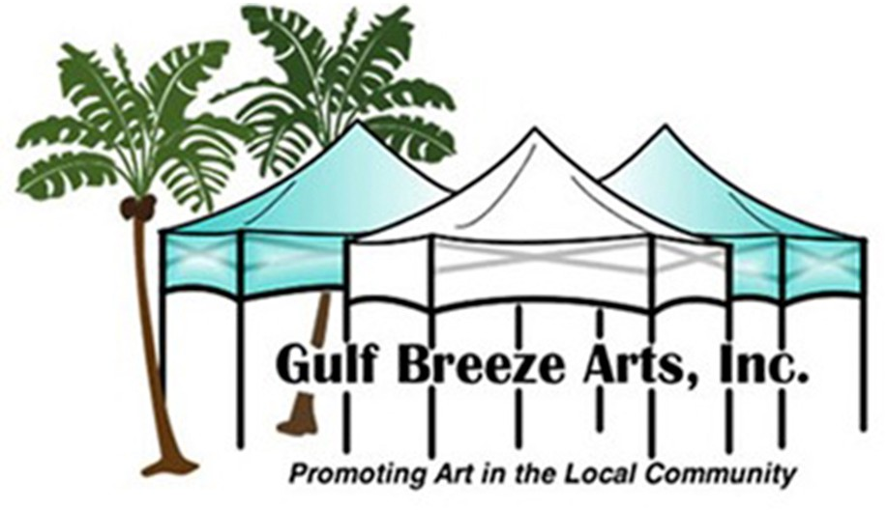26th Annual

Gulf Breeze Celebrates the Arts Festival March 28th & 29th, 2020

**Sponsor Information**

Name Phone

Address Email

Name/Logo on Sponsorship Board

Circle which level you would like:

PLATINUM GOLD SILVER BRONZE

$2,500.00 $1,000.00 $500.00 $300.00

Please make checks payable to Gulf Breeze Arts, Inc

and mail to Gulf Breeze Arts, Inc

P.O. Box 52

Gulf Breeze, FL 32562

If you would like, also enclose a business card with logo for our website and festival brochure

501C(3) Non-Profit Disclosure Requirement Registration #CH38189

“A COPY OF THE OFFICIAL REGISTRATION AND FINANCIAL INFORMATION MAY BE OBTAINED FROM THE DIVISION OF CONSUMER SERVICES BY CALLING TOLL-FREE (800-435-7352) WITHIN THE STATE. REGISTRATION DOES NOT IMPLY ENDORSEMENT, APPROVAL, OR RECOMMENDATION BY THE STATE.”