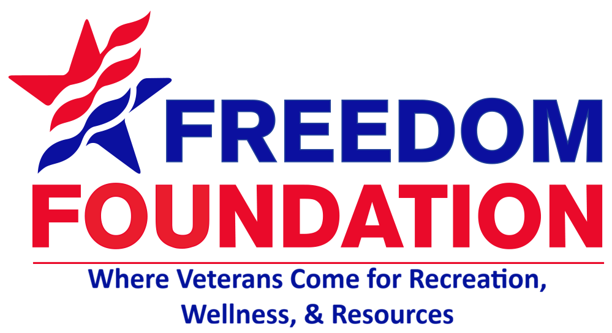  The Veterans Voice  Serving Those Who Served  Issue 12 | October 2026  Message from the Director  As October arrives and the seasons begin to change, I want to take a moment to personally thank each of our veterans and the families who stand beside them. Your service, sacrifice, strength, and dedication have made a lasting impact on our community and it is a privilege to know and serve so many of you.  At the Freedom Foundation, you are more than the people we serve—you are a part of our family. Thank you for allowing us to be a part of your lives. I hope this month brings you time to make new memories and appreciate the blessings around us.  -Mary Seely Executive Director  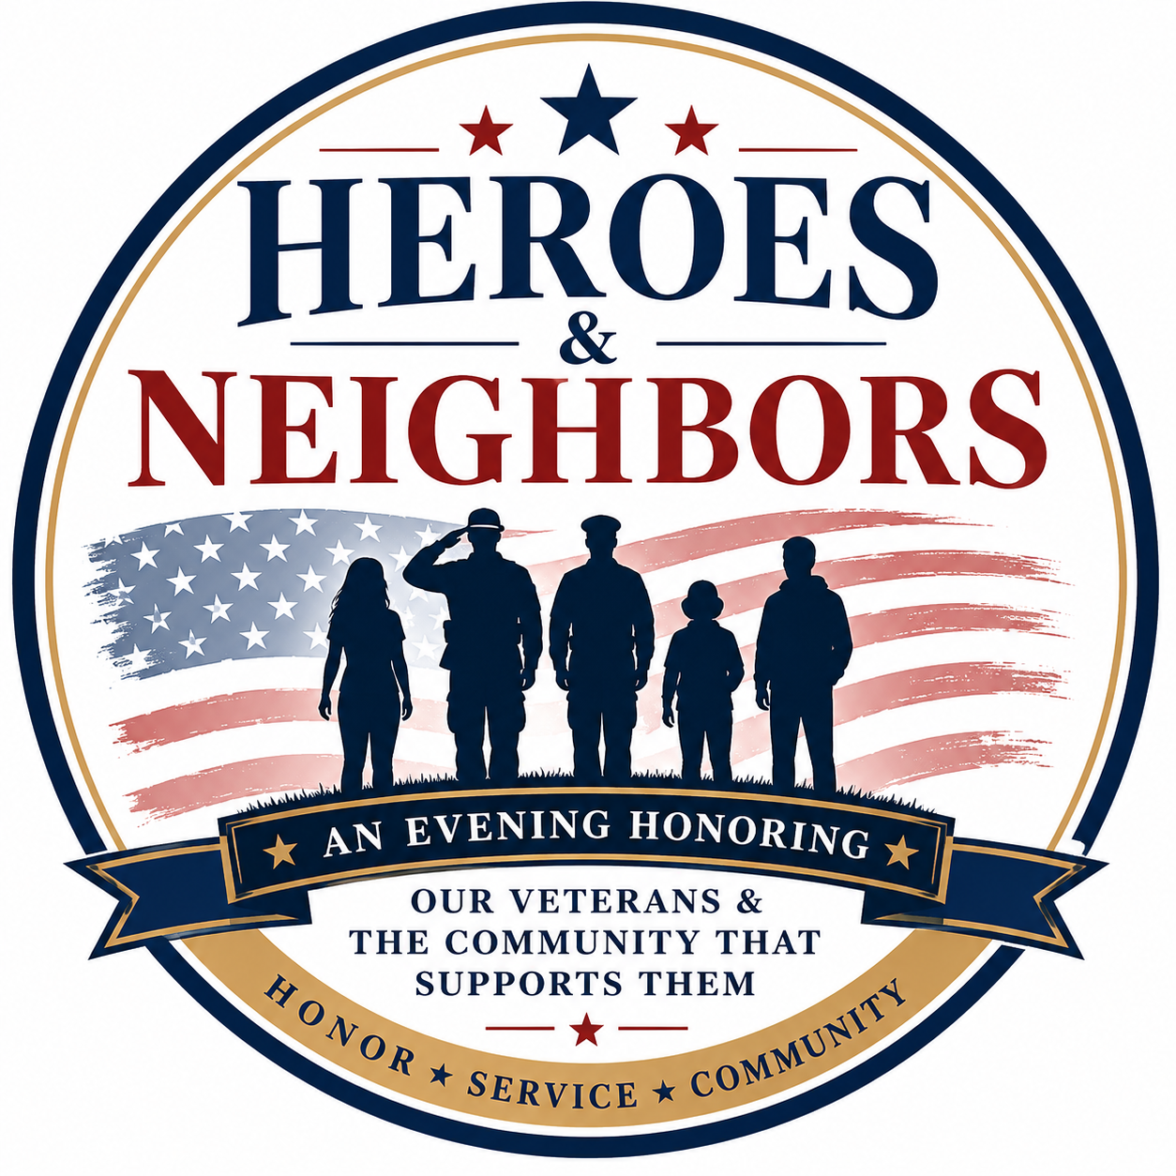
  Announcements
  🥪 Thursday Lunches – Lunches served between 11:45am-12:15pm weekly. Monthly menu can be located at www.facebook.com/FreedomFoundationCR/# or at the Freedom Foundation which is located at: 4001 Center Point Rd. NE Cedar Rapids, IA. 52402.
  ✂️Haircuts are the first Friday of every month. Next visit will be Friday, October 2nd at 11am and then Friday, November 6th. Sign-up at the Freedom Foundation today!
  Save the Date: Nov. 6th from 5pm-9pm we will be hosting our annual Veteran’s Appreciation event. Mark your calendars!
  Upcoming Events
  🎉Bingo! The Freedom Foundation will be hosting our monthly Bingo on Tuesday, October 20th, starting at 12:00pm – 2:00pm. Come play, visit with friends, and take-home fun prizes! The following Bingo game will be November 17th.
  🎱 Enjoy Pool? We host a billiards tournament every 3rd Saturday of the month. Come out and win cash prizes. Next upcoming is October 17th starting at 8:15am.
  🎤 Join us for karaoke every 3rd Thursday of the month, next on October 22nd, starting from 10am – 11am.
  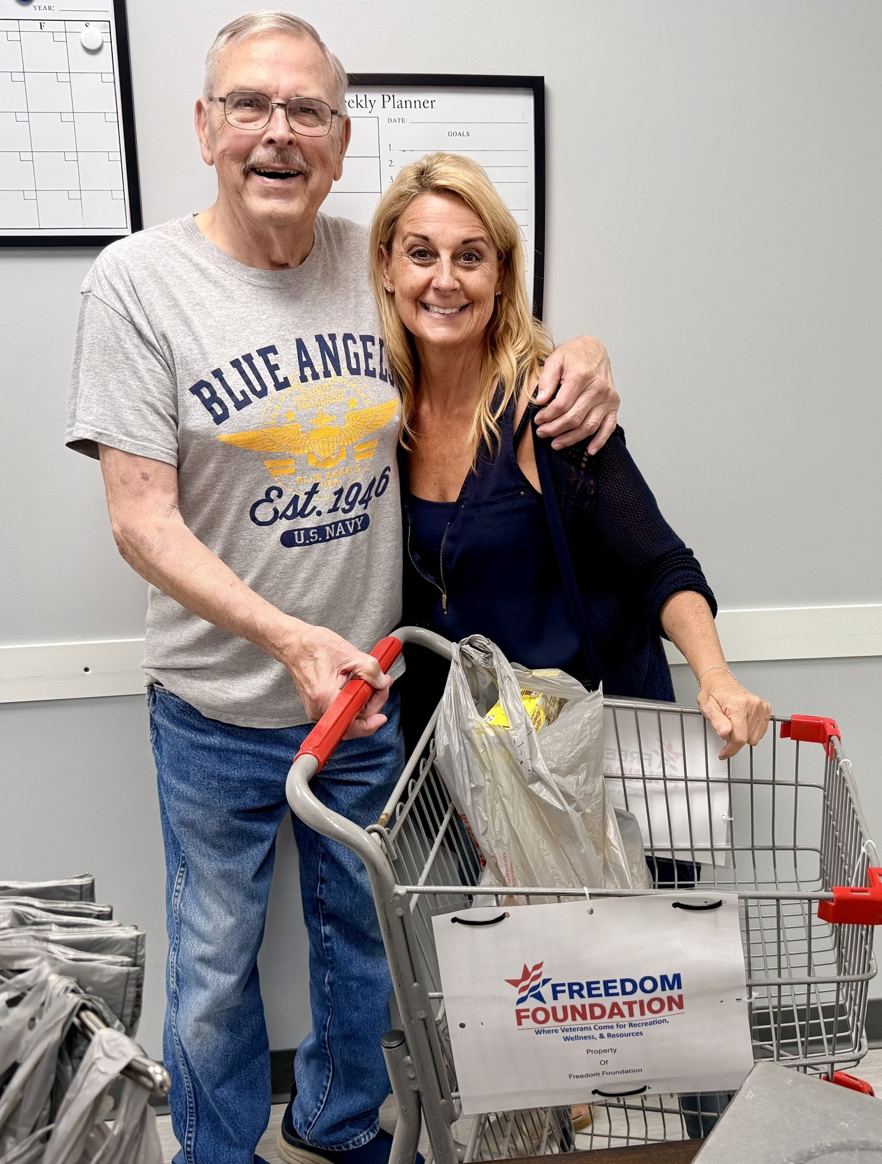
  Bernie & Mary at the Veteran Market
  New Updates
  This month we want to give a quick update on some of the new changes happening at the Freedom Foundation. The first is our new Veteran Market layout. Instead of choosing items off a table, we have created a more personal, private shopping experience.
  We have also updated our Veteran Market operating days and hours.
  Our Veteran Market schedule is now:
  Mon, Wed, Fri, 11am – 1pm.
  Sat. 10am -12pm.

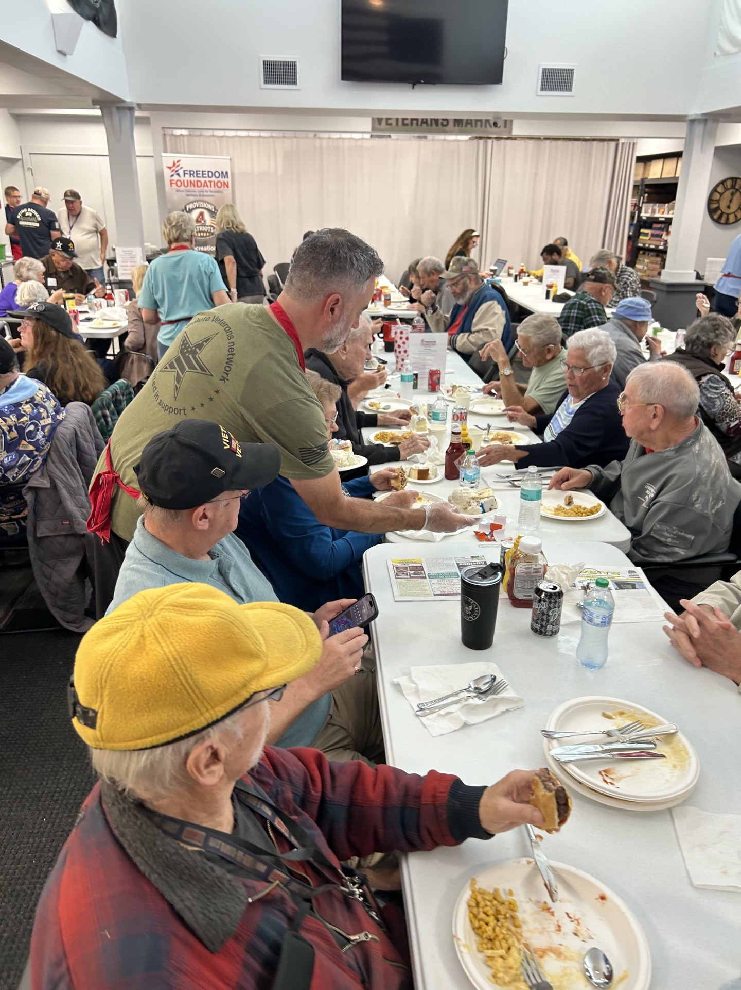TransAmerica  Local Community Resources  Need to file a claim?  Contact the Linn County Veteran Service Office (319) 892-5160.  Need to talk?  Cedar Rapids Vet Center (319) 378-0016.  Looking for work?  IA Workforce (319) 365-9474.  Asking for help with home repairs?  Matthew 25 can help. (319) 362-2214.  In Crisis? Help is closer than you think.  Dial 988 then press 1 or text 838255. 24/7. |  |  | Thank You Sponsors  October Sponsors  A special thank you to all our community sponsors. This month, we want to thank Atlantic Bottling Co., TransAmerica, TrueNorth, Kenwood Leadership Academy, Skogman Realty, and Collins Community Credit Union. Thank you all for everything you do to support our veterans.  “Their remembrance be as lasting as the land they honored.” – Daniel Webster  Veteran Appreciation Event  Heroes & Neighbors  November 6th, the Freedom Foundation will be hosting our annual Veteran Appreciation Event: Heroes & Neighbors sponsored by Cedar Rapids Bank & Trust.  Come join us for a fun evening of celebrating our veterans and the community that supports them. The event will include a catered dinner, entertainment, veteran recognition and a car giveaway to a veteran family in need.  All participants will need to obtain their tickets through the Freedom Foundation. |  |  | 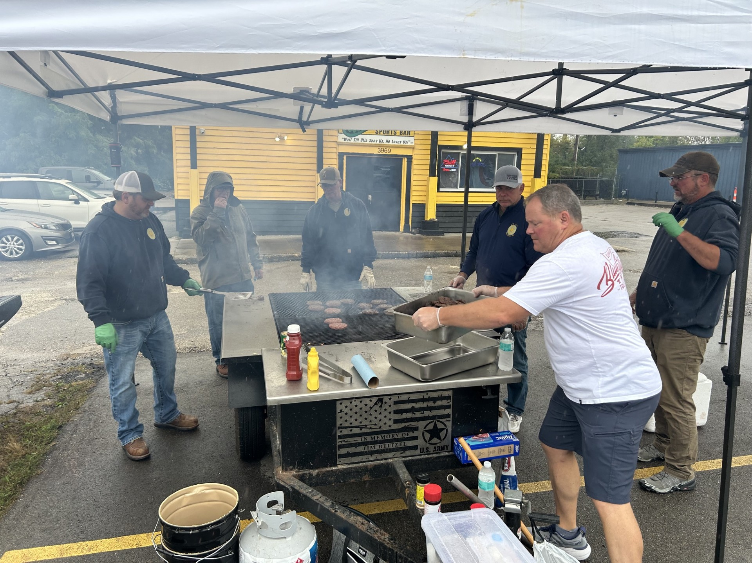  Sons of the Legion Post #650  Closing Notes  On behalf of the Board of Directors, we want to say thank you to all our staff, friends, donors, community partners, and volunteers for all you do.  Recreation Wellness Resources  The Freedom Foundation offers a place for veterans to come in, feel welcome, and enjoy the camaraderie of fellow service members from all branches.  We offer our veterans, spouses, widows, and active duty the availability to utilize our Veteran Market resources.  We serve a community meal every Thursday to veterans, widows, active duty and their spouses free of charge.  Our Veteran Emergency Assistance Fund is a resource for veterans to use once a year to help cover emergencies or other financial difficulties.  Please stop in and see us today.  https://usfreedomfoundation.org/

