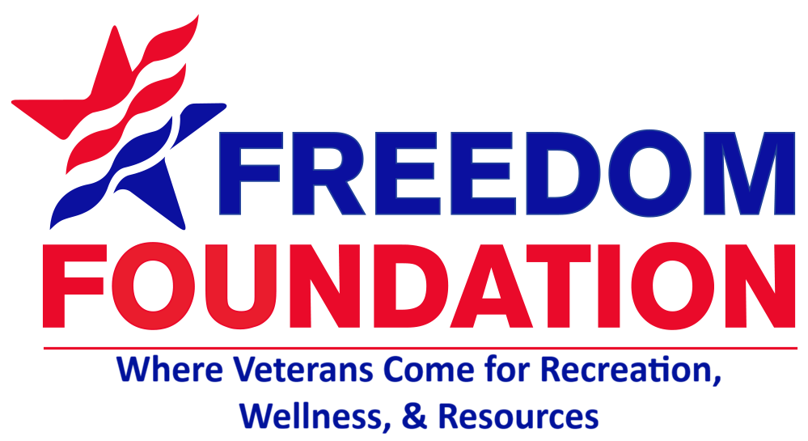  The Veterans Voice  Serving Those Who Served  Issue 11 | September 2026  Message from the Director  Dear Veterans, friends and family,  thank you for your service, sacrifice, and unwavering dedication to our nation. Your strength and commitment have helped shape the communities we call home. We encourage you to celebrate not only our veterans but also the families, friends, neighbors, and community members who stand beside them. Strong communities are built through connection, understanding, and support. Together, we can create a community where every veteran and family feels valued, supported, and connected.  -Mary Seely Executive Director  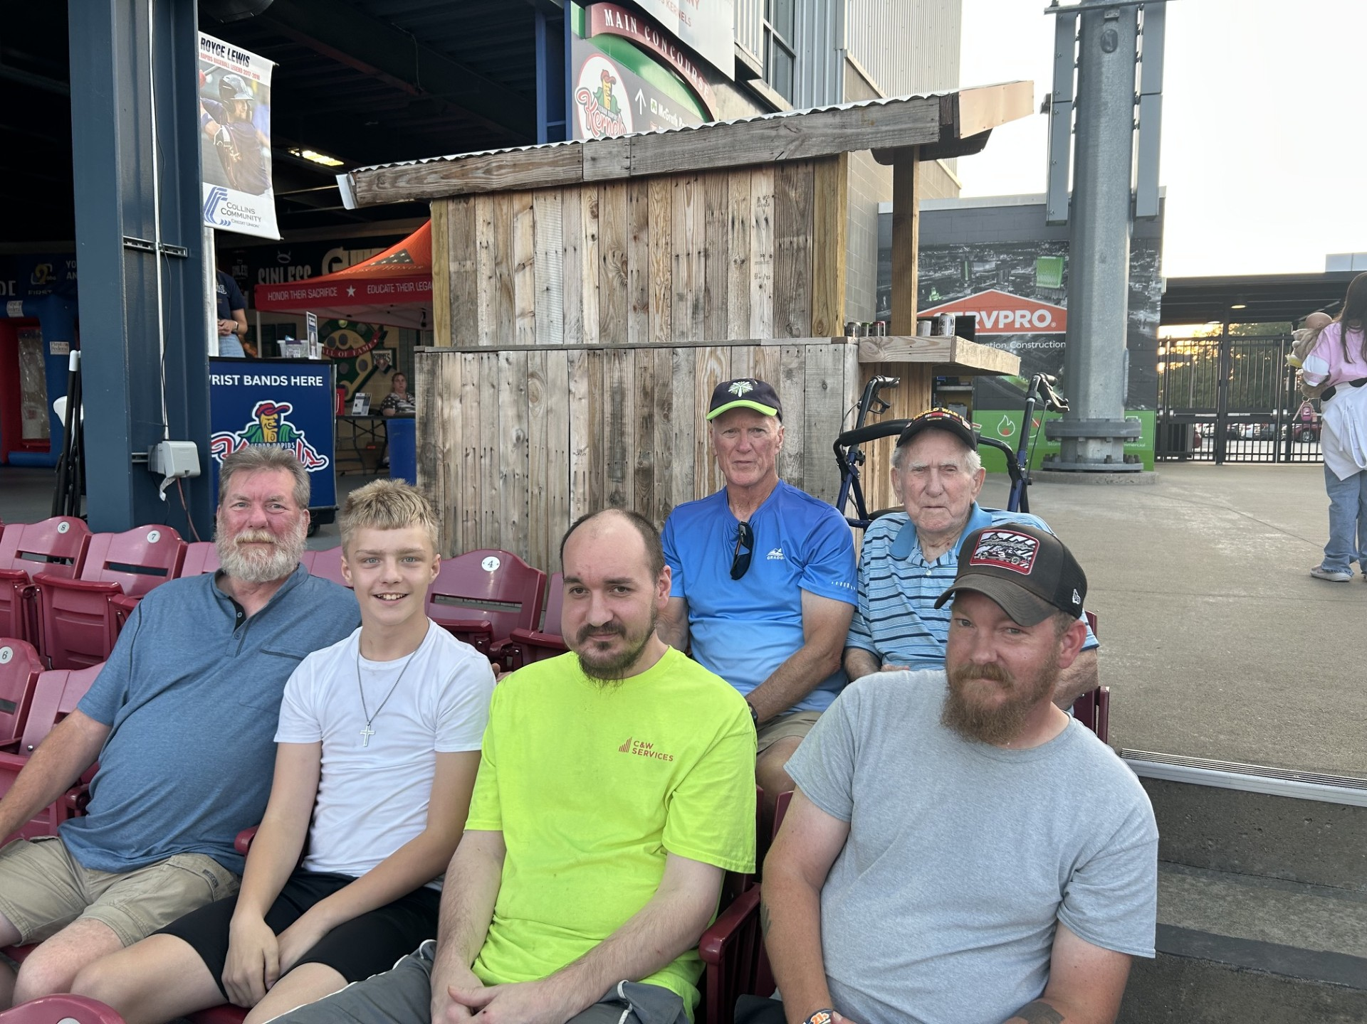  July 3rd BBQ
  Announcements
  🥪 Thursday Lunches – Lunches served between 11:45am-12:15pm weekly. Monthly menu can be located at www.facebook.com/FreedomFoundationCR/# or at the Freedom Foundation which is located at: 4001 Center Point Rd. NE Cedar Rapids, IA. 52402.
  ✂️Haircuts are the first Friday of every month. Next visit will be Friday, September 11th at 11am and then Friday, October 2nd. Sign-up at the Freedom Foundation today!
  Save the Date: Nov. 6th from 5pm-9pm we will be hosting our annual Veteran’s Appreciation event. Mark your calendars!
  Upcoming Events
  🎉Bingo! The Freedom Foundation will be hosting our monthly Bingo coming up on Tuesday, September 15th, starting at 12:00pm – 2:00pm. Come play, visit with friends, and take-home fun prizes! The following Bingo game will be October 20th.
  🎱 Enjoy Pool? We host a billiards tournament every 3rd Saturday of the month. Come out and win cash prizes. Next upcoming is September 19th starting at 8:15am.
  🎤 Let’s hear those voices sing! Join us for karaoke every 3rd Thursday of the month, next on September 19th, starting from 10am – 11am.
  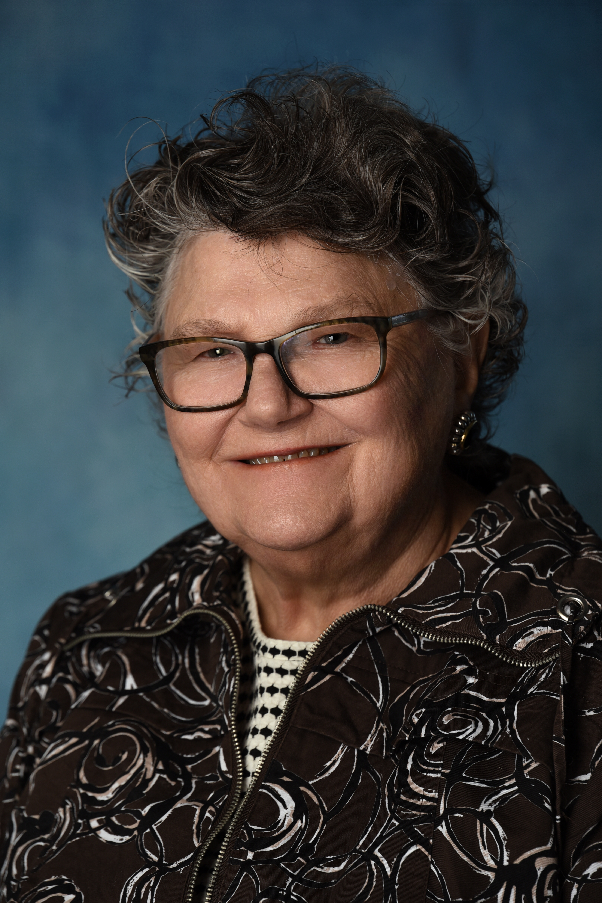
  Adrienne Walls
  Volunteer Spotlight
  This month, we’re proud to shine a spotlight on Adrienne Walls, a dedicated volunteer who has been part of the Freedom Foundation family since 2020.
  If you’ve visited the Veterans Market on a Wednesday, chances are you’ve met Adrienne. Adrienne is also actively involved with her local VFW, where she continues to support veterans and advocate for community events that bring people together. Thank you, Adrienne, for your dedication and service. We are grateful to have you as a part of the team.
  Thank you, Adrienne, for your dedication, commitment, and sacrifice.
Kernal’s Veteran Appreciation Night
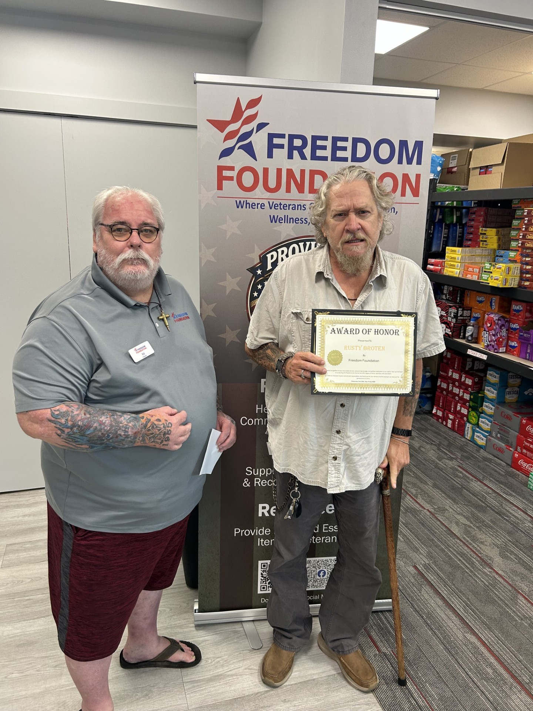Veteran of the Week  Local Community Resources  Need to file a claim?  Contact the Linn County Veteran Service Office (319) 892-5160.  Need to talk?  Cedar Rapids Vet Center (319) 378-0016.  Looking for work?  IA Workforce (319) 365-9474.  Asking for help with home repairs?  Matthew 25 can help. (319) 362-2214.  In Crisis? Help is closer than you think.  Dial 988 then press 1 or text 838255. 24/7. |  |  | Thank You Sponsors  September Sponsors  A special thank you to all our community sponsors. This month, we want to thank Atlantic Bottling Co., GreatAmerica, The Cedar Rapids Kernal’s, Kepros Physical Therapy, and TrueNorth. Thank you all for everything you do to support our veterans.  “Freedom is the open window through which pours the sunlight of the human spirit.” – Herbert Hoover  Holistic Health  September Wellness  Fall into Fitness: As the weather cools, now is a perfect time for engaging in outdoor activities with your families, such as walking, biking, hiking, etc.  Suicide Prevention & Mental Awareness: September is suicide prevention month. Remember to check on your friends and family. If you’re struggling, don’t hesitate to call in reinforcements, we never fight alone.  Health & Preventative Care: Don’t forget to stay up-to-date on your flu shots and vaccines. With cold and flu season approaching, remember to wash your hands before you touch your eyes, nose or mouth. |  |  | 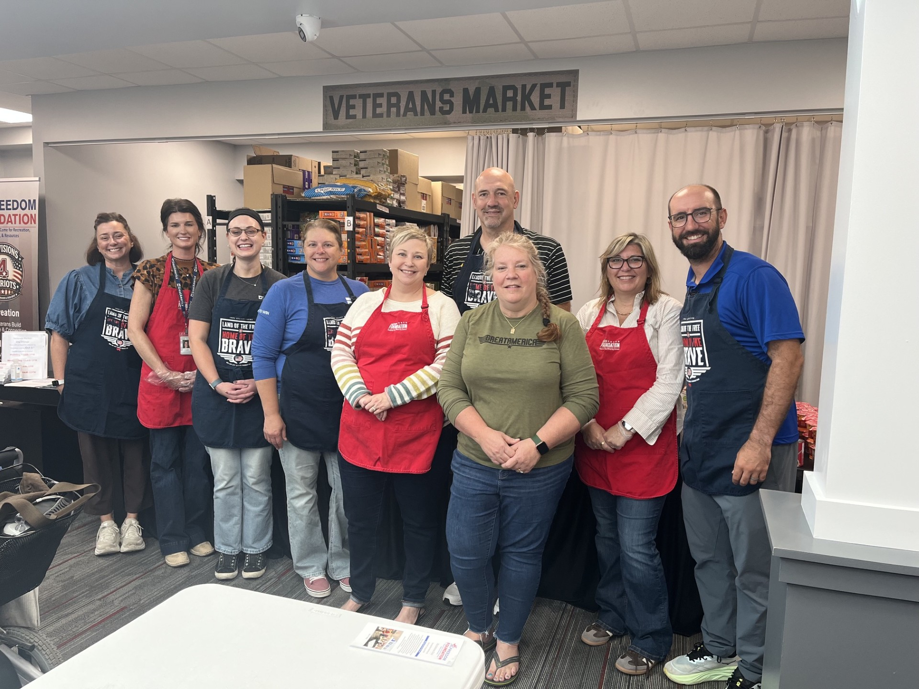  GreatAmerica Financial Services  Closing Notes  On behalf of the Board of Directors, we want to say thank you to all our staff, friends, donors, community partners, and volunteers for all you do.  Recreation Wellness Resources  The Freedom Foundation offers a place for veterans to come in, feel welcome, and enjoy the camaraderie of fellow service members from all branches.  We offer our veterans, spouses, widows, and active duty the availability to utilize our Veteran Market resources.  We serve a community meal every Thursday to veterans, widows, active duty and their spouses free of charge.  Our Veteran Emergency Assistance Fund is a resource for veterans to use once a year to help cover emergencies or other financial difficulties.  Please stop in and see us today.  https://usfreedomfoundation.org/

