  The Veterans Voice  Serving Those Who Served  Issue 7 | May 2026  Message from the Director  Dear Veterans, friends and family,  Thank you to everyone who helped support us through the winter into spring. Your dedication and commitment to our Foundation remain the backbone of our support system. This May, we are excited to face new challenges and opportunities to help us better support you and your families.  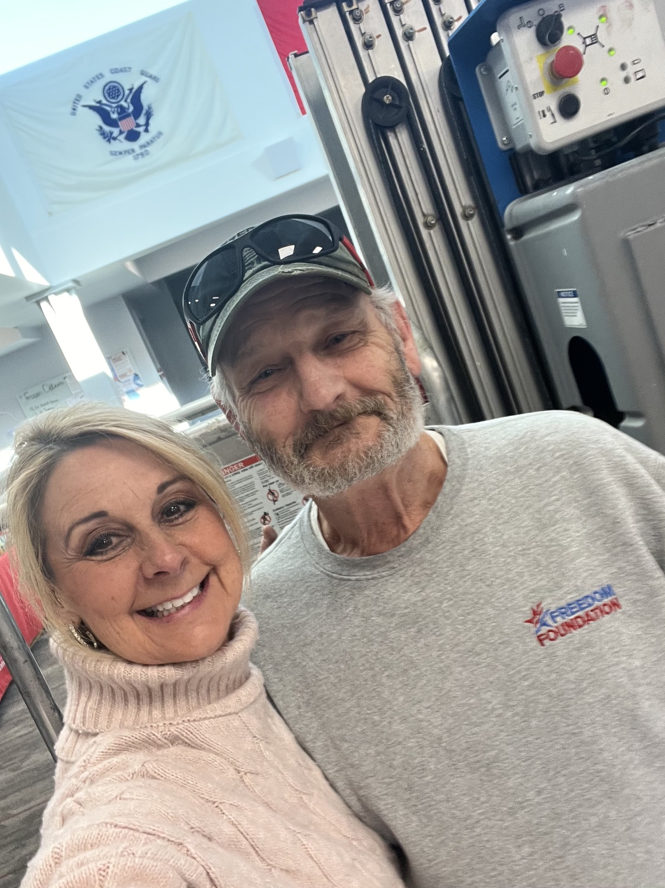  Mary & Jeff  Thank you all for your continued service and commitment. – Mary Seely Executive Director
  Announcements
  🎱 Enjoy Pool? We host a billiards tournament every 3rd Saturday of the month. Come out and win cash prizes. Top 3 win.
  🥪 Thursday Lunches – Lunches served between 11:45am-12:15pm weekly. Monthly menu can be located at www.facebook.com/FreedomFoundationCR/# or at the Freedom Foundation which is located at: 4001 Center Point Rd. NE Cedar Rapids, IA. 52401.
  Volunteer Spotlight
  This month, we want to highlight Sean Nix and Jen Toenjes from our Saturday Veteran Market team. Sean and Jen have been with the foundation for several years and recently helped one of our veterans through a medical emergency. Their quick responses and desire to help is what makes them such an amazing addition to our Freedom Foundation Family. Thank you both for all you do for us.
  Upcoming Events
  ✂️Haircuts are the first Friday of every month. Next visit will be Friday, June 5th at 11am and then Friday, July 3rd. Sign-up at the Freedom Foundation today!
  🎉Bingo time! The Freedom Foundation will be hosting our first Bingo with prizes coming up on Tuesday, May 19th, starting at 12:00pm – 2:00pm. Come play, visit with friends, and take home some fun prizes!
  Freedom Foundation
  4001 Center Point Rd. NE
  Cedar Rapids, IA. 52401
  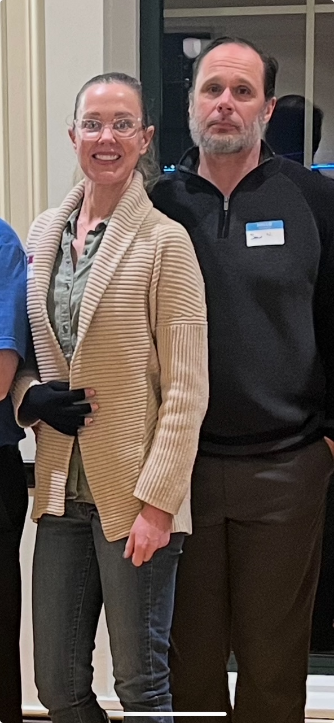
  Volunteers Jen T. & Sean N.
  Freedom Foundation
  Numbers at a glance 2025:
  Lunches Served – Over 4,500 meals served to veterans and their families.
  VEAF Assistance – Over $56,000 in assistance given out.
  Donations – Over 48,000 lbs. of food and supplies donated.
  Veteran Market – Over 46,000 lbs. of food and supplies given away.
    - Recreation, Wellness, & Resources

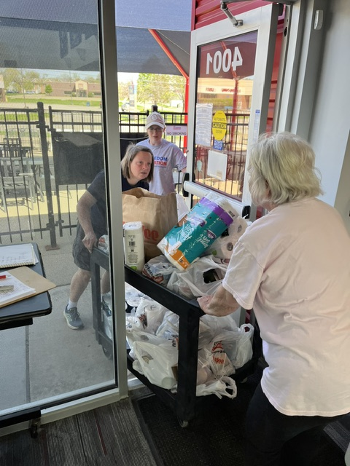  Local Community Resources  Need to file a claim?  Contact the Linn County Veteran Service Office (319) 892-5160.  Need to talk?  Cedar Rapids Vet Center (319) 378-0016.  Looking for work?  IA Workforce (319) 365-9474.  Vocational Rehabilitation Specialists Inc. (VRSI) (515) 918-1583.  Asking for help with home repairs?  Matthew 25 can help. (319) 362-2214.  In Crisis? Help is closer than you think.  Dial 988 then press 1 or text 838255. 24/7. |  |  | Thank You Sponsors  Thank you to all our community sponsors  With our Provisions 4 Patriots event underway, we want to thank all our sponsors for their dedication and support. A special Thank you to Hy-Vee and ServiceMaster by Rice, who helped plan, host, and transport all donations to the Freedom Foundation. And thank you to all our volunteers who stepped up to help out.  “America without her Soldiers would be like God without His angels.” – Claudia Pemberton  Holistic Heath  May Day Arrives  Engaging in outdoor activities as the weather warms up. Going for a walk or working in the garden is a great way to get started this spring.  The sun is starting to shine again so make sure to put on sunscreen and get outside to soak up the rays.  Hydration remains the topic as things heat up. Don’t forget to stay hydrated when getting back outside. |  |  | 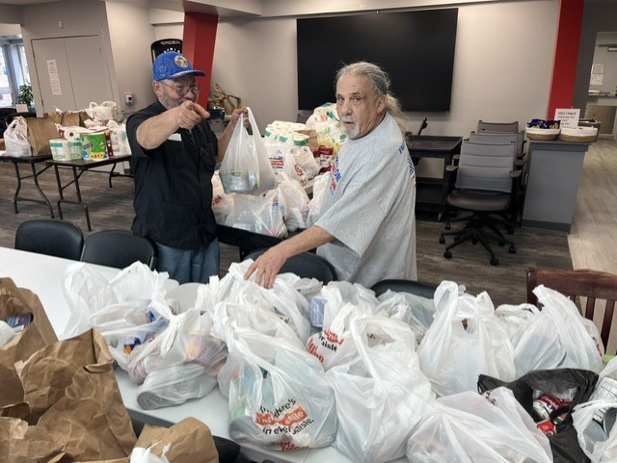  Closing Notes  On behalf of the Board of Directors, we want to say thank you to all our staff, friends, donors, community partners, and volunteers for all you do.  Our Products and Services  The Freedom Foundation offers a place for veterans to come in, feel welcome, and enjoy the camaraderie of fellow service members from all branches.  We offer our veterans, spouses, widows, and active duty the availability to utilize our Veteran Market resources.  We serve a community meal every Thursday to veterans, widows, active duty and their spouses free of charge.  Our Veteran Emergency Assistance Fund is a resource for veterans to use once a year to help cover emergencies or other financial difficulties.  Please stop in and see us today.

