  The Veterans Voice  Serving Those Who Served  Issue 6 | March 2026  Message from the Director  Dear Veterans, friends and family, spring is right around the corner! We’re all looking forward to the shift in weather, but let’s also put a shift in our perspectives. Take time to lend a helping hand to your neighbor or someone you know in need. You never know what someone is going through.  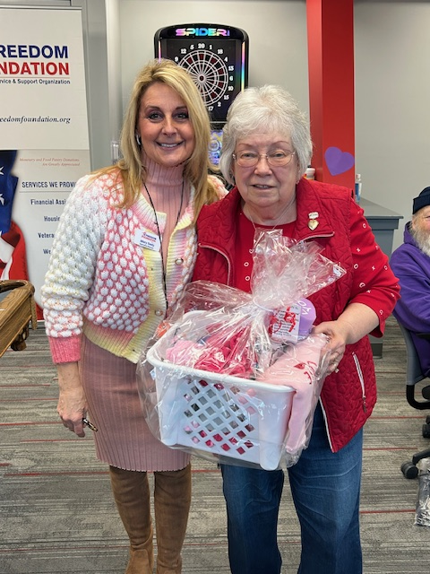  Thank you all for your continued service and commitment – together we will Restore That Which Was Earned. – Mary Seely Executive Director
  Announcements
  🎱 Enjoy Pool? We host a billiards tournament every 3rd Saturday of the month. Come out and win prizes!
  🥪 Thursday Lunches – Lunches served between 11:45-12:15 weekly. Monthly menu can be located at www.facebook.com/FreedomFoundationCR/# or at the Freedom Foundation which is located at: 4001 Center Point Rd. NE Cedar Rapids, IA. 52401.
  Volunteer Spotlight
  This month, we want to highlight Jim O’Connor. Jim has been helping out at the Freedom Foundation for over 10 years. Jim served in the U.S. Air Force and served a tour in Vietnam. Jim’s favorite part of coming to the Foundation is enjoying and participating in the camaraderie amongst his fellow veterans. Thank you, Jim!
  Upcoming Events
  ✂️Haircuts are the first Friday of every month. Next visit will be Friday, March 6th at 11am and then Friday, April 3rd. Sign-up today.
  🎉Bingo time! The Freedom Foundation will be hosting our first Bingo with prizes coming up on Tuesday, March 24th, starting at 12:30pm – 1:30pm. .25 cents a card, come play, visit with friends, and take home some fun prizes!
   |  | Freedom Foundation  4001 Center Point Rd. NE  Cedar Rapids, IA. 52401
  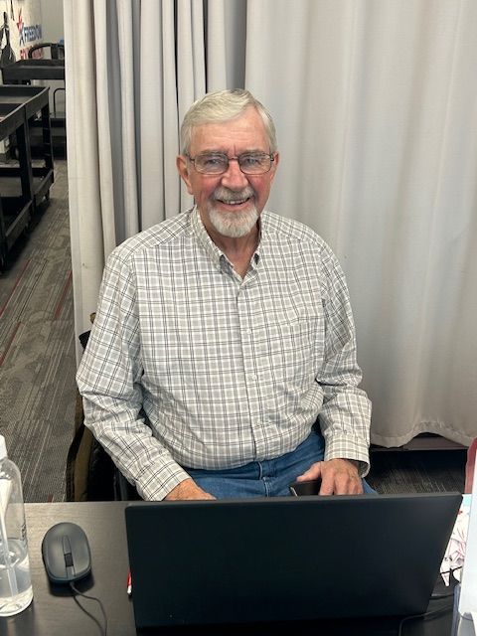
  Volunteer Jim O’Connor
  Freedom Foundation
  Numbers at a glance 2025:
  Lunches Served – Over 4,500 meals served to veterans and their families.
  VEAF Assistance – Over $60,000 in assistance given out.
  Donations – Over 48,000 lbs. of food and supplies donated.
  Veteran Market – Over 46,000 lbs. of food and supplies given away.
    - Restore That Which Was Earned

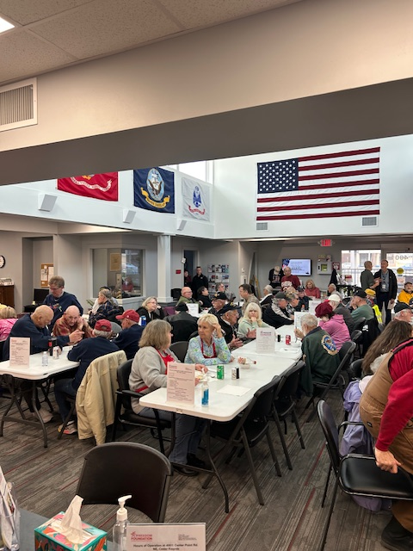  Local Community Resources  Need to file a claim?  Contact the Linn County VSO (319) 892-5160.  Need to talk?  Cedar Rapids Vet Center (319) 378-0016.  Looking for work?  IA Workforce (319) 365-9474.  Asking for help with home repairs?  Matthew 25 can help. (319) 362-2214. |  |  | Thank You Sponsors  Thank you to all our community sponsors who provided food and service for our weekly meals.  Thank you to First Lutheran Church, Jan Bloomhall & friends, TrueNorth, Parker Group, and Collins Community Credit Union for being our community sponsors. Without you, The Freedom Foundation wouldn’t be what it is today. Thank you for feeding, serving, and taking time out of your day to spend with our veterans.  “The secret of happiness is freedom, and the secret of freedom is courage.” —Thucydides  Holistic Heath  Spring Routine:  Get Moving! – Stay active this spring by gardening, taking walks, even stretching or light Yoga can boost energy and improve flexibility.  Eating Healthy – Eating light warming foods and incorporating local greens can help you stay healthy and keep your hormones balanced.  Stress Management – Setting a sleep schedule (7-9 hours) and practicing mindfulness can help reduce stress this season. |  |  | 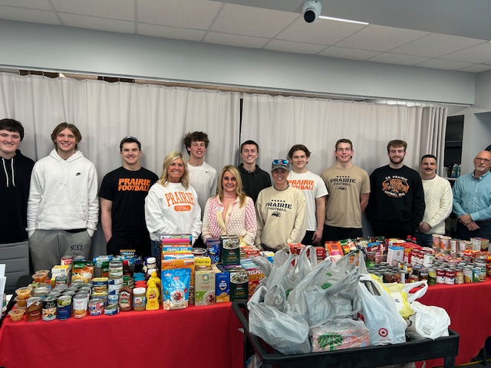  Prairie Highschool Boys Football Team with their donation  Closing Notes  On behalf of the Board of Directors, we want to say thank you to all our staff, friends, donors, community partners, and volunteers for all you do.  Our Products and Services  The Freedom Foundation offers a place for veterans to come in, feel welcome, and enjoy the camaraderie of fellow service members from all branches.  We offer our veterans, spouses, widows, and active duty the availability to utilize our Veteran Market resources.  We serve a community meal every Thursday to veterans, widows, active duty and their spouses free of charge.  Our Veteran Emergency Assistance Fund is a resource for veterans to use once a year to help cover emergencies or other financial difficulties.  Please stop in and see us today.

