Current Diet Analysis Form

Horse’s Name: Emma Age: 29 Estimated Weight: 1100 lbs. on weight tape

Current Diet: 1 lb. timothy hay pellets soaked 2x daily = 2lbs, 2 lbs. Hallway Fibrenergy feed 2x daily= 4lbs.
Grain Amount Fed Daily in Pounds as per the Feed Label: 6-18 lbs. daily of Fibrenergy per day depending on horse’s size and needs. Safe Starch 6-20 lbs. per day based on needs (see feed tag).
Grain Amount Fed Per Meal: 1 lbs. hay pellets, 2 lbs. Fibrenergy totaling 3 lbs. per meal, equaling 6 lbs. daily. Supplements fed in AM.
Supplements: 1 scoop SmartCBD plus Calm, swapping to plus Joint. 1 scoop Insulinwise, ½ scoop beef gelatin, salt or electrolytes. Raspberry leaves (Mare Magic) used when I remember to buy it. Sandclear was started 1 week per month in September going forward.

Hay Type: Triple Crown Safe Starch forage, ¼ bag per day spread through the field for her and Stella to share either once or twice per day. Also roughly 2 flakes of orchard/timothy spread out twice daily. Feeding as much as they will eat. Hay pellets also count for 2 extra lbs. of hay before soaking daily.

Estimated Current Nutritional Needs
Nutrient | Current Amount Daily Total Based On Grain | Estimated Requirement
Magnesium (Mg) | 5.44 g | 7.47 g
Iron (Fe) | Unlisted | 398.4 mg
Cobalt (Co) | Unlisted | 0.5 mg
Copper (Cu) | 89.08 mg | 99.6 mg
Iodine (I) | Unlisted | 3.5 mg
Manganese (Mn) | Unlisted | 398.4 mg
Zinc (Zn) | 272.72 mg | 398.4 mg
Selenium (Se) | 1.08 mg | 1 mg
Vitamin A | 36,000 IU | 14,940 IU
Vitamin D | 4,600 IU | 3,287 IU
Vitamin E | 480 IU | 498 IU
Vitamin C | 560 mg | No Requirement
Crude Protein | 217.92 g
Lysine | 12.68 g | 27 g
Threonine | 9.96 g | 16.6 g
Methionine | 3.63 g | 7.2 g
Mcals | Min. mcals (5720 kcals) | 16.58 mcals (16,580 kcals)
Ca | 15.4 g | 20 g
P | 10.88 g | 14 g

Nutrient | Safe Starch Nutrients per lb. | Safe Starch Nutrients per 5 lbs.
Magnesium (Mg) | 2.27 g | 11.35 g
Iron (Fe) | 81.81 mg | 409.05 mg
Copper (Cu) | 15.9 mg | 79.5 mg
Manganese (Mn) | 54.54 mg | 272.2 mg
Zinc (Zn) | 54.54 mg | 272.2 mg
Selenium (Se) | 0.13 mg | 0.65 mg
Vitamin A | 4,000 IU | 20,000 IU
Vitamin D | 750 IU | 3,750 IU
Vitamin E | 110 IU | 550 IU
Crude Protein | 11% or 49.94 g | 249.7 g
Lysine | 1.58 g | 7.9 g
Threonine | 1.36 g | 6.8 g
Methionine | 0.45 g | 2.25 g
Leucine | 1.72 g | 8.6 g
Mcals | mcals (1100 kcals/lb.) | mcals (5500 kcals/lb.)
Ca | Min. 2.72 - Max. 4.54 g | Min. 13.6 - Max. 22.7 g
P | 1.81 g | 9.05 g
10% NSC, ADF 30%, NDF 46%

Estimated Current Nutritional Needs
Nutrient | Current Amount Daily Total Based On Grain(4 lbs.) and Safe Starch hay (5 lbs.) | Estimated Requirement
Magnesium (Mg) | 61.74 g | 7.47 g
Iron (Fe) | 409.05 mg | 398.4 mg
Cobalt (Co) | Unlisted | 0.5 mg
Copper (Cu) | 168.58 mg | 99.6 mg
Iodine (I) | Unlisted | 3.5 mg
Manganese (Mn) | 272.2 mg | 398.4 mg
Zinc (Zn) | 544.4 mg | 398.4 mg
Selenium (Se) | 1.73 mg | 1 mg
Vitamin A | 56,000 IU | 14,940 IU
Vitamin D | 8,350 IU | 3,287 IU
Vitamin E | 1,030 IU | 498 IU
Vitamin C | 560 mg | No Requirement
Crude Protein | 217.92 g
Lysine | 20.58 g | 27 g
Threonine | 16.76 g | 16.5 g
Methionine | 5.88 g | 7.2
Tryptophan | 1.5 g | 5.4
Mcals | Min. 11.22 mcals (11,220 kcals) | 16.58 mcals (16,580 kcals)
Ca | Min. 29g – Max. 38.1 g | 20 g
P | 19.93 g | 14 g

Nutrient | Wiser Concepts InsulinWise Nutrients Per Serving
Leucine | 2,100 mg (2.7 g)
Lysine | 1,740 mg (1.74 g)
Glutamic Acid | 1,010 mg
Resveratrol | 750 mg
Quercetin | 500 mg
Proline  (for protein synthesis & structure, metabolism, and nutrition plus immune system and wound healing) | 470 mg
Alanine  (can produce carnosine, which reduces lactic acid- good for reducing fatigue and increasing endurance) | 395 mg
Glycine  (plays a role in the central nervous system, and supports connective tissues as well as nervous tissues) | 250 mg

Nutrient | SmartCBD Pellets JOINT Nutrients Per Serving
CBD from Hemp Extract | 100 mg
MSM | 7,500 mg
Glucosamine HCL | 5,000 mg
Turmeric Powder | 4,000 mg
Resveratrol | 700 mg
Chondroitin Sulfate | 500 mg
H.A. | 50 mg

Nutrient | SmartCBD Pellets CALM Nutrients Per Serving
CBD from Hemp Extract | 100 mg
Magnesium | 5,000 mg (5 g)
Ashwagandha Root Extract | 1,000 mg
Passion Flower Extract | 500 mg
Vitamin B1 (Thiamine) | 500 mg
Siberian Ginseng | 250 mg

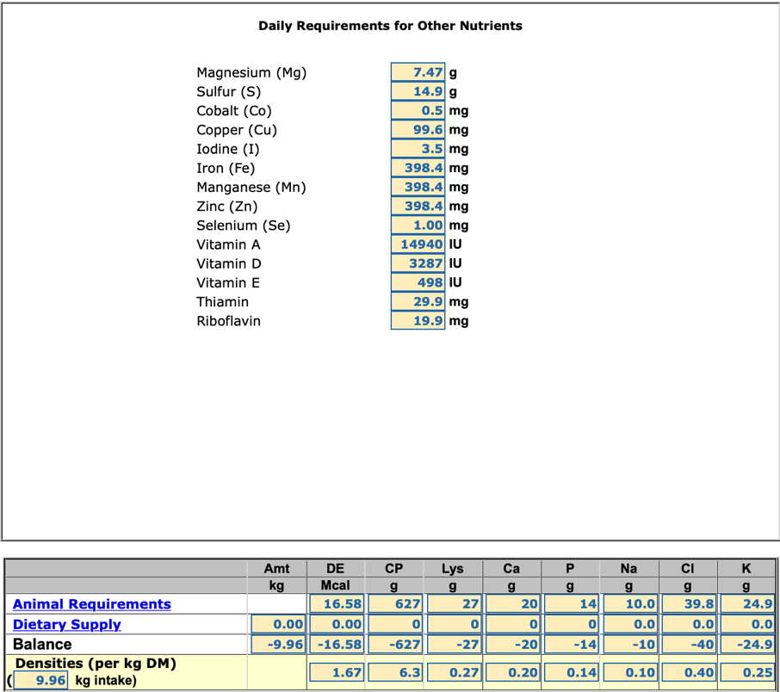

Notes About Nutritional Findings:
-Overall Emma’s diet is great. She is meeting most of her nutritional requirements, and has a good body condition score of 5. She is a bit low in a few nutrients when looking at grain alone, but supplementing with the Safe Starch forage has filled nearly all of those gaps, and the few remaining are very small gaps.
-Emma is slightly low in her calories, although this does not take into account the flake hay she receives, the calories from that are likely lower. She has great teeth for 29, but long-stem hay alone does not seem to sustain her anymore.
-The soaked hay pellets provide her some extra hydration, and give her extra forage (and minimal calories) while being very easy to chew.
-The Fibrenergy seems to be a good feed option for her- she likes it and palatability has been an issue for her in the past. It is also high in fat, low starch/NSC, and is able to help her meet most of her nutritional requirements even fed 2 lbs. under the suggested feeding rate when paired with Safe Starch. She could also eat more of the Fibrenergy if needed. It contains beet pulp as well as soy hulls plus timothy & alfalfa hay, which allows me to keep beet pulp in her diet while not adding another feed bin, as well as alfalfa at a low level.
-Emma is a great weight now, and has picked up slight weight before winter which is fantastic. She weight tapes at roughly 1149, which I have rounded down to 1100 based on her haircoat being ready for winter. I hope to get her on a scale soon. I recommend keeping her at a 5-5.5 for the winter, and adding more feed or feedings as needed.
-I did not do it during her fall shots, however I may either have blood drawn over winter or add on to her spring Coggins blood draw to check her vitamin E, purely out of curiosity as she is on a dry lot style track, after living on a dry lot for 2 years.

New Feeding Plan Recommendations
New Grain Amount Fed Per Meal: For now, remain at the current feeding amounts of 1 lbs. soaked timothy pellets per meal (2 lbs. daily), 2 lbs. Fibrenergy per meal (4 lbs. daily), and continue her current supplements.
Note: Her CBD supplement is about to change to a joint/cbd supplement.

Over the winter, it may be a good idea to up her grain amounts to 6 lbs. of Fibrenergy per day, as well as upping the amount of Safe Starch they get in the field, although I will likely do another diet analysis to check her estimated nutrient levels before doing so to ensure she doesn’t go too far over in any areas. Ultimately I will focus on upping her calories in the best way possible for her.
They typically have access to decent grazing over the winter as well, which will aid in her maintaining her weight.

She may also begin receiving 3 meals per day rather than 2 if necessary over winter. In this case I will either add an identical lunch meal, or we may feed grain only during breakfast and dinner, and a hay pellet meal at lunch.

Continue soaking her feed throughout winter to assist in hydration as well as help her teeth with the hay pellets. Emma is due to have her teeth checked in May 2025 at the latest.

