Owner’s Name:
Phone:
Email:
Farm:
Horse’s name:
Horse’s Age: Height: hh
Estimated Weight: lbs.
Breed:
Sex: Mare Gelding Stallion
Would your barn manager like to be involved in this process? Y or N
Horse’s Current Diet
Grain Type & Amount:

Hay Type & Amount:

Rough Water Intake Daily (ex. 5-10g):

Salt Intake Daily:

Medications:

Supplements:

Past Supplements:

Known Allergies:

Medical History
Colic History Y or N Surgical Y or N
Date: Date:

Laminitis/Founder History Y or N
Date:

Diarrhea Y or N Thyroid Imbalance Y or N
Rapid Weight Loss Y or N
Rapid Weight Gain Y or N
PPID Y or N PSSM Y or N
Equine Metabolic Syndrome Y or N
Confirmed Ulcers Y or N
Other Medical Conditions:

Date of last Dental exam:
Dental history, choke history, missing teeth, dropping feed:

Hoof Condition:
Barefoot, shod, hoof boots:
If shod or in boots, what type:

How often do they see the Farrier:

What is the condition of the hooves? Shelly, chipped, do they lose shoes easily, thrushy, etc.

Body Condition:
Coat Condition (Shiny, shaggy, dull):
Current Body Condition Score: #
Owner’s Ideal Body Condition Score: #
Is the horse a “hard” or “easy” keeper?

Temperament:
Horse’s temperament daily overall:
Horse’s temperament in the field:
Horse’s temperament in the stall:
Does your horse Crib, weave, paw, eat dirt, wood chew, etc.? Please explain:

Horse’s temperament during tacking/ grooming:
Girthy? Y or N Biting? Y or N Kicking Y or N Tail Swishing Y or N Dancing/Pawing Y or N
Head Tossing Y or N Pooping Y or N
Horse’s temperament under saddle:
Ideal Temperament Changes:

Living Environment:
Hours in a stall:
Stall Size:
Hay Availability in Stall, amount and how it’s fed (hay net, loose, hay feeder):

Hours in field:
Field size:
Pasture Quality and Height (inches):
Field Buddies:
Is hay given in the fields? Y or N
Is hay given in winter only, or during warm months as well?
Is horse blanketed in winter? Y or N
Circle All Used: Sheet Medium Heavy Other
Number of grain feedings daily:
Where is grain fed? Inside/outside?
Is grain fed at chest height, ground feeder, etc.?
Is the barn environment busy, calm, loud, etc.?
Who is in charge of feeding grain meals:
Does horse eat hay before, during, or after grain meals?
How long does the horse go without hay on average daily/overnight:

Deworming History:
Date of last fecal egg count:
Results:
Date of last deworming:
Type of deworming medication:
Typical deworming schedule:

Vet History:
Date of last vet exam:
Is the horse up to date on standard vaccines? Y or N
Vaccinated for Botulism? Y or N
Has your horse had blood testing for nutritional deficiencies? Y or N
Are you willing to do blood testing for nutritional deficiencies? Y or N
Are you willing to involve your vet:
If new health issues arise Y or N
For currently untreated issues Y or N or N/A
For newly suspected health issues Y or N
To further consult on health/body condition if needed Y or N
Vet Diet Recommendations:

Riding Information If Applicable:
Date of last saddle fitting:
Type of bit:
Discipline:
Days a week riding currently:
Number of hours ridden weekly:
Ideal amount of days ridden weekly:
Ideal number of hours ridden weekly:
How is the horse’s current energy level during work:
Does the horse need more energy? Y or N
Does the horse have enough energy? Y or N
Is the horse “hot”/overly anxious or overstimulated? Y or N
Do you compete with your horse? Y or N
Level of Competition:
How often do you travel for competition:
How is your horse for trailering?
Does the horse have access to hay on the trailer? Y or N
Do you use calming supplements? Y or N
How is your horse’s temperament at shows/off farm?
How long does it take the horse to settle after coming home?
Does your horse get special feed/supplements on competition days?
Are you looking for additional diet support for competition days? Y or N
Nutrition Management “Budget”
Ideal grain budget(highlight): $ $$ $$$
Brands you love:
Brands you don’t love:
Do you prefer (circle or highlight)
- Performance feed
- Complete feed
- Ration balancer
- Forage based feed
Are you willing to add supplements? Y or N
Would you prefer (circle or highlight)
- Oil/liquid
- Pellets
- Powder
Ideal supplement budget: $ $$ $$$
What areas are you looking to target with supplements? (topline, hooves, joint care, weight gain, etc.):

Is loose salt/mineral salt an option?
Y or N
Does your horse get soaked grain? Y or N
Is the farm able to soak grain? Y or N
Will the horse eat soaked grain? Y or N
How many feedings a day are possible for your current barn?
Would you like to add more forage to your horse’s diet? Y or N

Please take this space to describe your goals for this nutritional consult program for you and your horse:

All Consults: Please submit photos of your horst front, back, and both left and right sides. Please have your horse standing as square as possible on level ground.
Feel free to send videos as well.
Please provide photos of the hay your horse eats, the field they are in, and the feed scoop(s) used. More info attached.

Body Condition Scale Scoring Sheet

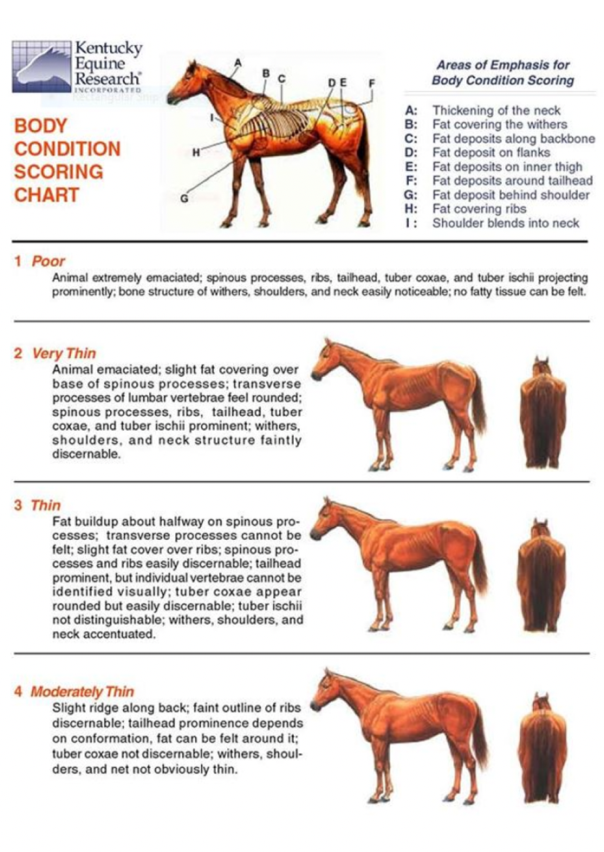
This is for you, the owner, to use to score your own horse as accurately as possible for this form

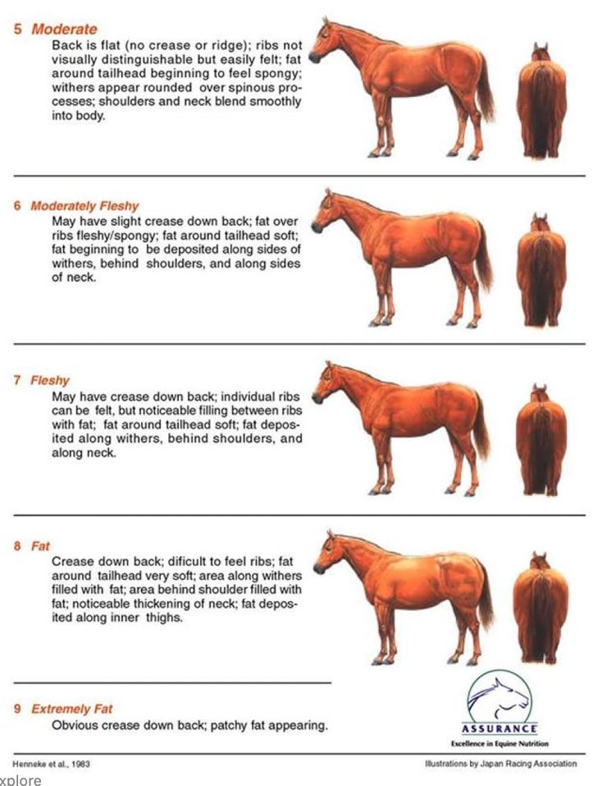

Photo List
Please submit photos of your horst front, back, and both left and right sides. Please also provide photos of all 4 feet.
Please have your horse standing as square as possible on level ground.
Feel free to send videos as well. Videos can be of the horse at rest in a stall/field, being ridden, showing stereotypic behaviors, etc. Anything you think may be helpful.
Photos/videos can be sent to hsfequinenutrition@gmail.com or sent to Facebook Messenger @HSFEquineNutrition.

Please also provide photos of:
- Grain, supplements, and medications
- The hay your horse eats, and any nets or holders used
- The field(s) they are in
- The feed scoop(s) used
- Your horse’s muzzle(s) if they wear them
Examples on next page

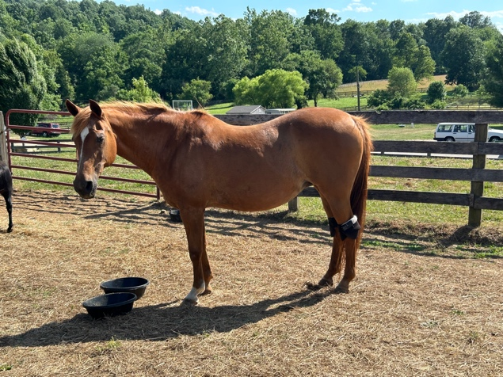
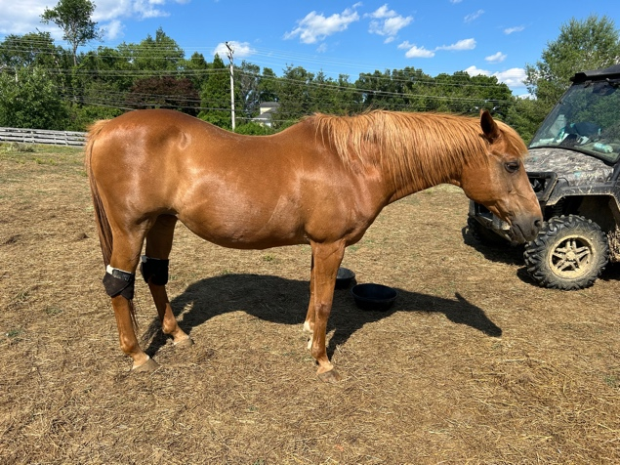
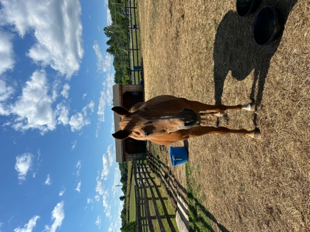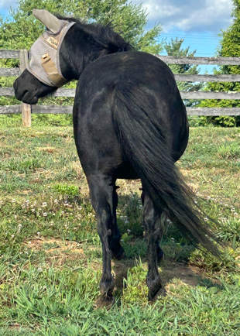
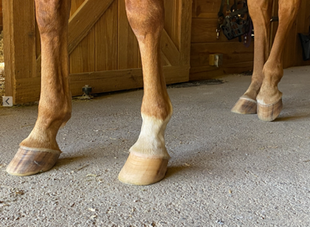

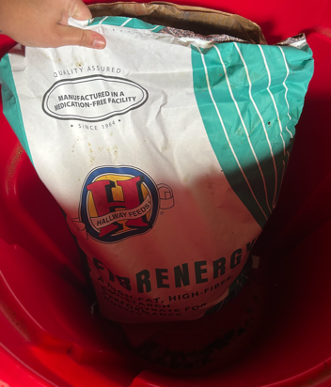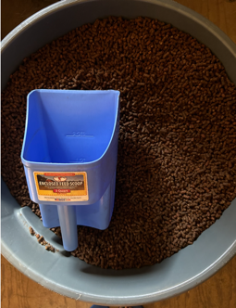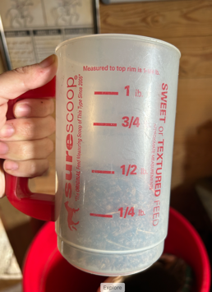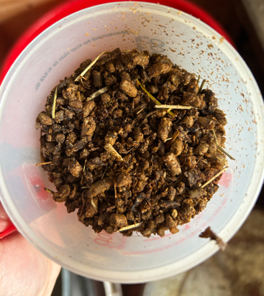
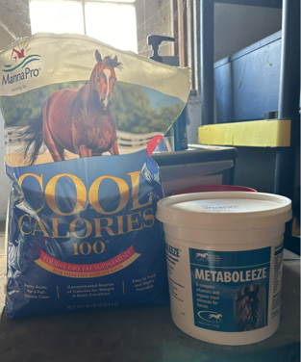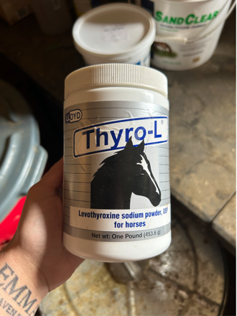
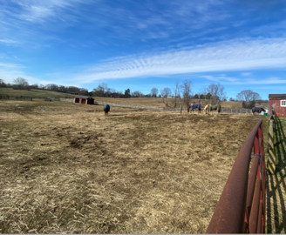
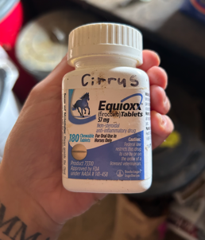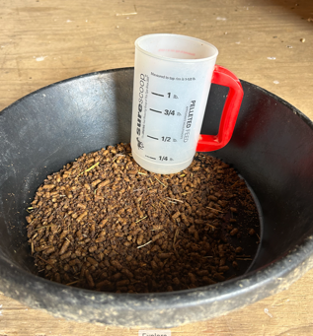
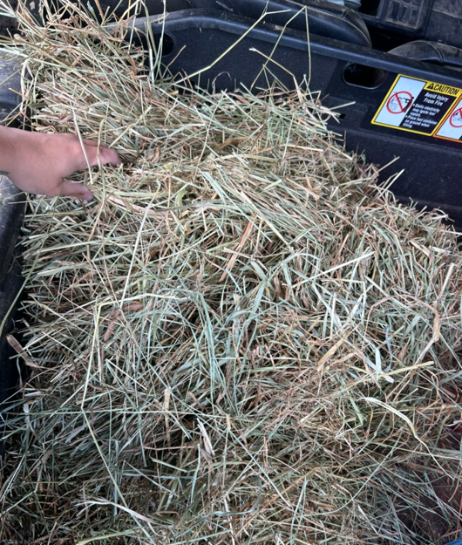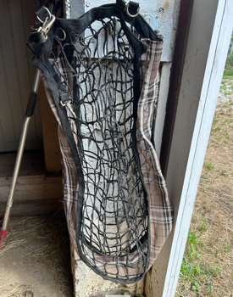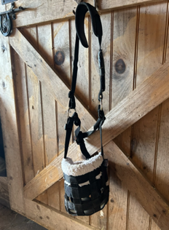
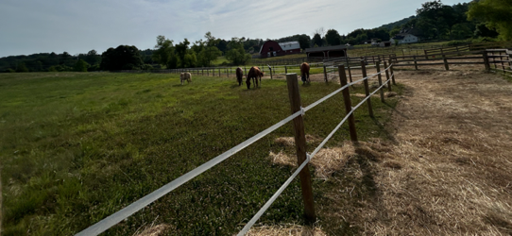

Rules & Information for In Person Consults:
- Please be on time for our appointment, and simply communicate if you are running late.
- Horses must be up to date on all vaccines.
- Horses must not have any contagious diseases upon the time of my visit, or come into contact with contagious diseases within 72 hours.
- The barn must be free of contagious diseases upon my visit.
- Horses must be safe to be around within reason for any animal. Any aggressive behaviors must be disclosed prior to first appointment.
- Owner must not have any illness or have been in contact with ill person(s) within 24 hours of my visit. Please wear a mask and let me know so I can wear a mask if you have been in contact within anyone with an illness within 72 hours of our consult.
- Barn Manager/Owner must be okay with me being on premises and making nutrition recommendations. Management/Stable Owners are welcome and encouraged to join us during our consults.

This nutrition consult is intended to give you as much information about your horse’s diet as possible, and to provide recommendations for places where the diet can be improved and/or altered.
Rules & Info for Virtual Consults:
- Please be on time for our appointment, and simply communicate if you are running late.
- All required photos must be submitted by 5 pm the day prior to your consult. Any extra photos/videos may be sent any time prior to or during the consult as needed.
- Please ensure you have a good signal at your farm prior to booking a virtual consult. It is possible to have a consult without live video of the horse/facility however, it is not preferable.

