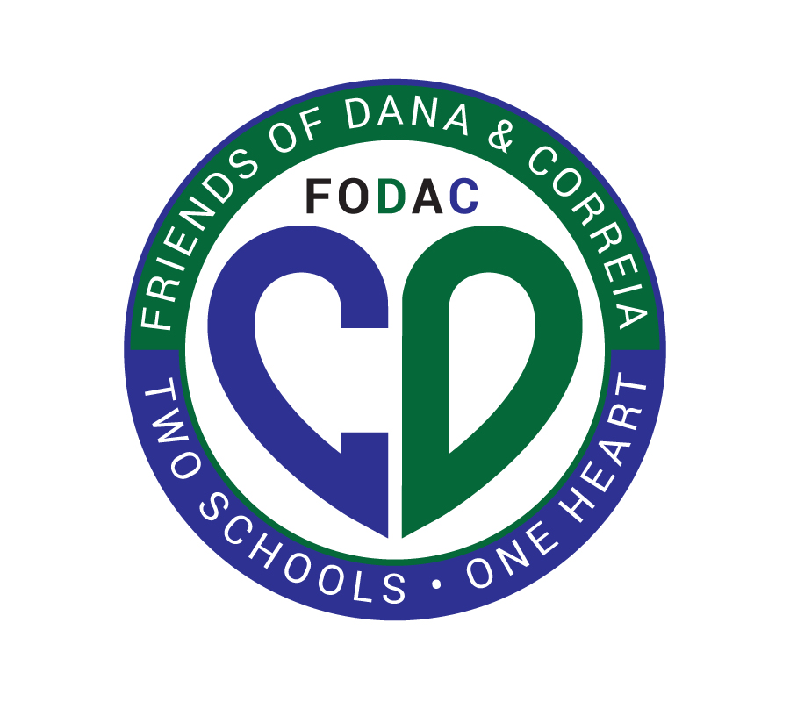

My name is Stacey Hoffmayer, and I’m the president of Friends of Dana and Correia Middle Schools, a nonprofit organization dedicated to supporting our public middle schools; Dana and Correia, in Point Loma. **We represent over 1600 middle school students and their families.**

We are seeking local community members and business owners to partner with us as our sponsors for our public middle schools upcoming fundraiser. This is a wonderful opportunity to support our students while gaining visibility within the community. Your sponsorship or in-kind donation, will help fund essential programs, resources, and activities that enrich the educational experiences of our students, reaching over 1600 middle schoolers and their families in Point Loma.

We are excited to announce our inaugural **Loma Palooza** – a one-of-a-kind **music festival for kids, by kids**! This event will be at one of the **hottest music venues** in Point Loma, **The Harp. April 27th from 12-6pm**.

This event will provide a platform for young local talent and performers. All of the proceeds will go directly toward funding student enrichment activities, teacher grants, etc that the school district doesn’t cover at Dana and Correia Middle Schools.

We believe this is a fantastic opportunity to work together and showcase the spirit of local support and collaboration. Your involvement would be greatly appreciated, and we would love to discuss how we can partner to make Loma Palooza a memorable and impactful event for all.

Thank you for considering this exciting opportunity! We look forward to hearing from you.

Warm regards,

Stacey Hoffmayer

415.812.1460 / president@fodacms.org

President, Friends of Dana and Correia

[www.fodacms.org](http://www.fodacms.org)

Federal Tax ID: 33-0781746