Please submit the proposal in the below form on or before April 1, 2023, to allow for adequate review prior to the vote.
- If complete and pre-approved, open discussion occurs at FoDaC meeting.
- The Executive Committee votes on the proposal, typically at the following month’s meeting.
- Attach price quotes, pictures, comparative research, etc. of requested proposal. Please choose the most cost-effective option.
- We recommend you attend the FoDaC meeting to present your proposal and answer questions.
- All funds must be spent during the current school year.

Complete and submit to Principals sirwin@sandi.net and jmcdade@sandi.net and FODAC President fodac.president@gmail.com.

PROPOSAL TITLE: | Dana Robotics Team
Date Proposed: | 9/13/2022
Your Name/School/Department: | Ashley Lewis/Dana Middle School/Robotics Club
Email: | danarobotics@gmail.com
Type of Proposal/Project: (grant, etc.) | Grant
Proposal Description: | Dana Robotics teams participate in the FIRST LEGO League Challenge each year, an international competition where students use STEM principles and creative problem solving to build and program robots, learn research and presentation skills, and work as a team. We are requesting support to pay the registration fees required to participate in FIRST LEGO League competitions consistent with what FODAC has granted our club in previous years. We are also requesting additional funds to replace our aging EV3 Mindstorms robot kits (a model that LEGO has retired and no longer sells parts for) with new SPIKE Prime robot kits, which will last for several more years of competition.
Please provide an explanation of the proposal and a justification for the funding requested: | - Our club charges dues of $100 per student and we offer scholarships for those who cannot afford to pay. In order to cover the costs associated with participating in the FIRST LEGO League Challenge without increasing dues or dipping into our scholarship fund, we need an additional $250 per team ($500 total). This is the same amount that FODAC granted us last year.  - Our club has six older robot kits that will soon need to be replaced. We are requesting $1,515 to cover the cost of three kits and plan to raise the remaining funds from external sources to cover the other three.  - A budget spreadsheet is attached below.
Please provide details re: how to implement the proposal and elaborate on why the costs as proposed represent the best implementation. | - We will submit receipts for the team registrations and robot kits to reimbursed by FODAC  - We are also requesting that FODAC continue to hold the club’s reserve funds in its bank account, which we will use to cover scholarships for students in need.  - Additionally, we plan to do some external fundraising this year to purchase new robot kits as mentioned above. We ask that FODAC continue to serve as the Dana Robotics Club’s fiscal sponsor for any grants received since we do not have a formal organization with 501c3 status. The parent association has been the continuous thread that has helped hold this club together from year to year and we are very grateful to have your support.
Cost $: | $2,015
Who will it benefit, how and why? | Students in the LEGO Robotics program learn how to solve engineering problems, learn about motors and sensors, learn to code using the EV3 Scratch programming language, learn about teamwork and inclusion, and research solutions for a real-world STEM problem. This year’s Super Powered theme is all about energy, how it’s generated, distributed, and stored, and how we can improve our energy systems to be more sustainable and benefit our communities. By participating in this program, Dana Middle School is reinforcing its commitment to high-quality STEM education and offering a healthy after-school activity with positive role models to get kids engaged in learning.
Percentage of students affected by this proposal: | - The $500 for registration fees will support two (2) teams – roughly 14-18 students this year  - The $1,515 will purchase three (3) robot kits with an expected lifespan of eight (8) years, benefitting roughly 50-80 students.

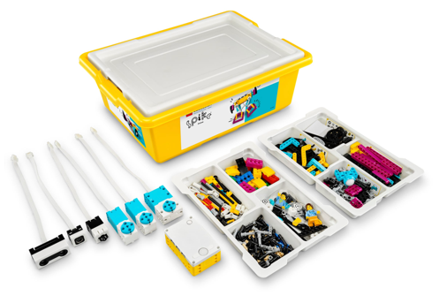LEGO Education SPIKE Prime robot kit ($385)
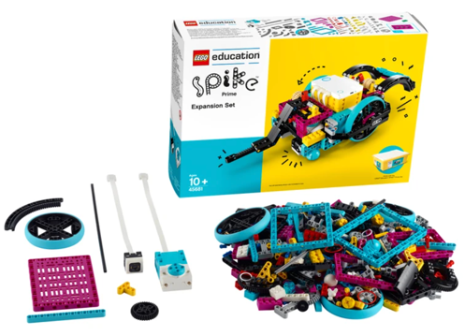LEGO Education SPIKE Prime Expansion Set ($120)

Dana Robotics Budget, 2022-2023 |  | Number of kids | 14
2 Team Scenario |  | Fee per kid | $100
Projected Expenditures 2 Teams | Each | Qty. | Total
Challenge Registration | $250 | 2 | $500
Challenge Set | $95 | 2 | $190
Qualifying Tournament | $150 | 2 | $300
Championship Tournament | $100 | 2 | $200
Innovation Project materials | $30 | 2 | $60
Team apparel/t-shirts | $300 | 2 | $600
SPIKE Prime Robot | $385 | 6 | $2,310
SPIKE Prime Expansion Set | $120 | 6 | $720
Staff Appreciation | $50 | 1 | $50
 |  |  | $4,930
Projected Income
Team Fees |  |  | $1,400
FODAC Grant |  |  | $2,015
External fundraising |  |  | $1,515
Residual Budget from 2021-2022 |  |  | $396.67
 |  | Total: | $5,327
 |  | Remaining funds (available for scholarships): | $397

