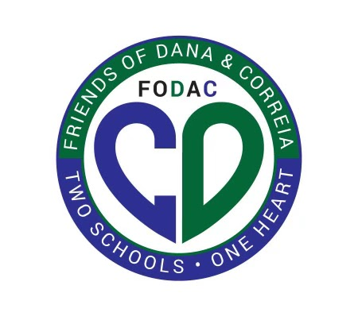

**Friends of Dana & Correia Middle Schools (FODAC)**

**GRANT REQUEST**

Each year, FoDaC allocates a certain amount of money in the budget for student and staff enrichment opportunities at Dana and Correia. This year (2024-2025), the board has allocated $10,000 for these grants.

1. Please submit grant requests on the below form as early in the school year as possible to best receive funding in a timely manner**.**
2. Attach quotes, pictures, etc. of items being requested. Please choose the most cost-effective option.
3. Once submitted, it will be reviewed by the FoDaC Board in a timely manner.
4. The Board will then vote on the proposal at the following Board meeting, with the approval or denial communicated by the next General meeting (1 week later)
5. All funds must be used during the current school year to retain our non-profit status.
6. If this is a field trip funding request, please first get clearance from your school’s principal.

***Please email completed request to*** [***grants@fodacms.org***](mailto:grants@fodacms.org)

| Date Requested: |  |
| --- | --- |
| Your School: |  |
| Your Name/Department: |  |
| Your Email: |  |
| Please provide a thorough description of your request, including who will benefit and how. |  |
| Cost $: |  |
| Approximate percentage of students benefiting from this grant: |  |

| ***THANK FOR YOU SUBMITTING YOUR REQUEST.***  ***Please email completed request to*** [***grants@fodacms.org***](mailto:grants@fodacms.org) |
| --- |