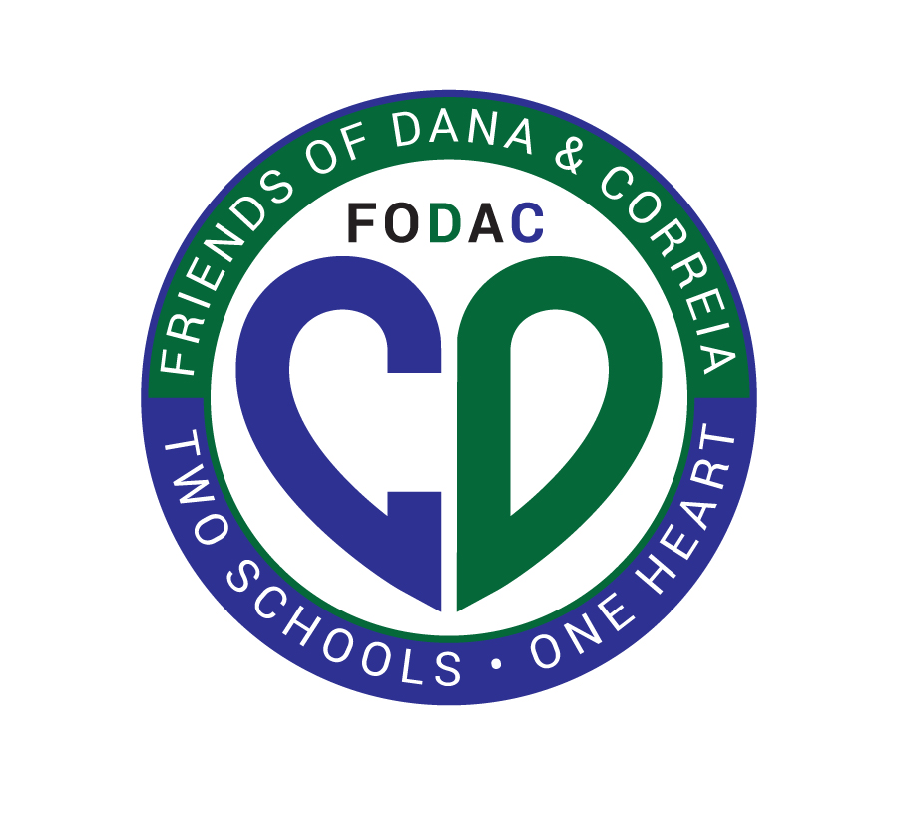

Friends of Dana & Correia Middle Schools - Donation Form
Thank you for supporting Friends of Dana & Correia Middle Schools (FoDaC)! Your contribution directly benefits the students and educational programs at Dana & Correia Middle Schools.That is over 1600 students and their families that FoDaC represents. Thank you.

Donor Information
Full Name:
Address:
City:
State:
Zip Code:
Email Address:
Phone Number:
Donation Amount
Please select your donation amount:
- In-Kind Donation (Please describe below)
- $100 - “Groupies”- An entry level sponsorship with selective recognition
- $300 - “Gold Label” -Name and Logo on all digital event communications, email, e-blast and social.
- $500 - “Headliner”- Dominate branding throughout event, Logo link with click through to your website for the remaining school year
- Amount: $ ____________.

Acknowledgement Preferences
How would you like to be recognized for your donation?
- Public Acknowledgement
- Anonymous
- Check - Please make checks payable to:
Friends of Dana & Correia Middle Schools
Mail to: 4302 Valeta Street, San Diego, CA 92106

