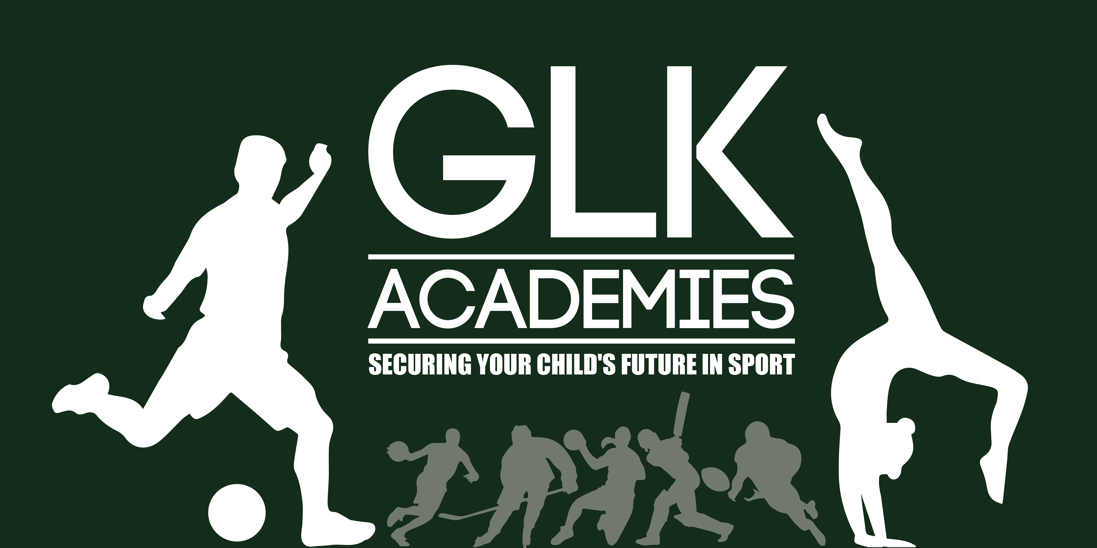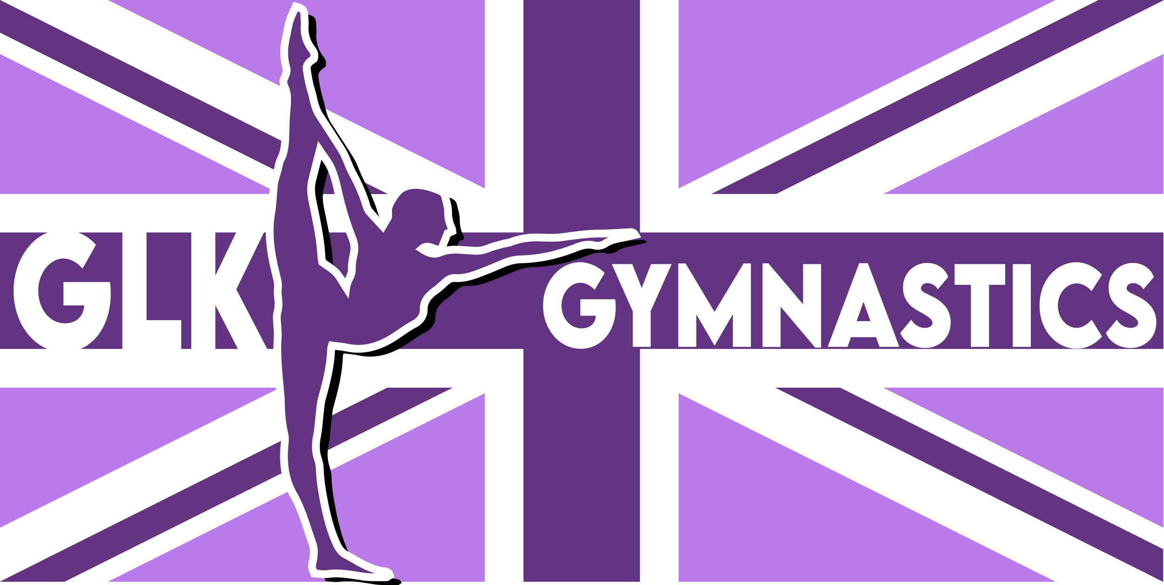

Behaviour Policy

For
GLK ACADEMIES

GLK Academies & GLK Gymnastics Behaviour Policy 2025-2026
Securing Your Child’s Future in Sport

Introduction
GLK Academies and GLK Gymnastics are committed to creating a safe, positive, and inclusive environment for all children and young people. Effective behaviour management promotes the welfare, safety, and enjoyment of everyone in our care. Our approach is rooted in respect, consistency, and safeguarding practice in line with Keeping Children Safe in Education 2025.

Expectations for Children
Whilst at any GLK session, we expect children to:
- Use socially acceptable behaviour at all times.
- Respect one another, including differences of race, gender, ability, age, religion or belief, and sexual orientation.
- Treat coaches, peers, and the wider community with kindness and respect.
- Develop their independence through self-discipline and responsibility.
- Participate positively in activities and ask for help when needed.
- Enjoy their time at GLK.

Encouraging Positive Behaviour
At GLK, we encourage and reinforce positive behaviour by:
- Staff acting as positive role models.
- Praising appropriate behaviour.
- Using rewards such as stickers or verbal praise to celebrate success.
- Sharing achievements with parents and carers.
- Encouraging children to reflect on their successes and contributions.

Preventing Bullying and Child-on-Child Abuse
GLK has a zero-tolerance approach to bullying, cyberbullying, discriminatory language, and all forms of child-on-child abuse, including physical, emotional, or sexual harassment. Coaches are trained to identify, challenge, and report such behaviours in line with our Safeguarding Policy. Any incidents will be treated seriously, with appropriate action taken to safeguard all children.

Dealing with Inappropriate Behaviour
We understand that as children learn and grow, they may require support and guidance to manage their behaviour. Our approach is calm, consistent, and fair. We aim to address the behaviour while maintaining respect for the child.
Steps may include:
1. Verbal reminder and explanation of expected behaviour.
2. Temporary removal from the activity (time out) with a restorative conversation before rejoining.
3. Discussion with the child to understand the cause or trigger.
4. Informing parents and, where appropriate, developing a behaviour support plan.
5. Temporary suspension from GLK activities if behaviour does not improve.
6. Permanent exclusion from GLK activities in cases of persistent or severe behaviour.
All steps will be taken with the child’s welfare in mind and with the goal of supporting long-term positive behaviour.

Restorative Approach
GLK promotes restorative practices, helping children to reflect on their behaviour, understand its impact, and make amends. This supports the rebuilding of positive relationships and a safe environment for all.

Link to Safeguarding
Persistent, serious, or harmful behaviour will be treated as a safeguarding concern and referred to the Designated Safeguarding Lead. All behaviour management strategies are underpinned by GLK’s Safeguarding Policy.

Staff Expectations
All staff and volunteers at GLK are expected to:
- Model positive behaviour always.
- Apply behaviour management strategies consistently and fairly.
- Follow GLK’s Staff Code of Conduct and Safeguarding Policy.
- Work in partnership with parents and carers to support children’s behaviour.
- Record and report incidents of inappropriate behaviour in line with GLK procedures.

Conclusion
At GLK Academies and GLK Gymnastics, we are committed to maintaining an environment where all children feel safe, respected, and able to thrive. By working together with children, parents, staff, and schools, we promote positive behaviour and secure the best outcomes for every child.

