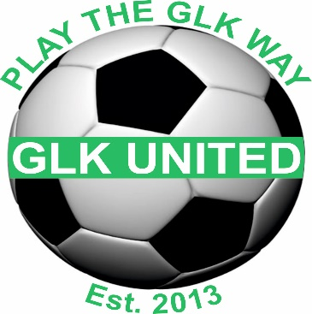

*All fines accrued by individual teams will be paid for by that team manager, this includes late match reports and any fines deemed inappropriate behaviour by the FA/LEAGUE.
*All monies due must be delivered to Gavin Kelly or by bank transfer with prior notification before the specified date.
*All managers/assistants must wear GLK branded clothing, any other clothing is unacceptable.
*Any referee fees will be paid by GLK to the manager monthly when an invoice is received.
*Managers meetings must be attended by either the team manager or assistant when required.
*Managers/Assistants are responsible for clearing away all mess left after training sessions/games.
*Your first point of contact for any welfare issues is Kirsty Hitchcock, 07947179445.
*All teams will be provided with 1 football per child at the start of the season, any additional footballs must be paid for by the manager.
I will:
- Show respect to others involved in the game including match officials, opposition players, coaches, managers, officials and spectators
- Adhere to the Laws of the Game Display and promote high standards of behaviour
- Always respect the match officials' decisions
- Never enter the field of play without the referee's permission
- Never engage in public criticism of the match officials
- Never engage in, or tolerate, offensive, insulting or abusive language or behaviour.
BREACH OF ANY OF THESE RULES, YOU WILL BE GIVEN A WARNING WHICH MAY LEAD TO SUSPENSION.
I understand that if I do not follow the code, any/all of the following actions may be taken by my club, NDYAL League or the County FA.

I may be:
- Required to meet with the club, league or County Welfare Officer
- Suspended by the club from attending matches
- Suspended or fined by the County FA
- Required to leave or be sacked by the club in addition
- My FA Coaching Licence may be withdrawn

WE APPRECIATE THAT THIS IS A VOLUTARY ROLE, YOUR EFFORTS ARE MUCH APPRECIATED.

PLEASE SIGN………………………………………………………………………….
DATE……………………………………..

