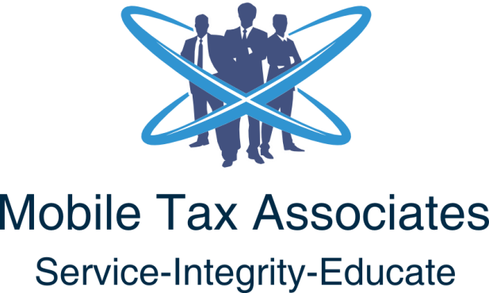
PO Box 492993 Lawrenceville GA 30049
Tel 678-870-7550 Cell 678-668-9096 Fax 877-943-8481
Email: Robert@mobiletaxassociates.com
Website: https://www.mobiletaxassociates.com

Tax Return Preparation Service Agreement

General Tax Return Preparation Service Agreement
This Service Agreement is to inform you, the taxpayer, of the services we will provide for you, and the responsibilities you have for preparation of your individual Federal or State income tax returns.

Tax Return Preparation
- We will prepare your current 2019 Federal or State tax returns based on information you provide. Services for preparation of your return do not include auditing or verification of information provided by you. No credit in 2019 will be provided for previous client consultation fees charged or paid.
- At initial meeting to engage our firm, you must present valid unexpired US Government Identity documents with photo for the primary and secondary taxpayer and all dependents. This is being done to prevent identity theft and for verification we are working with the correct taxpayers.
- You must also have your correct direct deposit information for refunds.
- Any audit or examination work will be billed separately from tax preparation fees based on our schedule of fees which is available upon request.
- You must review the return carefully before signing to make sure the information is correct.
- The tax preparation fee does not include bookkeeping.
- Fees must be paid in full before your tax return is delivered to you or filed for you. Fees can be paid in full at time of service, deducted from refund, or billed at Net-10 through PayPal.
  - PAID IN FULL
  - PAID FROM REFUND
  - BILLED BY PAYPAL AT NET-10
  - If you terminate this Service Agreement before completion, you agree to pay a fee for work completed. Invoices unpaid after two weeks from due date will be charged a 5% surcharge on the balance per week until paid in full.
- As the Service Agreement is signed by all parties, a $39 deposit will be due to begin work and is applied as a Credit toward your tax preparation fees. If you should decide to terminate the Service Agreement prior to the tax return preparation is completed, the $39 fee is non-refundable.
- In the case of any personal or business checks that is dishonored by our bank, there is a $30 fee which will be charged and due within 10 days. An invoice will be prepared and sent via PayPal for payment.
- In cases where your refund is subsequently taken by the IRS or State Tax Authority to pay past due debts such as (Child Support, Back taxes, Installment Agreements, Defaulted Student Loans), you are still responsible for making full payment on this Service Agreement based upon fees charged.
- Mobile Tax Associates for 2019 is working with Refund Advantage where you may qualify for a loan based on meeting the qualifications with Meta Bank. We also provide which is an Identity Theft Protection Service. There is an additional fee charged for the Identity Protection and is optional.
- Fees for responding to IRS or State Tax Authority correspondence will based on our schedule of fees.
- Preparation fees do cover limited assistance, copies of your tax returns either electronically or printed and mailed, and these fees are shown in the Schedule of Fees charged during the year. There is in 2019 a separate fee for additional copies of tax returns mailed, $0.07 per page plus mailing fee of $5.85 each.
- The Service Agreement to prepare your 2019 tax returns terminates upon the delivery of your completed returns, full payment of fees and original documents returned to you. Please store your supporting documents and copies of your tax return in a secure place for at least seven years. If requested, Mobile Tax Associates will store your information in a secure file with encryption with user identification and password access.
- All client files, documents, W-2/1099 and correspondence are maintained with Client Codes plus 9-digit password protected files which are updated and changed on a random schedule.
- A Referral Bonus will be paid to clients upon the point where the referral signs a Service Agreement with Mobile Tax Associates to begin work. The Referral Bonus is 5% of the fees paid by the client and will be refunded via PayPal within 30 days of the date Referral signs the Service Agreement.

Taxpayer Responsibilities
- You agree to provide us all income and deductible expense information from all sources. If you receive additional information after we begin working on your return, you will contact us immediately to ensure your completed tax returns contain all relevant information.
- Once your original federal or state tax return has been filed electronically or by mail, and you now receive additional W-2/1099 or other income documents, we suggest you may need to file an amended return once the original return has completed processing. Amended returns are charged a separate fee based on our Schedule of Fees and they must be mailed to separate mailing addresses depending on the state.
- You affirm that all expenses or other deduction amounts are accurate and that you have all required supporting written records. In some cases, we will ask to review your documents.
- You must be able to provide written records of all items included on your return if audited by either the IRS or state taxing authority. We can provide guidance concerning what evidence is acceptable.
- Provide ALL W-2 / 1099-INT / 1099-DIV / 1099-A / 1099-C / 1098 (Mortgage Interest and School Tuition)
- Taxpayer, spouse and dependents proof of identity (SSA Card, or Driver License)
- ITIN for Non-Residents and ATIN for Adopted Children
- Prior year IRS Tax Return (Form 1040) and State if applicable (Example: Georgia Form 500)
- Proof of Direct Deposit Account (Voided Check) with Routing and Account Number
- Information about Child Care Provider, Name, Address, SSA or EIN
- Form 1095-A, 1095-B or 1095-C for Health Insurance Coverage
- Any Proof of Self-Employment Income (Receipt Book, ledger, checking account)
- Taxpayer children over the age of 18 years or considered an adult in their state must provide POA if needed, to share information with parents or others in order to protect their personal information.
This Service Agreement shall be governed by the laws of the County of Gwinnett in the State of Georgia and any applicable Federal Law.

Signatures. By signing below, you acknowledge that you have read, understood, and accept your obligations and responsibilities and that you understand our responsibilities in preparing your tax return as explained above. For a joint return, both taxpayers must sign and date the return.

_________________________________ ___________________________________ ____________________
Primary Taxpayer Date Secondary Taxpayer Date

Mobile Tax Associates Representative Date

Privacy Policy The nature of our work requires us to collect certain nonpublic personal information about you from various sources. Mobile Tax Associates complies with Internal Revenue Code Section 7216, Disclosure or Use of Tax Information by Preparers of Returns which limits the use and disclosure of information obtained during the return preparation process to activities directly related to the preparation of the return. There are also specific and limited exceptions that allow a preparer to use or disclose return information without the consent of the taxpayer. We collect financial and personal information from applications, worksheets, reporting statements, and other forms, as well as interviews and conversations with our clients and affiliates. We may also review banking and credit card information about our clients in the performance of receipt of payment. Under our policy, all information we obtain about you will be provided by you or obtained with your permission. Our firm has procedures and policies in place to protect your confidential information. We restrict access to your confidential information to those within our firm who have a need to know in order to provide you with services. We will not disclose your personal information to any third party without your express written permission, except where required by law. We maintain physical, electronic, and procedural safeguards in compliance with Federal regulations that protect your personal information from unauthorized access. Please contact us with any questions regarding our privacy policy.

If you believe your tax return information has been disclosed or used improperly in a manner unauthorized by law or without your permission, you may contact the Treasury Inspector General for Tax Administration (TIGTA) by telephone at 1-800-366-4484, or by email at complaints@tigta.treas.gov

