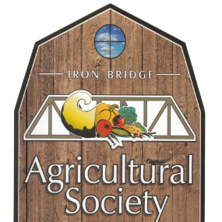

Iron Bridge Agricultural Society

The Iron Bridge Agricultural Society is bringing back the Fall Fair Parade. The theme for the 2022 parade is “Back to the Farm”. We are encouraging businesses, non-for-profit organizations, families, and friends to register no later than Friday, August 26, 2022; if you can ride it, you can register it! Come out and show the community how creative you can be (music and candy are permitted)
We ask all participants to meet at the Lions Club Ball Field located in the Village of Iron Bridge by 10:30 a.m. for line up and pictures. The parade will begin at 11:00 a.m. starting at the ball field and ending at the recreation centre. A map of the route will be provided.
Please cut and return bottom portion to:
Kerry or Kelsey, Parade Organizers, 7 Bridge Street, Iron Bridge, ON P0R 1H0
Phone: (705) 989-5934

Organization Name
Type of entry Animal Unit i.e Horse Float (please specify)
Commercial Unit Non-for-profit
Marching Unit Business
Tricycle/Bicycle Lawn Tractor
ATV/UTV
Contact Person
Phone
Email

