FOR OFFICE USE

Volunteer Ref # _________ Date ________

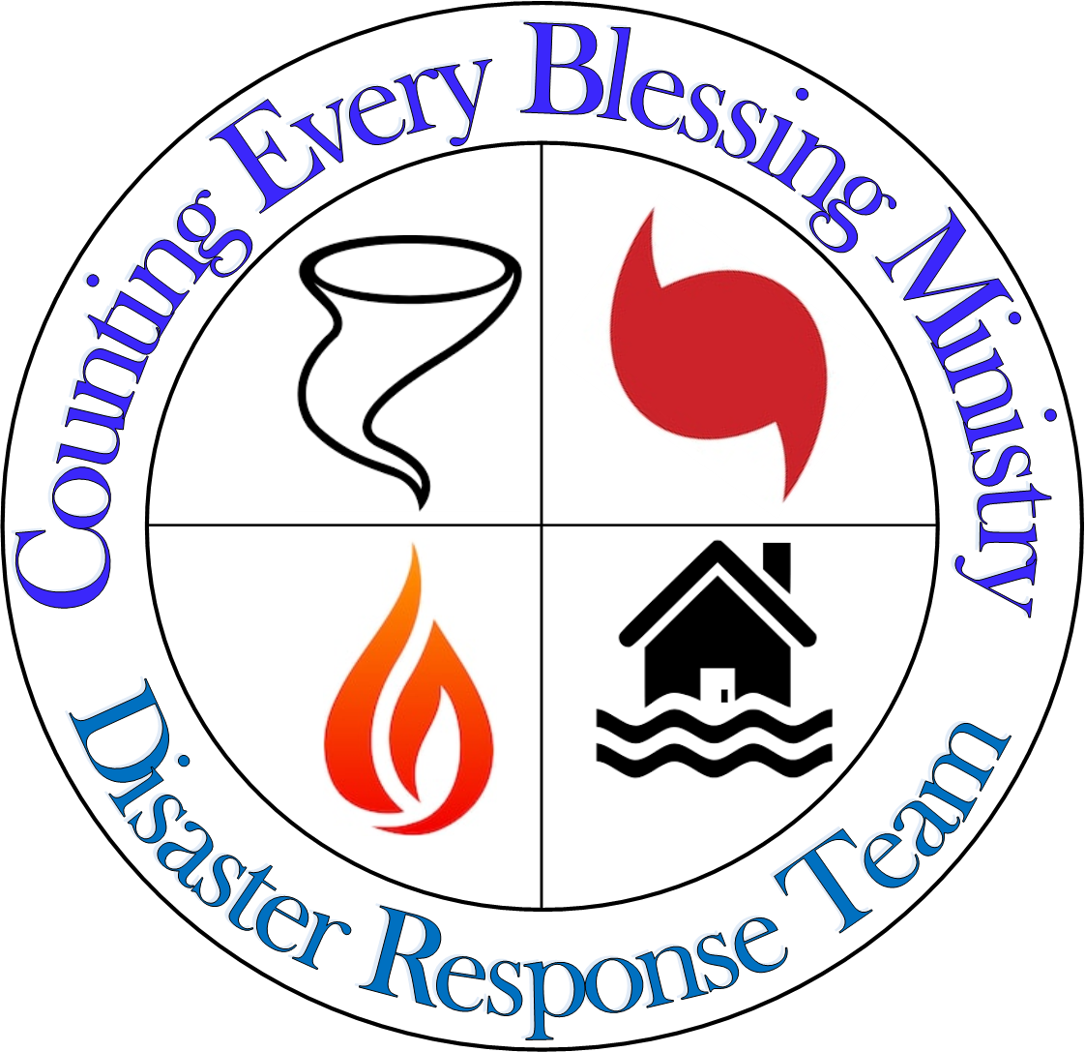
Volunteer Application Form
Thank you for your interest in volunteering with Counting Every Blessing Ministry.

Volunteers play a vital role in the community, especially in the instance of a natural disaster. All volunteer applications are reviewed with consideration of current volunteer opportunities. The information you provide will be stored in confidence under the provisions of the Data Protection Act. Your completed form will be held securely and confidentially. Only authorized staff will have access to your information.
Personal Details

Name: __________________________________________ Mr.  Mrs.  Miss.  Ms. 

Address: _____________________________________________________________

City: _____________________ State: _______________ Zip Code: _______________

Telephone: (Home) _________________________ (Mobile) _________________________

E-Mail: __________________________________________

Birth-date: _______________________________________
Day / Month / Year

Emergency Contact Information:

Name: ___________________________________ Relationship: _____________________

Telephone: (Home) _________________________ (Mobile) _________________________

Name: ___________________________________ Relationship: _____________________

Telephone: (Home) _________________________ (Mobile) _________________________

Equal Opportunities
Counting Every Blessing Ministry is committed to equal opportunities and all volunteer recruitment decisions will be based on merit, suitability for the role and experience. All volunteer recruitment decisions will not be influenced by race, nationality, religion, sex, marital status, family status, sexual orientation, or disability. Counting Every Blessing Ministry fully endorses a working environment free from discrimination and harassment.

Your Skills and Interests

1. Have you ever done any voluntary work before? Yes  No 
If you answered yes, please tell us a little about the experience.

2. Why do you want to volunteer with Counting Every Blessing Ministry?

3. Do you have any particular skills or qualities that you could use in your voluntary work?

5. What kind of voluntary work interests you?

 Disaster Response Team
 Community/Fund Raising Events
 Food/Beverage Distribution
 Disaster Shelter/Aid
 Other: ____________________

6. When are you available for voluntary work?  Totally Flexible

 | Monday | Tuesday | Wednesday | Thursday | Friday | Saturday | Sunday
Morning
Afternoon
Evening

7. How long do you intend to volunteer for? _______________________________________________
(note that some opportunities demand a minimum time commitment, ie. Disaster Response Team)

8. Where do you wish to volunteer? ____________________________________________________
(County / City Area/ State Region)

9. How did you find out about volunteering with Counting Every Blessing Ministry?

 Information / Outreach meeting
 Family / Friend
 Leaflet / Poster
 Word of Mouth
 Internet: www.cebministry.org
 Media: Radio / Television / Newspaper
 Current Volunteer
Referred by: ___________________________
 Another Ministry/Church
 Other ______________________________

References

1.
Name: ______________________________________ Relationship: _________________________

Place of Work: ___________________________________ Position: _________________________
(If applicable)

Telephone: (Home) ____________________________ (Mobile) _____________________________

E-Mail: ______________________________________

2.
Name: ______________________________________ Relationship: _________________________

Place of Work: ___________________________________ Position: _________________________
(If applicable)

Telephone: (Home) ____________________________ (Mobile) _____________________________

E-Mail: ______________________________________

If you have any questions when completing this application form, please call Counting Every Blessing Ministry at 817-880-3008 or e-mail info@cebministry.org.

Is there any additional information you would like Counting Every Blessing Ministry to know?

I declare that the information I have provided is true. All my actions as a volunteer will reflect the ethics of Counting Every Blessing Ministry. I will uphold the ethics and standards of Counting Every Blessing Ministry in my role as a volunteer.

Signed __________________________________________ Date __________________________

For office use only Notes

Volunteer Position ______________________________

Volunteer Interview _____________________________

Volunteer Role Description sent ___________________

References Collected ___________________________

Volunteer Start Date ____________________________

