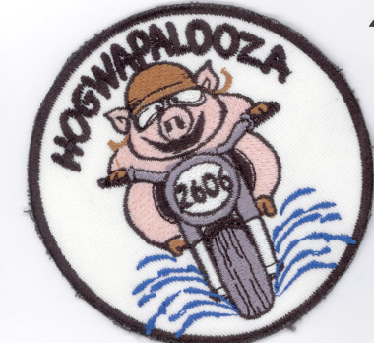

HOGwapalooza

***BOOK YOUR ROOM NOW WHILE THERE IS AVAILABILITY!!!!***

14th Annual - Chapter Lake Cruise & Overnighter! Saturday August 16th, 2025

(After the ride, all are invited to the cookout and the overnighter at this cool hotel/pool/bar)

*(HOGwapalooza – Summer Patch Ride and annual Rocker)*

What: HOGwapalooza! Chapter Cruise Over Two Lakes and 4 Bridges.

After ride all are welcome to grab some food and beverages from Harter

House in Kimberling City for a group cookout back at Cruise Inn.

When: 9:00am Meet, 9:30 am Kick Stands Up, 10:45-11am Break/Gas (Hwy 76

Cenex) 12:15-12:30pm (Break/Gas (Hwy 39 Conoco), 1:00-2:15pm Lunch (Flat Creek Grill) 3:30pm Cruise Inn Throttle Down (Ride sign in and Chapter Group Picture with Cruise Inn sign showing Temperature in background).

Who: HOG Chapter #4982 Members and Guests.

Where: Hwy 65 South & Hwy F (meet in Wal-Mart parking lot)

Why: Ride and Have Fun!!! Have a blast on twisties and cruise around Lake

Taneycomo and Table Rock Lake. Enjoy a cookout, and overnighter.

Route: Walmart Ozark, Hwy 14 W, (R) to Hwy 125 S, (R) to Hwy 76 E

Break/Gas at Hwy 76 Cenex. Continue on Hwy 76 to roundabout (take Lake Road/Main St. Hollister (R) to Hwy 165, (L) to Hwy 265, (R) to Hwy 65 S, (R) to Hwy 86 W. (R) Hwy 39 N Break/Gas at Hwy 39 Conoco,

(R) Hwy 76, (L) Hwy 173 to Flat Creek for Lunch.

After lunch take Hwy (173 turns into Hwy 76, (R) to Hwy 413 S, (R) to Hwy 13 S to Cruise Inn Throttle Down

(There will be a return ride leader for those not staying for the cookout or overnight)

Check Cruise Inn Throttle Down Inn out!!! https://cruise-inns.com/

Call for reservations: (417) 779-4158

Owner: Chip, also Louie the inn’s Parrott!

For more info: Kevin Cervellere kfcervellere@gmail.com Cell: 417.839.0096