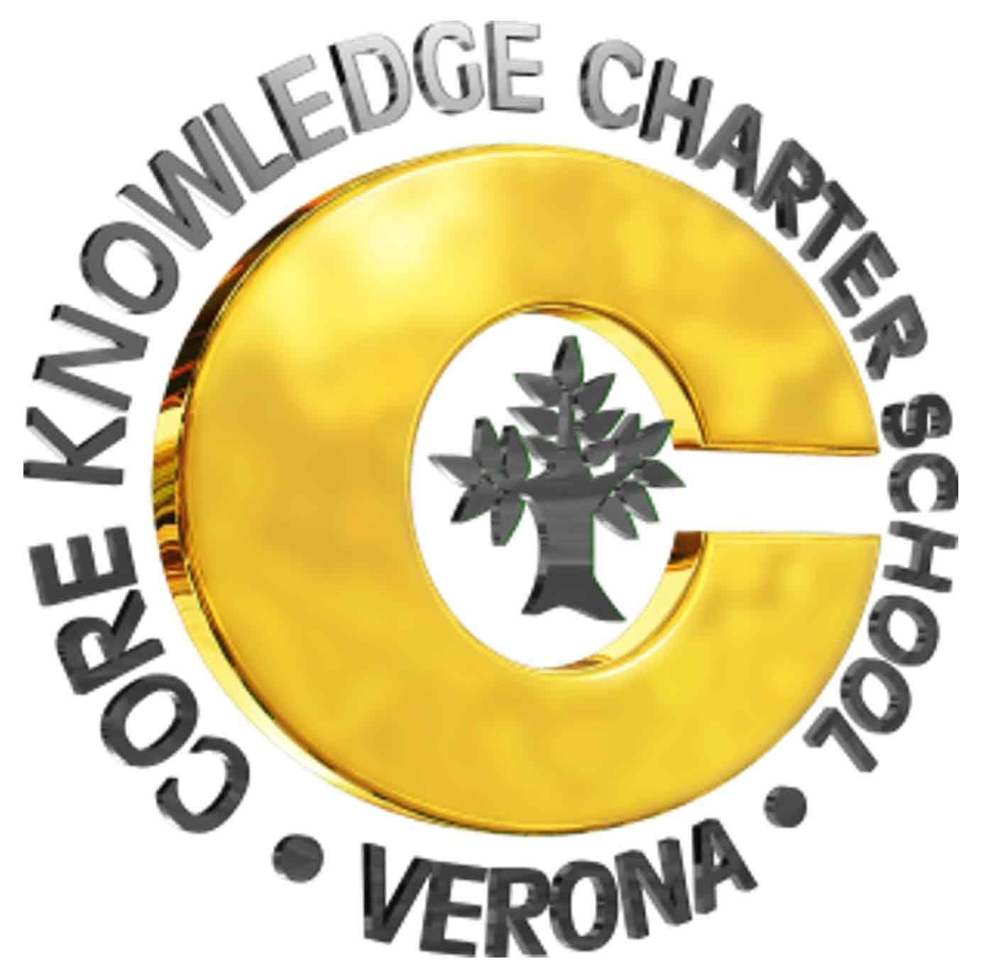  Governing Council  5 JUN 2019  6:00pm  Location: CKCS Step Room  7 Norms of Collaborative Work:  - Pause  - Paraphrase  - Pose questions  - Put ideas on the table  - Provide data  - Pay attention to self and others  - Presume positive intentions  Discuss: Council discussion & vote  Dialogue: Council discussion, gathering of ideas, exploration | AGENDA  - Reading of the CKCS Mission Statement  - CKCS is a public school option for parents, students and teachers in the Verona Area School District where students develop strong learning skills and a broad base of knowledge through the use of proven educational materials and programs in a safe and structured environment.  - Audience recognition & rules of participation  - Dates, announcements and brief agenda items  - Next GC meeting – July 10  - Parking lot items  - Approve previous minutes - MAY  - PRT update (Chris)  - PASS update (Linda)  - Director’s Report (Rick)  - Board topics  - Dialogue iPads (Rick)  - Dialogue Social Studies curriculum review (Nicole)  - Dialogue GC Bylaws (Joleen)  - Dialogue elections (Joleen)  - Future agenda and/or parking lot items  - Adjourn

