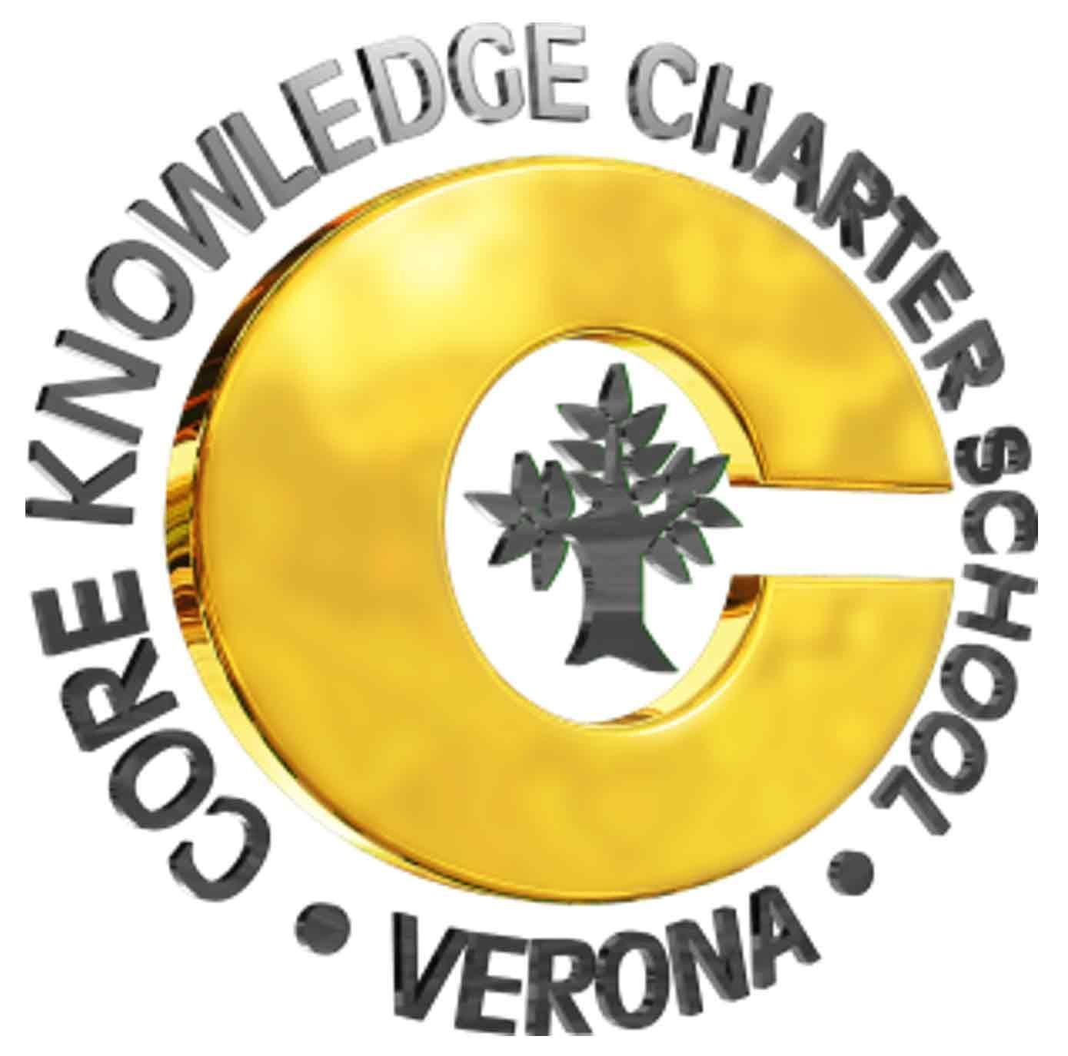  Governing Council  14 Aug 2019  6:00pm  Location: LMC (library), CKCS  7 Norms of Collaborative Work:  - Pause  - Paraphrase  - Pose questions  - Put ideas on the table  - Provide data  - Pay attention to self and others  - Presume positive intentions  Discuss: Council discussion & vote  Dialogue: Council discussion, gathering of ideas, exploration  GC Board Members:  - Rick Kisting, Director  - Nicole Boedecker, Curriculum Coord.  - Joleen Rau, President  - Shunta Lewis, Vice President  - Erin Marriott, Secretary  - Abbey Weiss, Treasurer  - Charles Gleason, Parent Rep  - Lauren McQuisten, Community Rep  - Melissa Moser, Community Rep | AGENDA  - Reading of the CKCS Mission Statement  - CKCS is a public school option for parents, students and teachers in the Verona Area School District where students develop strong learning skills and a broad base of knowledge through the use of proven educational materials and programs in a safe and structured environment.  - Audience recognition & rules of participation  - Dates, announcements and brief agenda items  - Next GC meeting – Sep 11  - Parking lot items  - Discuss previous minutes - July  - Dialogue PRT update (Chris)  - Dialogue PASS update (Linda)  - Board topics  - Dialogue 2019-2020 GC Board (Abbey)  - Discuss District Management Plan (Rick)  - Discuss BRMS/CKCS Working Agreement (Rick)  - Hiring Committee Report:  - Tracy Ayers, Educational Assistant (Shunta and Rick)  - Dialogue GC Working Agreement (Abbey)  - Dialogue Individual Goals (Abbey)  - Director’s Report (Rick)  - Future agenda and/or parking lot items  - iPads  - GC By-Laws  - Adjourn

