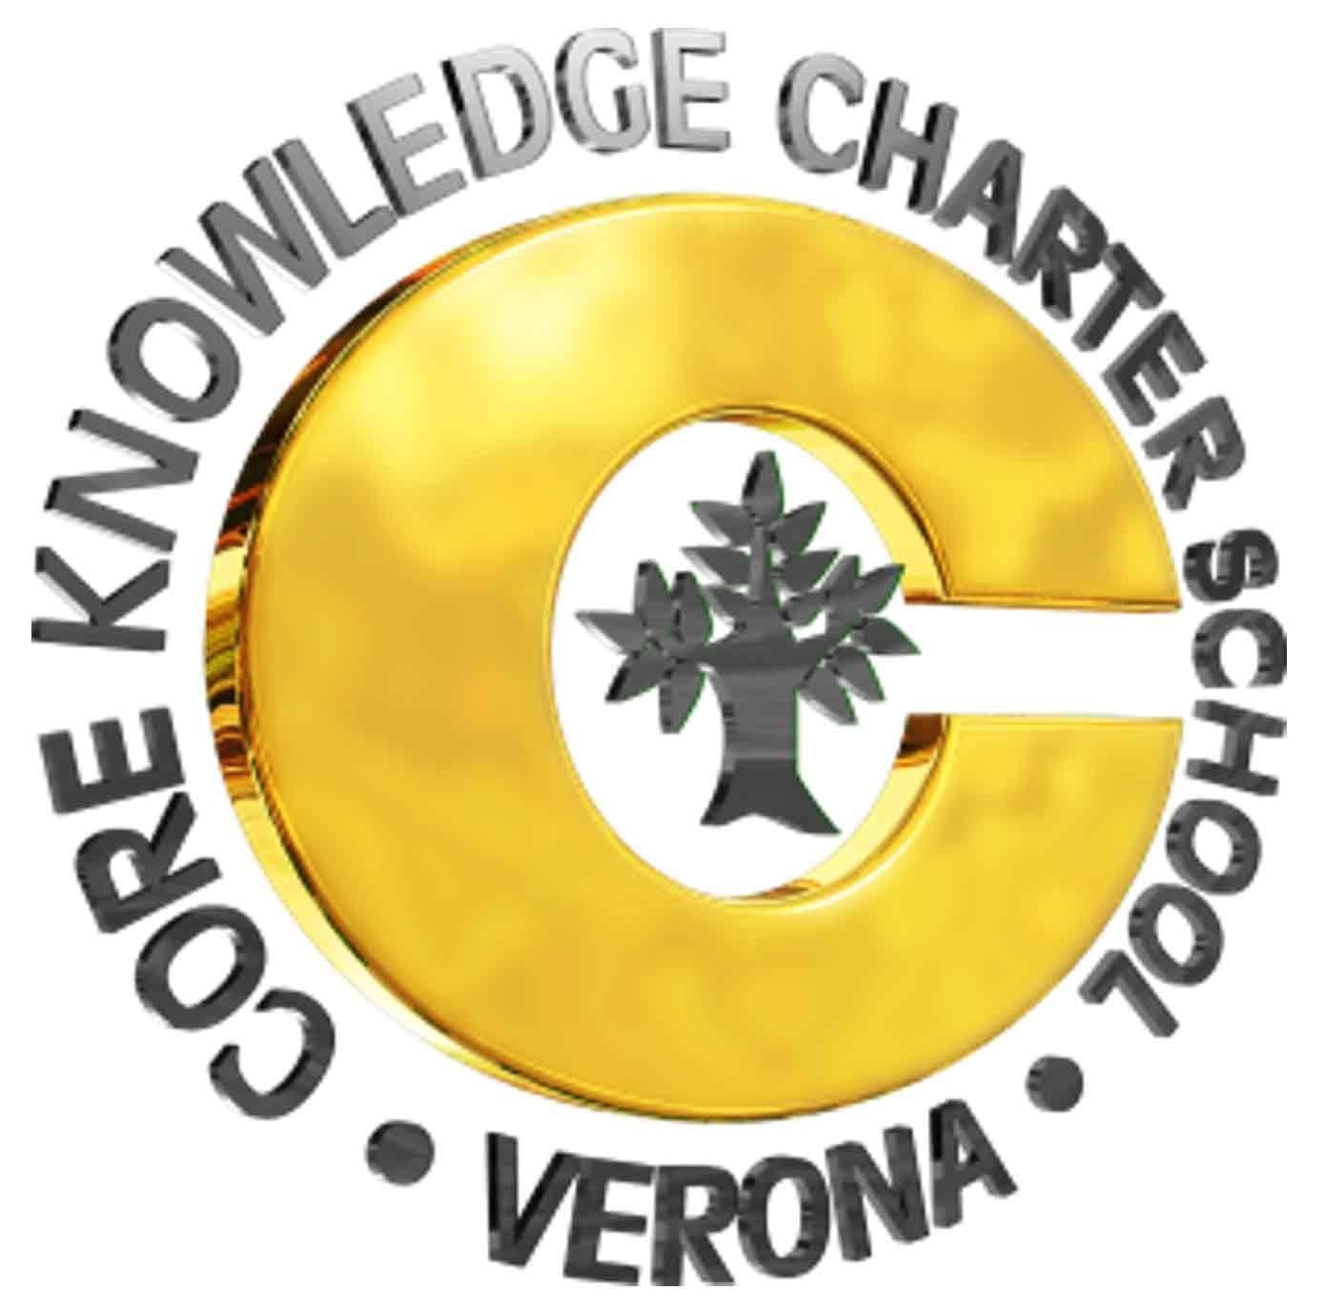  Parent Round Table  December 7, 2020  7pm  Location: Virtual Meeting  7 Norms of Collaborative Work:  - Pause  - Paraphrase  - Pose questions  - Put ideas on the table  - Provide data  - Pay attention to self and others  - Presume positive intention  2020-21 PRT Board Members:  - Open – President  - Sara Hereley, Vice President of Community Building (Acting President)  - Sarah Wood, Vice President of Fundraising  - Laura Meicher, Treasurer  - Jessica Retrum - Secretary  2020-21 PRT Officers:  - TBD | AGENDA  - Reading of the PRT Mission/Vision  - MISSION: Supporting a strong CKCS community through fundraising and community events.  - VISION: The Verona Area Core Knowledge Charter School (CKCS) Parent Round Table (PRT) is a support organization promoting community among the students, parents and staff by: hosting events aimed at building community; coordinating fundraising efforts at the school/parent level to complement the district provided budget; and ensuring generated funds are being allocated appropriately based upon the best interests of the students and staff.  - Introductions/rules of participation  - Dates, Announcements, Brief Items  - Approval of November 2020 PRT Meeting Minutes  - APproved pending Laura’s feedback  - GC Update  - PASS Update  - CKCS School Update and Director’s Report  - Next PRT Meeting – Jan 13th  - Board Topics  - Parent/Guardian/Staff Input  - Budget Updates – Laura  - Budget updated pending Gigi sales.  - Fundraising Updates  - Fall Virtual Book Fair – Sarah W  - No final update from Scholastic. Sarah Wood to reach out again for final numbers.  - School Supply Kits – Sarah W -  - Sarah reached out and began conversation around dates. Sarah W. To reach out to Joe/colleague about logo wear from FirstDay.  - Cupcake Fundraiser – Sara H/Laura  - 47 orders placed.  - Sara H. Reach out with orders pending payment.  - Laura M. Reach out to orders needing clarity.  - Sara H. To place order and get clarification on order pick up, sorting, and clarity on payment.  - Spring Merchandise Sale – Sarah W  - Reached out to the event coordinator and she is on board. Needs date for event. May 10-16 Charter School week, Include new families.  - Knowledge-a-Thon (with PASS) – Sara H  - Sara H. Needs an update from Jen and if we would do an event this year or not.  - Spring Flowers Sale – Sara H  - Time it around Mothers Day. Sara H. Will reach out to get more details. Jessica offered to partner in support.  - Unfundraiser Spring Messaging? Jessica  - Plug into the newsletter and free community events  - Community Building Updates  - Teacher Appreciation Gifts – Sara H  - Teacher Appreciation Luncheon – Sara H  - Zoom Art Lesson – Sara H  - Date of 1/22/21 7-9pm, Latisha to send out a reminder via email. Sara H. Getting the image finalized more towards winter and Rick for supply assistance.  - Tyrol Basin Play Day - Jessica  - Reached out and waiting to hear back.  - Virtual Trivia – Sara H  - Pending February and more details. Sarah will reach out to Randy’s contact post cupcake fundraiser.  - Virtual Bingo – Jessica & Jaime  - February 12th K-2 6-7pm, 7:30-8:30pm. Get pass Zoom account and ask teachers to mail link and time. Guest callers. Reach out to Rick for approval of idea and logistics.  - Round II pending march event depending upon February turn out.  - Drive In Movie - Jessica  - Connected with Heather Haver she said yes. Kendra Noll (Country View) , Katie Baus (Sugar Creek PTO) PRT presidents - TBD April  - Donuts and Coffee for Staff – Sara H  - Spring Newsletter – Jessica  - Thank donors for un-fundraiser, contributions to teacher appreciation, recap how it is going. Jessica to get it to Sara H for review. Reach out to other boards for Pass and GC  - VACKCS.com Update Project - Laura M. And Sara H. to connect on our website update.  - Any other business  - Adjourn

