Memorandum of Understanding
Regarding ParaEducator Classification Review and
Classification of Special Education ParaEducators
This Memorandum of Understanding is entered into by Tacoma Public Schools ("the District") and the Tacoma Federation of ParaEducators Local 461, AFT/AFL-CIO.
The District and the Tacoma Federation of ParaEducators agree to the following:
• Section 33. Duration Clause
This Agreement shall be in full force and effect from September l, 2017 to August 3 1 , 20291 provided however, that in the event of a levy failure or significant loss of state or federal funding, applicable section(s) of the Agreement may be reopened at the request of either party.
The parties further agree to a salarv reopener for the 2020-2021 school vear.
This agreement remains in effect through the August 31. 2021.

For the District: For Tacoma Federation of ParaEducators:
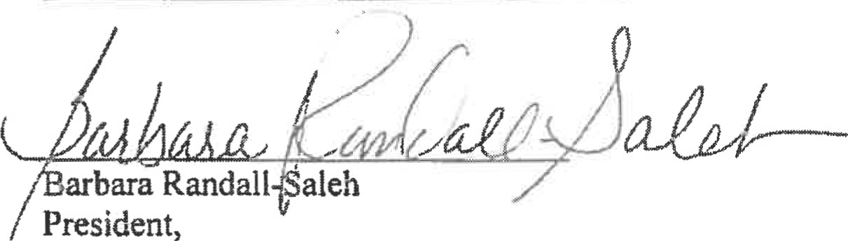
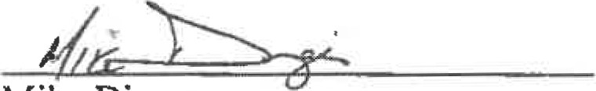
Mike Dinges
District Negotiator,
Tacoma Public Schools Tacoma Federation of ParaEducators
Date

