August 5th, 2019

Kawasaki Kisen Kaisha, Ltd.

Joint Approval in Principle (AIP) for New Concept Design of LNG-fuelled Ore Carrier

Kawasaki Kisen Kaisha, Ltd. (herein called “K” Line) is proud to announce that “K” Line and Namura Shipbuilding Co., Ltd. (herein called “Namura Shipyard”) have joint AIP (Approval in Principle) for the concept design of an LNG-fuelled Ore Carrier from DNV GL.

Work on this joint project for the development of an LNG-fuelled ore carrier has complied with both environmental and actual operation requirements as follows, based on the second generation WOZMAX®*1 of Namura Shipyard.

* To keep almost same deadweight and normal service speed as WOZMAX®
* To keep enough endurance for round-trip between Singapore and Brazil in gas fuel mode, arranging the LNG tanks in center section of hull.
* To achieve EEDI phase 3*2 by means of primary fuel changes to LNG.

Comparison of principal particulars

|  |  |  |
| --- | --- | --- |
|  | WOZMAX type GF | Second generation of WOZMAX® |
| Dimension | LOA: abt.329.9M x B: 57.00M x D: 25.60M | Same as on the left |
| Deadweight | abt.250,000 MT | Same as on the left |
| Service Speed | 14.3 knots | Same as on the left |
| Main Engine | Dual Fueled Diesel Engine x 1 set | MAN-B&W 6G80ME-C9.5 x 1 set |
| Fuel Oil Tank | LNG fuel tanks in center section of hull | Heavy fuel tanks |
| Endurance (LNG fuel) | Singapore to Brazil in gas fuel mode | - |

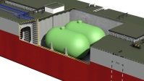

**LNG Fuel Tanks**

**WOZMAX type GF**

Gas fuelled vessel

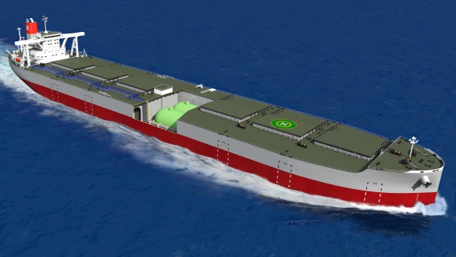

IMAGE of LNG-FUELLED ORE CARRIER

In addition to LNG fuel conversion, we studied the possibility of it being combined with Shaft Generator, Binary Cycle Power Generation System and Lithium Battery so as to further reduce CO2 emissions and confirmed that this system can achieve an additional further 4% reduction of fuel oil consumption.



IMAGE OF ON-BOARD GENERATIING SYSTEM

“K” LINE is continuously attempting to obtain greater efficiency in its operations as well as further reduction of CO2 emissions and environmental pollutants in accordance with “K” LINE ENVIROMENTAL VISION 2050*3, our long-term environmental management vision. This system is considered as one of the efficient systems that will help us achieve our goals by 2050.

Environmental concern with greenhouse gas emission effect is growing and “K” LINE will, based on “K” LINE ENVIROMENTAL VISION 2050, encourage less environmental load from marine transport by operating ships that are highly energy efficient and which contribute to conservation of the global environment.

*1 WOZMAX (registered brand of Namura Shipyard): an optimum size of vessel that can call main West Australian iron ore loading ports, which stands for “West” “OZ” “MAX”.

*2 EEDI (Energy Efficiency Design Index): the number of grams of CO2 emitted when carrying 1 ton of cargo for 1 mile, and 30% reduction is required in phase 3, compared with the reference value which is the average of vessels built between 1999 and 2008.

*3 “K” LINE ENVIROMENTAL VISION 2050 can be seen in below link:

⇒<https://www.kline.co.jp/en/csr/environment/management.html#002>

For further information, please contact

Kawasaki Kisen Kaisha, Ltd. (“K” Line)

Atsushi Tanaka, Manager, Ship Technical Group

Tel: 81-3-3595-5378