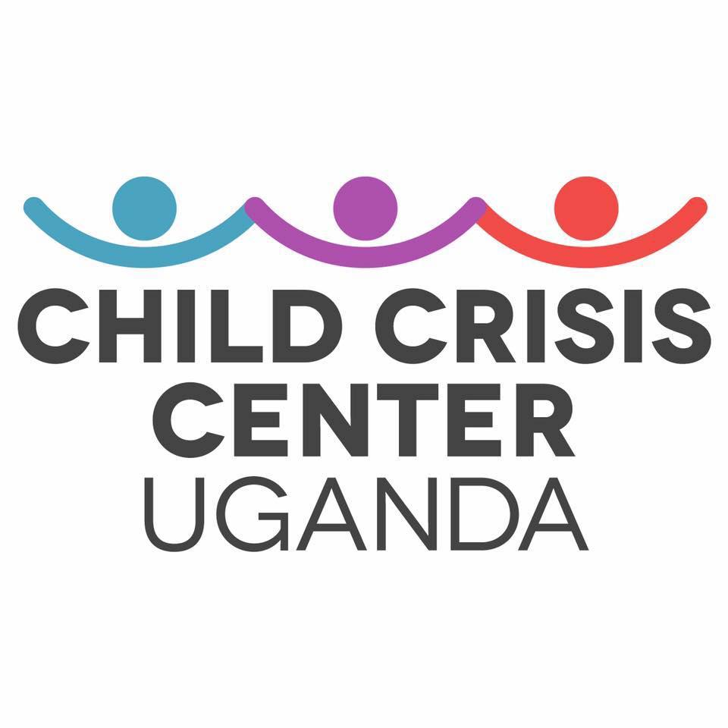

Sponsorship

Program

Child Crisis Center Uganda

Sponsorship Packet

Welcome to Sponsorship!
We are pleased that you are choosing to embark on this mission with us!
Child Crisis Center Uganda and a 501 c3 nonprofit organization. CCCU operates out of the USA and Uganda with headquarters in Pennsylvania, USA. Child Crisis Center Uganda has been in operation since October of 2017. Over the past few years CCCU has been aiding a group of orphaned children and widowed women in the rural village of Magooli, Uganda.
Since the creation of CCCU, the organization has been successful in building a brand new school building for the children called The Magooli Academy for Children - NAMAYINGO (MACN). This school is owned and operated by CCCU and is recognized as a nonprofit by the Ugandan Government. This is important because education is not as accessible for every child in Uganda like it is in other nations such as the United States. The schools that are run by the government are overcrowded and underfunded. In the case of Magooli, the closest school is about two miles away. The children have to walk to and from school daily leaving them beaten down, weak and in no position to learn. Since MACN will be recognized by the government as a nonprofit there will be no chance of overcrowding; MACN will only cater to the orphaned children that CCCU supports.
This is where you come in! In Uganda to go to school with proper resources, a student must pay school fees before each term. Even though there was no way to nix the fees altogether with the new school, CCCU has worked hard planning every way to reduce the costs. MACN fees are much lower than that of a government school but they are still there. CCCU’s Sponsorship Program allows for a child supported by generous donors like you to go to school for the whole year with the necessary supplies and tools to succeed.
Having a sponsor allows to child the best chance to succeed in school regardless of the financial situation they are in. Money from sponsorship goes to the child’s necessary supplies such as: books, clothing, sanitary supplies, school & lunch fees. The children who are not sponsored are allowed to attend classes however they all have to share whatever remaining materials there may be, if any. A sponsorship sets a child up for with the best ability to succeed. These children are all so eager to learn and grow as individuals; they each have their own hopes, dreams and goals. By sponsoring a child through CCCU you are not only providing an education, but you are providing hope for a child. The children CCCU supports live very scant and difficult lives, hope goes a long way and can make all the difference in the child’s life.

Navigation

Welcome……………………………...……….……………….page 2

Application…………………………...………………………..page 4

Terms & Conditions…………………………………….…..page 6

How a CCCU Sponsor Helps………………….…..…………page 8

Application

Contact Information:

Name: Click here to enter name.
Co-Sponsor (if any): Click here to enter co-sponsor.
Address: Click here to enter address.
City: Click here to enter city. Country: Click here to enter country.
State: Click here to enter state. Zip: Click here to enter zip.
Telephone: Click here to enter telephone.
Cell Phone: Click here to enter cell phone.
E-mail*: Click here to enter email.
*A valid email address is required to receive tax receipts and child updates.
Please Select an Option Below:
☐ I would like to sponsor (Child’s name if known): Enter child’s name here
☐ I would like to sponsor an orphan child in a rural village of Magooli
Gender: ☐ Boy / ☐ Girl
Approximate Age: _ year’s old
☐ I would like to sponsor any orphan in the rural village of Magooli

Payment Options:
Billing begins each year in February and is due on the first of each month. Please choose the plan that best works for you. See details in Terms & Conditions (pg 6).
☐A. One payment of $420 USD
☐B. Two payment of $210 USD to be billed every 6 months
☐C. Four payments of $105 USD to be billed every 3 months
☐D. Twelve payments of $35 USD to be billed monthly
☐ Enclosed is my sponsorship payment of $ --- made by ( ☐ check / ☐ money order )
☐ E-payment via childcrisiscenteruganda.org/donate

Agreed to & Accepted:

Sign name here
Sign Name
--/---/----
Day / Month / Year
Print name here
Print Name

Terms & Conditions

Payment & Renewal:

- You may submit payments by check, money order, or online via childcrisiscenteruganda.org/donate. Please make out all payments to Child Crisis Center Uganda with your child’s name in the memo (if you have not yet been assigned a child and this is your first payment - don’t worry we we let you know shortly who you will be helping).

- There are several payment options. Payments begin when the child’s first term starts in February. You are expected to pay by the 1st of each month in correspondence with your selected plan.

  - One payment of $420 USD
  - Two payments of $210 USD to be paid in February and August
  - Four payments of $105 USD to be paid in February, May, August and November
  - Twelve payments of $35 USD to be paid monthly February through January

- CCCU will notify you in advance when it is time to renew your sponsorship via email.

- If CCCU does not receive your payment, you will receive a notification email informing you that your account is overdue. A two month grace period will be provided, after which your sponsorship will be considered terminated and the sponsored child will be returned to unsponsored status. At this point the child will be posted on CCCU’s website so they may receive a new sponsor. You are welcome to sponsor again at any time, but CCCU cannot guarantee that the original child will be available to sponsor.

- Receipt upon payment: CCCU will notify you upon receiving your payment via email along with a thank you from the President.

Assignment of Sponsored Child:

- There are three options when it comes to sponsoring a child. 1) You may select a child who is still looking for a sponsor from our website childcrisiscenteruganda.org/sponsor-a-child. 2) You may choose to be assigned a child based on gender and age. 3) You may select to randomly be assigned to sponsor any child who needs your help.

- CCCU reserves the right to change your sponsored child at any time. Should this happen, CCCU will notify you by email and reassign you to a new child of similar age and gender if possible.

- If the child you are sponsoring is expected to graduate CCCU will send you a message and ask if you would like to continue to make a difference in a new child’s life.

Terminating Your Sponsorship:

- If CCCU does not receive your payment, you will receive a notification email informing you that your account is overdue. A two month grace period will be provided, after which your sponsorship will be considered terminated and the sponsored child will be returned to unsponsored status. At this point the child will be posted on CCCU’s website so they may receive a new sponsor. You are welcome to sponsor again at any time, but CCCU cannot guarantee that the original child will be available to sponsor.

- We encourage sponsors to support the same child throughout the course of their education for as long as they are able. This allows children to continue their education uninterrupted and facilitates a relationship between the sponsor and the sponsored child.

- In the interests of the child, please try to give at least three months advance notice if at any point you decide to discontinue your sponsorship. Contact CCCU by email at sponsor.cccu@gmail.com to provide this notice.

Communication with Sponsored Children:

- You can send a message to your child at any time via email at sponsor.cccu@gmail.com or on our website childcrisiscenteruganda.org/sponsor-a-child. Please include your child’s name in the subject and the body of the email This message will be emailed to Uganda and Deacon Zalambi Joseph will share it with your child. Please allow for at least 3 business days for your message to be shared as we have limited man power on the ground in Uganda.

- If you would like to mail letters or items to your child in Uganda please reach out via email sponsor.cccu@gmail.com and inquire about any planned packages. Shipping to Uganda is expensive, if we already have a package planned we can try to accommodate your item as well (depending on size and weight we may have to charge you a small shipping fee). At any time we will be delighted to provide you with shipping information.

How a CCCU Sponsorship Will Help

Child Crisis Center Uganda does all that it can to ensure the livelihood of Magooli’s orphaned children. CCCU’s sponsorship program gives donors the opportunity to sponsor a child and make a positive impact in their lives. A CCCU sponsorship will allow the child to go to school for a whole year with the necessary supplies and attention that one needs to succeed. The money will go towards the child’s tuition fees, uniforms, school supplies and lunch fees.
- The child you sponsor will get the opportunity to receive an education. Your sponsorship will allow one special child to stay in school longer and get the most out of his or her education with the proper materials.

- The child you sponsor will get the opportunity to be healthy. The health of the child you sponsor will be monitored and care will be provided as needed. Children are taught about hygiene and how to maintain personal health. This includes working to provide consistent, nutritious food.

- The child you sponsor will get the opportunity to develop self-confidence and social skills. He or she will be part of a program where adult educators and peers offer love, guidance, personal attention, guided recreation and safety.

Children in this rural village of Magooli rely on sponsors and help from CCCU and outsiders to improve their conditions and thus their lives. All of these children are living with parents or family members that are unable to provide. Some children live with one parent while others are not so lucky. Those not living with their parents are living with relatives such as aunts, uncles or grandparents. May of these caregivers suffer from medical conditions or diseases that hinder their caretaking ability such as epilepsy, HIV/AIDS, and old age among others.

A sponsorship will give the child the materials they need to succeed, but a sponsorship will also bring the child undeniable hope. Although they don’t have much, these children make the most out of each and everyday. By you extending a hand and showing even the smallest bit of compassion you can change the lives of one or many children. A small fee to us gives someone else a lifetime of ability and promise.

Child Crisis Center Uganda sincerely thanks you for your interest in the program and our organization. The children and village of Magooli have captured our hearts so quickly. We are grateful and blessed that you have chosen to embark on this mission with us. So from all of us here in the USA and across the seas in Uganda, thank you.

