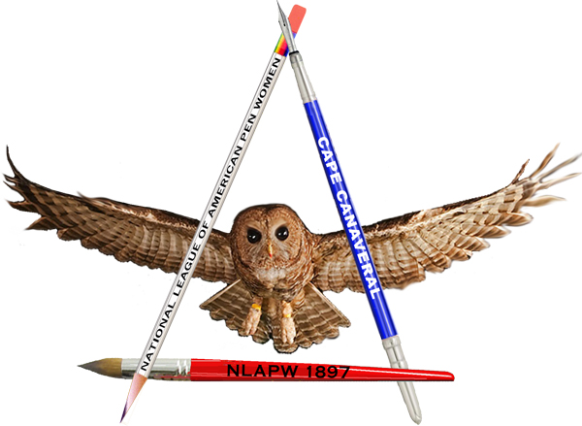
2026 Scholarship for Letters
National League of American Pen Women
Cape Canaveral Branch
Supporting Women in the Arts
Application

Directions:
Complete the application. There are three requirements for this application. First, fill in the required information below. Then, choose three from the list below and provide either a poem or short story for your selections. All entries must be typed in size 12 font with one-inch margins. Make sure your name is on each page. Short stories must be no more than 1500 words. Please do not submit epic poems, but any other style is permitted.

- Select three from the list below and write a short story, fiction or non-fiction or poem
Subject list:
- Pick a founding father or pivotal voice of the American Revolution and how they might still be relevant today, and how they are relevant to you.
- Tell us about someone in your life/school/church that is an unsung patriot.
- Tell us about someone you admire and why
- Speak to a gift in your life that you are thankful for
- What does writing mean to you?
- Tell us something about Brevard County you love
- Tell us about a moment that changed your life
- Tell us a story of a fictional character in a moment of the Revolutionary War

- Bio of your life, including goals and plans should be no more than 1000 words.

All work must be original. Plagiarism of any kind will result in your application being removed from the competition.

Submit your work, the application, entries and bio should be submitted in separate files and sent via email to jb@jbyanni.com

Deadline for application: March 30, 2026

Name: ________________________________________________________________
Address: _____________________________________________________________
City: ______________________________ State: ___________ Zip: ___________
Phone: ________________________ Email: _______________________________
Questions about this application and/or the scholarship should be addressed to jb@jbyanni.com

