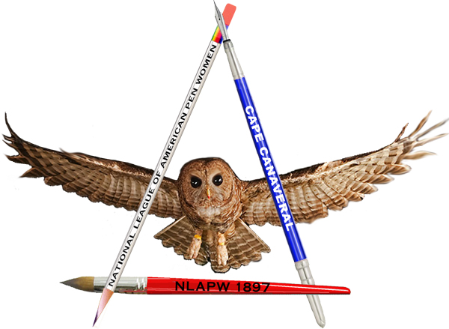
2026 Scholarship for Letters
National League of American Pen Women
Cape Canaveral Branch
Supporting Women in the Arts

The Cape Canaveral Branch of the National League of American Pen Women
offers a $1000 Scholarship in Letters

Deadline for application: March 30, 2026

Who may apply: Young women who are seniors in high school or college students in good standing in Brevard County and who have demonstrated interest and aptitude for writing.

Procedure: Applicants must fill in the required information on the application form, provide the selected short stories or poems and bio.

When the application and sample of writing from the list on the application are complete, submit the documents to the Scholarship Chair, Joy Yanni, at jb@jbyanni.com.

Incomplete applications or applications received after March 30, 2026 will be disregarded.

For questions regarding this scholarship, contact jb@jbyanni.com

The National League of American Pen Women is a professional organization of women in the arts. Founded in 1897, NLAPW supports awareness and expression of art, writing, and music in communities throughout the United States. For more information about NLAPW, please see www.nlapw.org. The Cape Canaveral Branch of NLAPW, founded in 1969, operates under the auspices of the Florida State Association/NLAPW.

Cape Canaveral Pen Women
5600 N. Banana River Blvd, Unit #8, Cocoa Beach, FL 32931
jb@jbyanni.com
canaveralpenwomen.org

