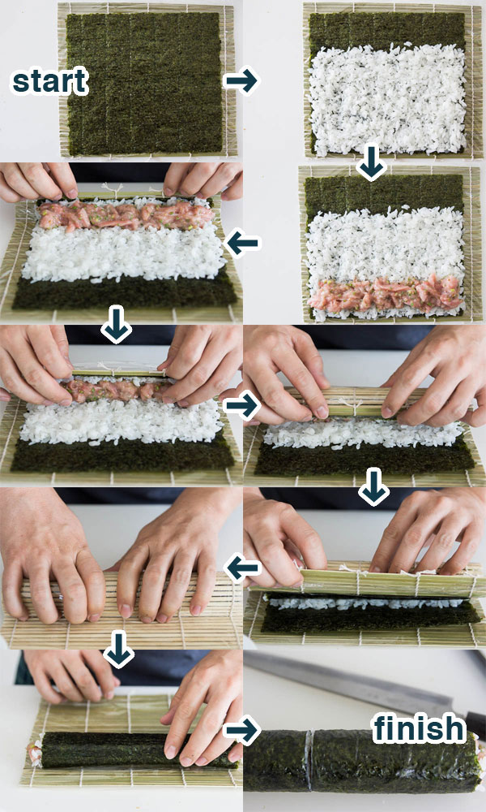

**Ingredients**

) Nori (seaweed) wrappers

) Vegetables (sliced thinly lengthwise. Cucumber remove the seeds. Parboiled or seasoned as desired.)

) Raw or cooked seafood (Use only the freshest fish. Imitation crab with cream cheese is popular.)

**Helpful things:**

) Bamboo sushi mat inside a Ziploc bag or wrapped in plastic wrap

) Sushi paddle for folding and transferring rice

) Small dishes for dipping sauces

) Chopsticks

**RICE**

* 2 cups Japanese short-grain rice (“sushi rice”)
* 2 cups water
* 1/4 cup seasoned rice vinegar (rice vinegar contains sugar and salt. It may be bought or you make it yourself.

1. Rinse the rice with cold water for 1-2 minutes or until the water runs clear.
2. Cook the rice using your favorite method or search online for instructions.
3. Transfer the hot rice immediately to a large mixing bowl and drizzle it evenly with the sushi vinegar. Use a spatula to very gently fold the rice — more of a slicing and lifting motion, rather than stirring and smooshing — until the vinegar is evenly mixed into the rice. Fan the mixture vigorously as you turn the rice – until it reaches room temperature. You may need two people to do this part. The rice should be glossy when finished.
4. Cover until ready to use. (Do not refrigerate or the texture will change.)

**SHOPPING**

Pacific Mercantile – 1925 Lawrence St, Denver

Huge, amazing, has everything

Turmeric Indian Grocery – 902 W Drake Rd #11

In Fort Collins, large variety, fresh veg.

Golden Dragon – 1605 Seymour Ave, Cheyenne

Small, a bit odd, but well stocked

Safeway and King Soopers will have most basic items in small packages

### Popular additions: Soy sauce, wasabi, spicy mayonnaise (Sriracha), Unagi (eel) sauce, teriyaki sauce. Pickled ginger (gari), masago or tobiko (fish eggs)

SUSHI