**Studio 924 LLC**

**Client Information Form**

Name___________________________________________________________

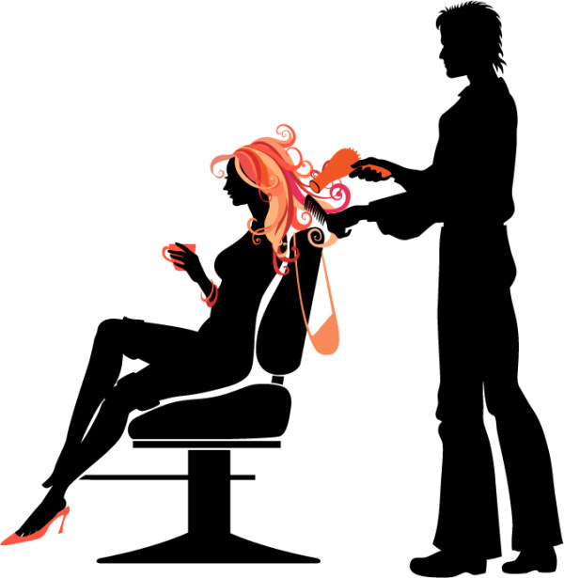Address_________________________________________________________

City_____________________________________________________________

State_____________________ Zip Code___________________________

Cell Phone_____________________ Alt Phone_____________________

Email___________________________________________________________

Address_________________________________________________________

Birthday_________________________________________________________