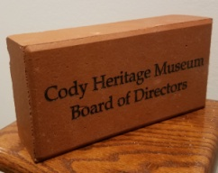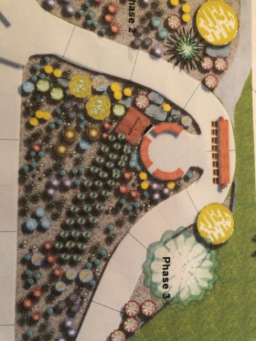

**Heritage Garden Paver Program**

Donor name ___________________________________________________ Phone ___________________________

Address __________________________________________________ Email ____________________________

Line 1 ___________________________________________________ ***[maximum 17 characters per line]***

Line 2 ___________________________________________________

Line 3 _______________________________________________ ***[Additional $10 for third line]***

Checks made payable to: **Cody Heritage Museum/Pavers (CHM/Pavers)**

If you would like to use a credit card, please complete the form online: www.codyheritagemuseum.org

**✁**

***Preliminary Heritage Garden plan***

***Please cut out and return your form/check to the Museum – or call our number if you need our assistance.***

The Cody Heritage Museum Board of Directors is in the process of building a **Heritage Garden** on the west side of the museum. The garden will be a permanent living exhibit consisting of an outdoor education area, native plants, pollinator plants, wildflowers, and grasses.

Native Elements Landscape designer Bobbie Holder has generously donated the design plans for the garden. It is a beautiful setting which will be a huge asset to Cody and to Sheridan Avenue.

A Fresno plow, 4 benches, and 4 historic wagon wheels have also been donated. The focal point of the garden will be the historic Halfway Stage Stop sign.

There is a meandering sidewalk in the garden which we would like to line with brick pavers purchased by Cody folk as a fundraiser for the **Heritage Garden**. The red pavers are a complement to the museum building. They are 4” x 8” in size and will include 2 lines of text.

The price of each brick is $225. It will be an additional $10 for a third line.

Our Cody roots run ***deep*** – please help plant ***yours*** in our garden.

With thanks,

Geri Hockhalter  
Heritage Garden Chair

 PO Box 701 Cody, Wyoming 82414 307.586.4272



[www.codyheritagemuseum.org](http://www.codyheritagemuseum.org) 1.307.586.4272 [info@codyheritagemuseum.org](mailto:info@codyheritagemuseum.org) located at 1092 Sheridan Avenue