Industrial Drug & Alcohol, Inc.

1007 E. Dominguez St. Suite# F, Carson, CA 90746

Tel: (310) 327-7680 Fax: (310) 327-7685

Office Hours: Monday-Friday 9:00 am – 6:00 pm

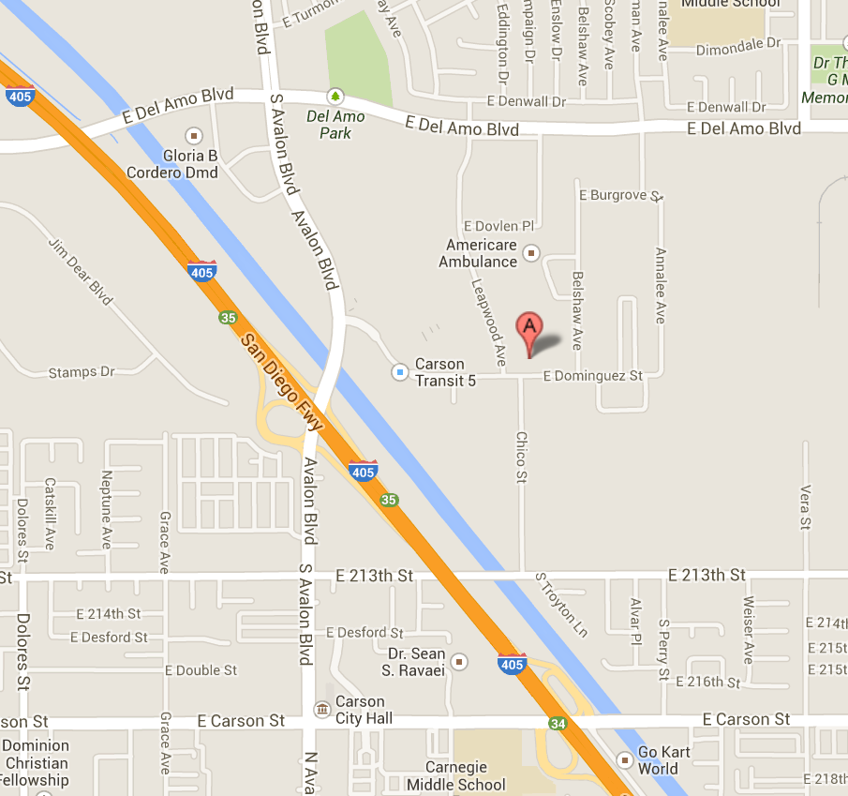

● 405 Freeway
Exit Avalon Blvd. Go North on Avalon and make a Right on Dominguez St. - Location is on Left side, directly after 24 Hour Fitness/IKEA, at corner of Leapwood Ave.
● Delamo Blvd.
Head South on Leapwood Ave. Location is on the Left side at corner of E. Dominguez St.

Industrial Drug & Alcohol, Inc.

1007 E. Dominguez St. Suite# F, Carson, CA 90746

Tel: (310) 327-7680 Fax: (310) 327-7685

Office Hours: Monday-Friday 9:00 am – 6:00 pm

Date: ______________ Time: _________________
Company/Contractor: ___________________________
Patient’s name: ______________________________
Service to be performed:
□ | DOT/Federal | □ | DOT-Like | □ | Non-DOT
□ | Drug Test
□ | Alcohol Test
□ | Consortium Membership (Random Program)
Reason for Test:
□ | Pre-employment |  |  | □ | Random
□ | Reasonable Suspicion/Cause |  |  | □ | Post Accident
□ | Return to Duty |  |  | □ | Follow-up

Special instructions/requests: _________________________________________________________________________________________________________________________________

Fax results to: _______________________________

□ | Bill Patient
□ | Bill Company (Authorized by):
Name:_______________________________________________
Signature:____________________________________________

