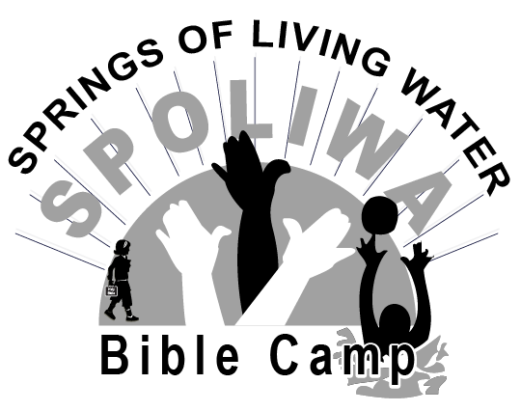
REGISTRATION FORM
Circle the week/ weeks your child plans to attend:
June 7-12 June 14-19 June 22-26

Camper’s Name: ____________________________________________
Date of Birth: ______________ Circle one: Male or Female, T-Shirt size _________
Street Address _______________________________________________________
City __________________________ State _______ Zip Code _________________
Emergency Contact + phone# ______________________________________________________________________________________________________________________________________
Parent Permissions/Authorizations
- I hereby authorize my child/children to take full part in the camping program with these exceptions:
____________________________________________________________
____________________________________________________________
____________________________________________________________
- My child/children have permission to take photos that may be used for future advertisement. Please initial: Yes _______ No _______

Parent/Guardian Signature ____________________________________________
MEDICAL FORM
The Camp’s insurance is a secondary insurance. We need the following information in case your child has an accident and needs medical treatment.

Insurer Name _____________________________________________
Insurance Company ________________________________________
Phone # or Address of Insurance company ______________________________________________________________________________________________________________________________________
Policy # _____________________________________________________
Medicaid/Medicare# __________________________________________

List any medications your child is currently taking: ____________________________________________________________________________________________________________________________________________________________________________________________________________________________________________________________________________

List any allergies your child has: _________________________________________________________________________________________________________________________________________________________________________________________________________

The following are articles you need to bring to camp. Be sure everything is marked and make a list of the things you have with you, so that you can take them home again.
- Bible
- Notebook & Pen
- Bedding for a twin bed (sleeping bag, sheet, pillow, blanket)
- Comfortable, modest summer clothing
  - No “hot pants”, tank tops or halter tops
  - Swimwear including swim shoes
  - Shower shoes
  - Sneakers/tennis shoes
  - Toothbrush, toothpaste, soap, deodorant, towels, washcloth
  - Flashlight
  - Insect repellent
- No cellphones, tablets, iPads, electronic games. See SPOLWA Bible Camp cellphone policy.

SPOLIWA Bible Camp Cellphone Policy
Our mission is to reach boys and girls with the gospel of Jesus Christ and to teach them how to live according to biblical principles. SPOLIWA Bible Camp is set apart for this purpose. Psalm 46:10 says, “Be still and know that I am God.”
That is why we are asking your help: We do not want cell phones and other electronic devices at camp.
A few things to know:
- Cell phones are not allowed. Phones remaining at camp will be kept in the office labeled by name and cabin.
- Please do not expect a text or call from your child. If your child needs to call, they can do so through the office. We will call your child and you can speak to him or her directly.
- Please call the camp (478-945-2041) We will find your child and you can speak with them. Meal times are best: 8am, 12pm, 5 pm (Regular office hours are between 8 am and 6 pm).
- Take their phone, wallet or other valuables home with you! We recognize this maybe a drastic step, but this will remove any temptation and protect the safety of your cellphone investment.
- We want you to know that we respect your God given responsibility to ensure the safety of your child and your desire to know what is going on while they are at camp. You can check our website, SPOLIWA.org to see snapshots into the week at camp!

Ronald Aaron
Ronald Aaron
Camp Director

