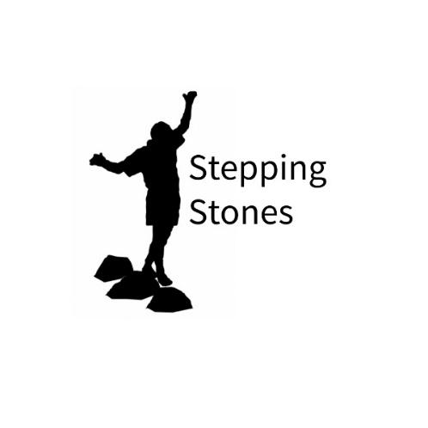 | Project Worker (Stepping Stones)  Responsible to: Connect Berwickshire Youth Project manager  Hours: 20 hours per week  Salary: £11.33 per hour with each subsequent year with 2% cost of living increase.  Status: Fixed term contract until 31st August 2024, with possibility of additional hours dependant on funding  Location: Connect Berwickshire Youth Project (Duns/Eyemouth)  Pre-Employment Checks: PVG and Satisfactory References  Closing Date: 31st July 2022
General Information
The Project Worker post is funded by The National Lottery Community Fund to deliver the Stepping Stones project in the Berwickshire area, working alongside youth work partners across the Scottish Borders.
Stepping Stones Project Worker supports young people aged 10-18 in their communities, with the aim of improving their emotional health and wellbeing, and life chances. The Project Worker will provide universal support to each young person based on their personal needs, helping them to achieve their full potential and to develop skills through non-formal education activities within a universal youth work setting.
The Project Worker will offer responsive and high-quality support young people on topics such as emotional heath, wellbeing, confidence, transition, anxiety, life-skills cyber-bullying and relationships by offering tailored one-to-one support, targeted small group sessions and activities. The project also supports young people to engage with training, volunteering, youth achievement awards, social action and joint activities with other youth groups in the Scottish Borders.
The post holder will ensure that an individual support plan is developed in partnership with each young person. Ensuring that we work closely with YouthBorders and in partnership with other local and statutory partners to ensure better outcomes for young people.

Job Description:
The successful candidate will be responsible for:
- The regular delivery of face-to-face youth work sessions during drop in sessions which are responsive to the needs of young people addressing issues around emotional health, wellbeing, and confidence building.
- Establishing, developing, and delivering a programme of innovative and engaging youth work activities on a one to one a group work basis
- Liaising and building positive working relations with our partner agencies e.g. primary and high schools, youth work provision and local community groups and signposting or referral to specialist agencies where necessary
- Developing and delivering on-line and social media opportunities for young people to learn and be supported
- Identifying developing, and managing the expansion of youth work services to meet demand and need of our young people service users
- To develop trusted relationships with parents and carers
- To ensure that individual learning plans are in place and up to date to ensure that all young people are involved in their own learning, their support plans and moving forward.
- Encouraging young people to participate in achievement activities such as Dynamic Youth, Youth Achievement and Duke of Edinburgh awards
- Participating in a range of administrative duties to ensure the effective management of the Stepping Stones project on a day to day basis. This includes keep up to date records on the projects online recording system.
- To contribute to written reports for internal trustees meetings as well as for YouthBorders through the production of accurate and detailed quarterly progress reports.
- Work closely with the other Project Workers across the localities to ensure the effective and efficient running of the project. Attending regular team meetings, participate in group communication and training/professional development.

Further Information about Stepping Stones:
This post is part of a partnership approach to youth work where young people can have support, advice and make a difference to themselves and in their communities.
Stepping Stones is developed and run by the award-winning Scottish Borders Youth Work Partnership. The Youth Work Partnership is made up of seven lead locality based universal youth groups: Beyond Earlston, Cheviot Youth, TD1 Youth Hub, Escape Youth Services, Connect Berwickshire Youth Project, Tweeddale Youth Action and Rowlands Selkirk.
For further information about Stepping Stones and the Scottish Borders Youth Work Partnership please visit YouthBorders website: Stepping Stones - YouthBorders

Person Specification
EDUCATION/QUALIFICATIONS
Essential  - Educated to SCQF Level 6 or above in Youth Work or relevant related field (e.g. education, community work, youth and childhood studies) or significant practical experience and a willingness to work towards qualification. | Desirable  - Degree level qualification in a relevant related field (e.g. education, community work, youth and childhood, health).
KNOWLEDGE
Essential  - Current issue impacting young people’s lives, wellbeing and opportunities.  - Principles and values of Youth Work  - The principles of child protection and safeguarding of children and young people.  - Awareness of the United Nations Convention on the Rights of Child. | Desirable  - Familiarity with Scotland’s Youth Work Outcomes  - An awareness and understanding of setting clear aims and objectives associated with youth service development.  - Knowledge of community-based activities for young people in the Scottish Borders.  - A specialism or interest in specific subjects or topic areas: e.g. STEM, Climate Change, Emotional Wellbeing, Health Inequalities, Alcohol, Drugs, Tobacco, Sexual Health and Relationships.
EXPERIENCE
Essential:  - A minimum of 2-year experience of working with young people in a professional, community or education setting.  - Experience of multi-agency and partnership working.  - Excellent active listening skills in a variety of settings.  - Experience of the delivery of a range of programmes and activities, face to face and online, which facilitate the personal, and educational development of young people.  - Experience in planning, delivery and monitoring and reviewing projects. | Desirable:  - Experience of working in and with community and voluntary organisations.  - Developing, supporting and leading volunteers and colleagues.  - Using digital technology to engage with young people.

SKILLS
Essential:  - Ability to initiate, develop and sustain effective relationships with young people.  - Ability to identify trusted information and provide access to information, support, and guidance to young people.  - Ability to plan, develop, implement, and monitor a learning programme with young people.  - Excellent communication skills, particularly the ability to communicate clearly and concisely to a range of audiences.  - Excellent organisational skills  - Effective time management with the ability to work under pressure.  - Good IT and digital skills | Desirable:  - Ability to assess and manage risk
PERSONAL ATTRIBUTES
Essential:
- Experience of working as a member of a team.
- Ability to motivate individuals and groups and inspire their confidence and trust.
- A tactful and diplomatic approach to dealing with sensitive and confidential information.
- Enthusiasm, commitment, and stamina.
- A flexible approach to working.
- A sense of humour.
- Resourceful.
OTHER
Essential:
- This post necessitates daytime and evening work.
- Willing to travel regionally as appropriate.
- Holder of a clean full driver’s license and with access to a car for business purposes.
- Completion of successful Protecting Vulnerable Groups (PVG) check.

For further information or informal enquiries about this role please contact David Shields david@bypconnect.com
If you'd like an application form please contact: office@bypconnect.com

