Section 105

Reimbursement for Medicare Premiums Through Employer

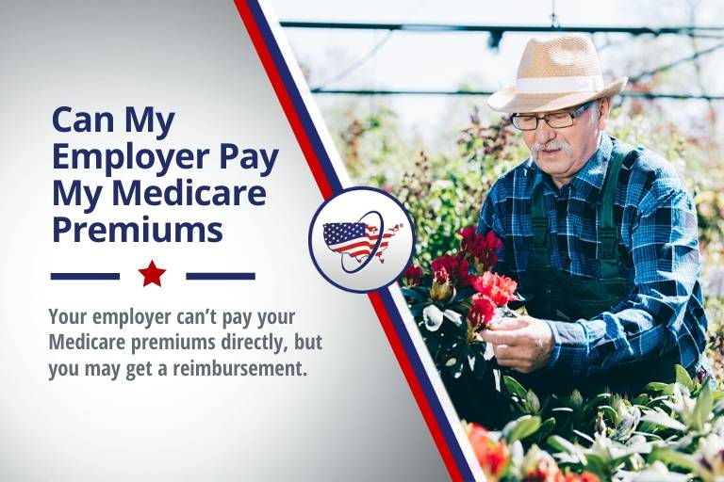

Do you ever find yourself wondering if your employer can pay for your Medicare premiums? While your employer can’t pay your premiums per se, you’ll be glad to know that they can and may reimburse you for your premium costs! To compensate you, your employer will need to create a Section 105 Medical Reimbursement Plan.
Should you even enroll in Medicare health coverage if you’re employed? If your company has less than 20 employees, Medicare will work as your primary insurance coverage when you turn 65 years old. Any employer coverage that you have will be your secondary insurance. It will only cover claims after Medicare first pays on the claims.
If the company you work for has 20 or more employees, employer coverage will work as your primary coverage, and Medicare will serve as the secondary coverage.
You could choose to pull out of your employer’s health plan and enroll in Medicare and a Medigap plan. You’ll have to heavily weigh all options, including benefits and costs associated with your employer’s health coverage versus Medicare.
Below, we’ll go over your options for being reimbursed for Medicare premiums you’ve paid out of pocket from your employer.

Medicare Premium Reimbursement with Employer Section 105 Plan
A Medicare premium reimbursement is a fantastic way for employees to receive refunds of their Medicare premiums if they’re actively working in a company.
The Part B premium will now be $144.60 in 2020, and not everyone wants to pay these costs if they have access to health care through an employer.
Often times, Medicare premiums may cost you less than costs for group insurance at your place of employment. If you prefer your Medicare coverage to your group coverage, you may be eligible to receive premium reimbursements if your company has the proper safeguards and programs in place.
Also, it’s important to keep in mind that getting reimbursed from Medicare vs. your employer are two different topics.

Section 105 Plan
A Section 105 Plan is a reimbursement health plan that lets small companies recompense employees for their medical costs on a tax-exempt basis. Although there are several different plan options, the most popular 105 program is a Health Reimbursement Arrangement plan.
A Section 105 plan can provide advantageous benefits and are prevalent in comparison to traditional group insurance. Some Section 105 plans permit reimbursements that are tax-free for any medical services that employees receive.

Medicare Premium Reimbursement Arrangement
A Medicare premium reimbursement arrangement is a system in which your employer will reimburse you for either some or all of your Medicare Part B or D premiums. As long as your employer’s payment plan ties in with the group health plan.

Employer-Sponsored Medicare Advantage Plans
Medicare Advantage plans let employers, government entities, and unions issue complete Medicare Advantage coverage to enrollees. Advantage policies can offer both Part A and B benefits and can also provide supplemental benefits above and beyond traditional benefits.

Medicare Employer Reimbursement FAQ’s
Can my employer pay my Medicare premiums?
Employers cannot pay your Medicare premiums directly. Employers can; however, designate funds for workers that can go towards health insurance coverage and premium payments with their Section 105 plan.

Can my employer pay my Medicare Part B premium?

Most companies are well aware of the high price tags associated with providing health insurance for their employees. Medicare could be a fantastic alternative and money-saver for your employer since its premiums are typically less than premiums for employer health coverage.
Naturally, it would make sense for your employer to pay for your Part B premium, right?
Well, as much as that seems like a sensible option, it’s not allowed. As a Medicare beneficiary, YOU are responsible for paying your premiums.
Although, employers do have the ability to reimburse any Medicare Part B and Part D premiums for employees who are actively working if their company’s payment plan ties in with the group insurance plan.

Can an employer pay for Medicare Supplement premiums?

Medicare Supplement coverage cannot be paid for by your employer directly. However, you can receive a refund for your monthly premiums by your employer. As stated above, your employer must have a Section 105 plan in place for employee insurance.
Part B will cover 80% of your health care expenses, but that still means that you’ll be responsible for the remaining 20%. However, if you arm yourself with enough supplemental insurance coverage, you’ll be more likely to alleviate some of those medical expenses. Health insurance through your employer could be an excellent option to help relieve these excess costs!
Your employer cannot write out a check for your Medigap coverage itself, but they CAN refund you for your monthly Medigap premiums, just so long as they arrange a Section 105 plan for their employee group.
Section 105 plans are in place to compensate employees for purchasing their health insurance plans, including Medigap and Medicare coverages.
There may be instances in which perhaps you can’t receive a refund for your Medigap premium. This doesn’t necessarily indicate that you should default to your employer’s health coverage for secondary insurance. Many times, Medicare Supplement plans prove to be less costly with a wide variety of coverages than that of an employer’s health plan.
Is employer reimbursement of Medicare premiums taxable income?
Some Section 105 plans may permit only the refunds on healthcare expenses and premiums, and the compensations aren’t taxable. If the Section 105 plan reimburses with cash for any remaining benefits, then both the money and reimbursements are taxable.
Can HRA reimburse Medicare premiums?
A Health Reimbursement Arrangement is a federally managed employer health plan. HRA plans permit enrollees to get reimbursement for their out-of-pocket health care costs.
Employers completely fund HRAs and are typically tax-exempt from Social Security, state, and federal taxes. HRAs can cover just insurance premiums, or they can also cover expenses and your premiums.
Can an employer reimburse an employee for Medicare premiums?

Employers can’t pay for your premiums directly, but you may receive a refund for the premium payments you’ve paid. Your employer must also have a Section 105 Plan that they can set aside funds to help pay for employee’s insurance premiums.
Can my employer reimburse me for my Part B premium?

Yes, as state previously your employer can refund you for your Part B premium if you’re employer has set up a Section 105 Medical Reimbursement Plan.
Can an employer force me to take Medicare?

Employers cannot force you to enroll in Medicare coverage if you choose not to do so. Employers cannot offer fewer health benefits to anyone who qualifies for Medicare. Legally, your employer cannot provide incentives or money to you if you choose Medicare over their employee insurance plan.

