The Band Director’s Notebook

Volume 4, Issue 1 Fall 2007

Continuing Education Courses for Music Teachers
HSBDNA Offers On Line National Accredited Professional Development for Music Teachers
The HSBDNA has formed a partnership with Columbus State University (Georgia) to offer Continuing Education Hours for music teachers. Through our unique academic structure, music teachers now have an opportunity to take courses on line and have an opportunity to keep their teaching certificate renewed.
Courses Can Be Completed On Line In 2-4 Days & Are Nationally Certified
Each course is specially designed for music teachers by music teachers. “The idea came to me several years ago when I found little or no opportunities for music teachers to take courses for development that actually pertained to music. As a music teacher I always had to take courses out of my field or pretty much generic education courses. These generic courses were selected by our school system professional development coordinator and were usually of no interest to our band directors”, stated Oliver Boone. “With the HSBDNA Continuing Education courses, now band directors and music teachers have a choice to take courses for development which interest them and correlate to those activities they are doing in their classroom”, stated Boone.
Each course is priced at $50 and is coordinated to music education principles. All courses are nationally certified and completed on line at the teachers’ convenience. Teachers can visit www.HSBDNA.com to register for any course.
HSBDNA Begins National Advertising Campaign
In just over two years the HSBDNA has emerged into a respected organization for band education. Through its multi websites (www.HSBDNA.com & www.CIMF.org;) the HSBDNA has entertained on average over 45,000 visitors per year.
Now the HSBDNA is announcing its national advertising campaign for its multi websites. The HSBDNA is selling advertizing space to sponsors and vendors through www.HSBDNA.com.
Vendors and sponsors pay for space on the sites for a monthly fee. All proceeds fund the HSBDNA and its divisions.
Full Banner Space=$100 month
½ Banner Space=$50 month
¼ Banner Space=$25 per month
Contact HSBDNA at 706-323-4649 or 706-570-9007
HSBDNA Number One on Google
Our name is getting attention. Just click on one of America’s favorite search engines and see if we pop up. Since our inception in 2005, the HSBDNA has grown to becoming a national leader and authority in band education. Visit us today at :
www.HSBDNA.com

Sousa Reenactment Concert to Benefit Hall of Fame
April 5, 2008 marks the celebration for the Induction Ceremony for the Class of 2008 for the National High School Band Director’s Hall of Fame. This year there will be a different flavor in the celebration.
A John Philip Sousa Reenactment Concert will be presented at the world famous Springer Opera House in Columbus, Georgia. Sousa performed twice on the stage of the famous site and together with the City of Columbus, the HSBDNA hopes to recreate a little bit of history.
The Bob Barr Community Band, under the direction of George Corradino, will play the role of the famous Sousa Band while Dr. Corradino portrays the great band leader. The concert will serve as the Official Induction Ceremony for the newly installed members of the National High School Band Director’s Hall of Fame.

Springer Opera House
Working with the Tourism Division of the City of Columbus, Georgia, the HSBDNA plans to invite five prominent bands to the area to perform a concert on the Springer stage. The concerts will be held during the day with the Sousa Concert held in the evening culminating the grand event.

Sousa Portrayed by Corradino on April 5, 2008
Interested in playing at the event? Contact us 706-570-9007.

HSBDNA Begins 2008 Membership Drive
Goal is 250 new members for the year
Membership Dues are $25 Per Year
Members receive unique benefits by joining the HSBDNA. As the nation’s largest organization specifically designed for high school band directors, members have a network of directors across the nation to receive current trends and issues focusing on wind instrumental music education. Through our offerings, members have access to music education research journals from the Band Director’s Notebook and our web site. HSBDNA Members also receive discounts on professional development courses through our Continuing Education Program.
HSBDNA Gaining Influence With Educational Leaders
The HSBDNA is being sought by educational and community leaders for obtaining professional authority on issues dealing with band education fiscal and personnel issues. The HSBDNA has been sought after by various leaders seeking our advice for school systems seeking additional band personnel for their program.

The HSBDNA offers professional assistance to leaders through our research to various groups seeking music education leadership advice. The HSBDNA has on its staff a team of professional music education leaders, many of those who have served as principals or central office staff members in various school systems. The HSBDNA was able to provide leadership in areas of justification for the hiring of additional band personnel. Additionally, the HSBDNA was sought for advice on a salary negotiation.
“We have at our disposal a team of professionals who have served as music teachers and school level or school system educational leaders”, stated George Corradino. “Educational and community leaders across the nation are discovering the HSBDNA as a voice of authority when it comes to band”.
To learn more about joining the HSBDNA, visit our web site at www.HSBDNA.com .

HSBDNA
is Gaining Influence
with
Educational Leaders
Across the Nation

Silver R.O.L.M. Music Company
New Band Literature for the Concert Band. Selections from Beginner to Level Four….Novelty & Marches
Call us today at 706-570-9007

continued on page 2

Inside This Issue
1 | Continuing Education Courses for Music Teachers
1 | HSBDNA Begins 2008 Membership Drive
2 | HSBDNA Begins National Advertising Campaign
2 | A Sousa Reenactment Concert
2 | Hall of Fame News
3 | Spotlight on John M. Long
continued on page 3

continued from page 1


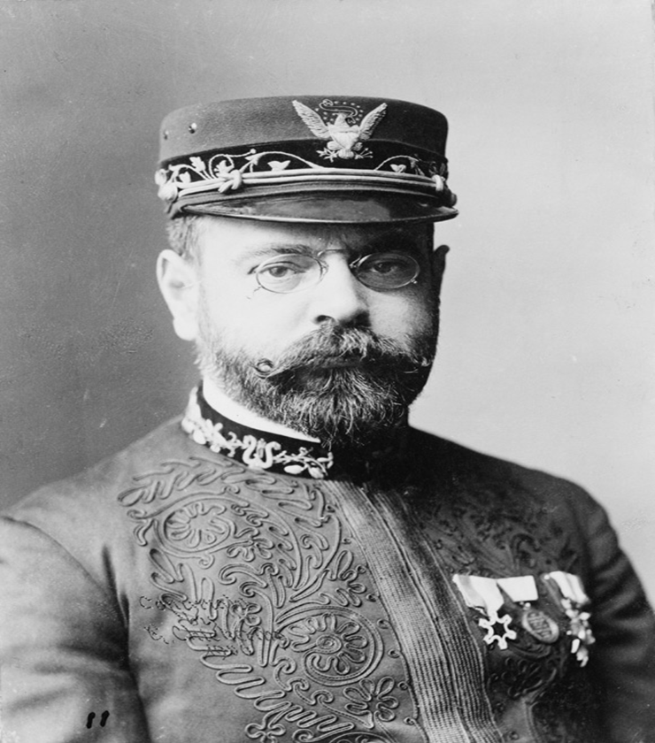
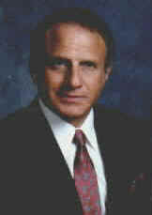

Spotlight on John M. Long
a legend in the Band World
At the age of 82, he has not missed a beat. The man who organized the famous Robert E. Lee High School (Montgomery, Alabama) in 1956 and led them to win in four national championships is a legendary figure in the band world.

Although his contribution at Lee High School is exceptional, Dr. John M. Long is more known for his work at Troy University as the Director Emeritus of the nationally known “Sound of the South” Troy University Band.

Presently retired, John Long has not stopped. His current office located on the campus of Troy University in Long, Adams, Hawkins Hall of Honor stands directly next to the John Maloy Long Hall for band. Both buildings are named in his honor.

When Long was recruited in 1965 by then Troy President, Ralph Adams, perhaps neither one of them knew what events would unfold for Troy University and the profession of band education. John M. Long has trained more high school band directors than any other educator in the nation. He is directly responsible for the success of thousands of young men and women through his love for band and music.

At the date of his retirement in 1997, John M. Long had served as the Director of Bands at Troy University for 32 years. Additionally he also served as Dean of Arts & Sciences and Dean of Fine Arts. Under his direction the Troy Band performed at such prestigious events as the American Bandmasters Association, the College Bandmasters National Association, and the Presidential Inaugural Parade.

Dr. John M. Long

continued from page 1

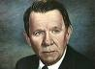

John M. Long would serve as President of the American
Bandmasters Association in 1979. He organized the
(Continued on page 4)
Southeastern United States Band Clinic in Troy-an event held annually honoring directors, bands and alumni.

Dr. John M. Long is not only respected for his musical accomplishments, but the manner in which he relates to his students. “I have learned so much from all of my folks”, states Long. “They have taught me much more than I have taught them”. Johnny Long has always had time to talk to students, parents, directors, etc. “He loves people”, stated Harold Blankenship, now director of the Huntingdon College Band (Alabama).

Johnny Long has always had time to talk to students, parents, directors,…………………………

Often sought as a clinician, adjudicator and guest conductor, Dr. John M. Long is a living legend in the arena of band education. More than 500 band alumni paid tribute to him on his retirement with a performance during the 1997 Homecoming football game. A bronze bust likeness was presented to Long during the ceremony. The bust stands proudly in the Long, Adams, Hawkins Hall of Honor today. Along side the artifact is hundreds of other exhibits honoring the members of the National Band Association Hall of Fame for Distinguished Band Conductors. Long is a member of this prestigious organization. Additionally, he was named a member of the National High School Band Director’s Hall of Fame located in Georgia.

Long receives HS Band Director’s Hall of Fame honor from Dr. Oliver Boone
“I just want to be remembered as a teacher who made a difference”, states Long. “He stays in contact with me all the time. It is so good to hear from him”, stated Oliver Boone, President of the HSBDNA. “He always has so much encouragement and praise for his folks. He makes us feel 10 feet tall every time he calls”.

In 1996, Assistant Director of Bands and Music Arranger Ralph Ford served as the interim director of the marching band during Dr. John Long's last year as Director of Bands. In 1997, the baton was passed to popular band composer and TSU alumnus Robert W. Smith.

In 1998, the Troy State University Board of Trustees and Chancellor Jack Hawkins, Jr. named the Troy University School of Music the John M. Long School of Music. Dr. Long continues to serve the band program today as a distinguished professor of music and Director Emeritus.

His office is laced with artifacts and pictures from United States Presidents, Senators, Members of Congress, Governors, etc. Oh and by the way, you will find plenty of pictures of his students and friends. “He is a friend, a mentor, “stated Boone who served under Long from 1974-1979. Former students and band director Roland Ventura perhaps stated it best when he described Long as. “the Great One”.

“Don’t be surprised when you hear the phone ring if it is Johnny calling to say hello”, says Frank Butenschon. “He cares more than anybody. He is the genuine article”.

Long at 2007 Troy Homecoming

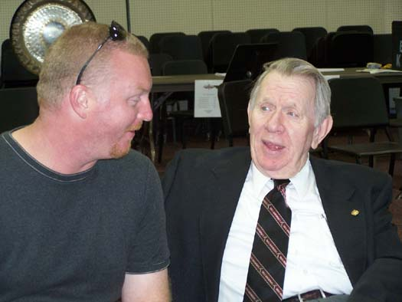
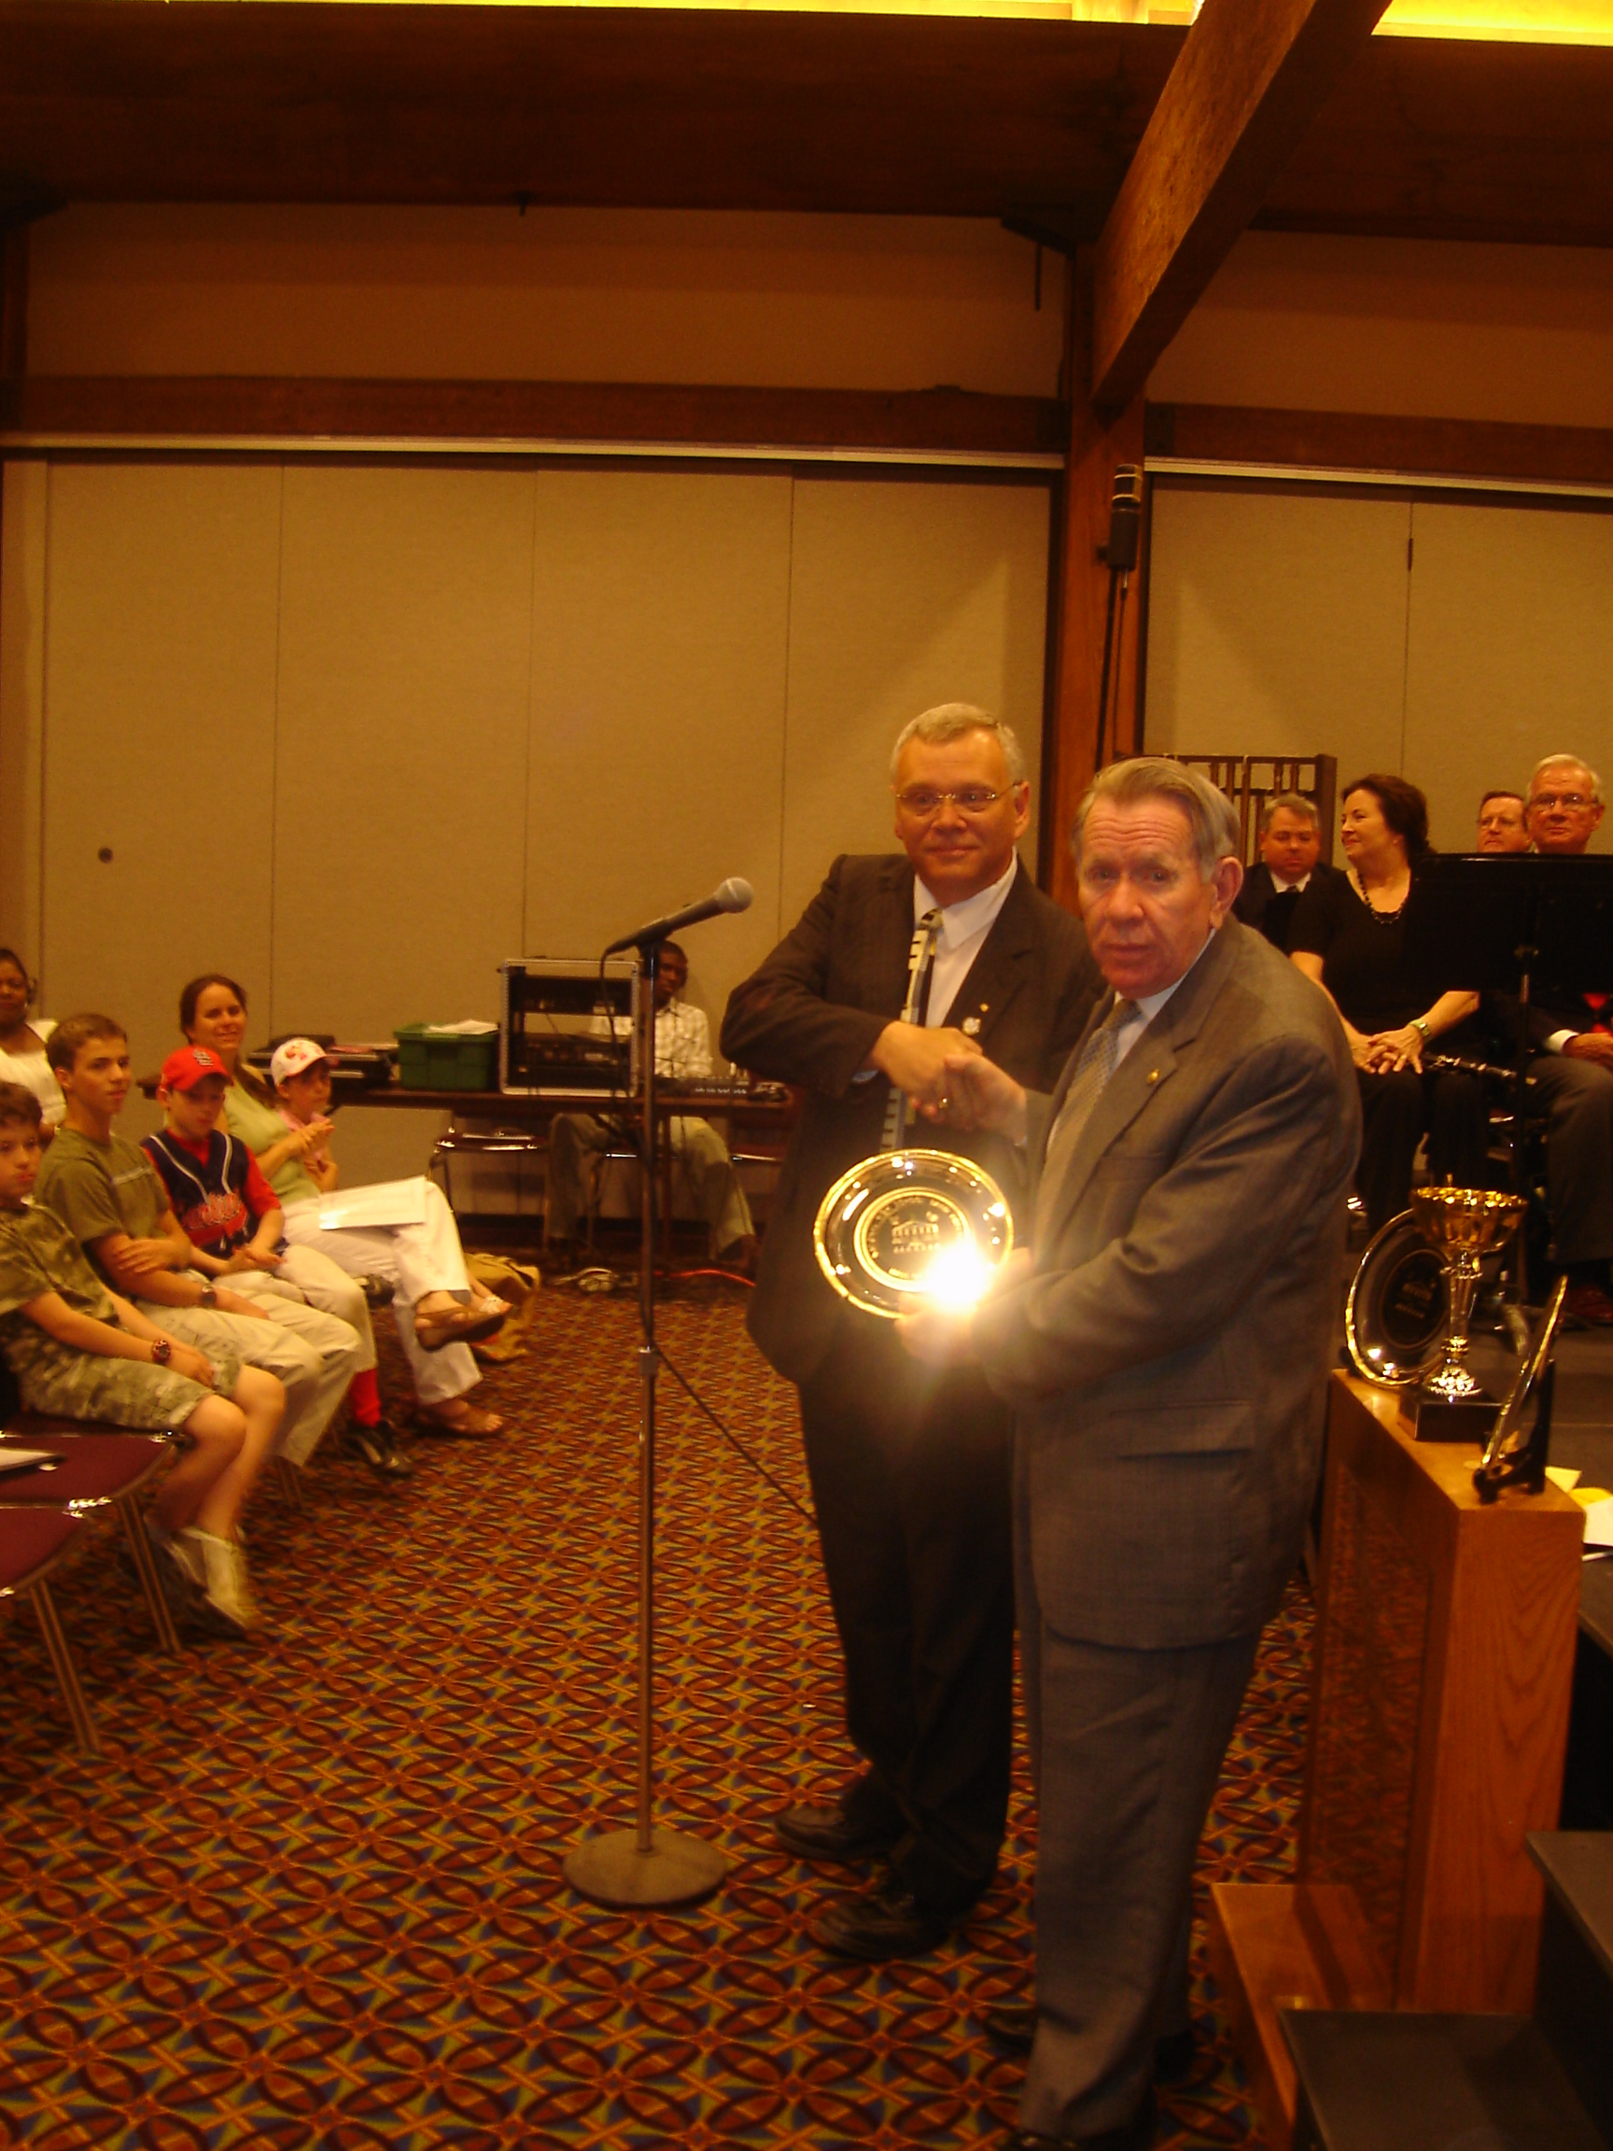
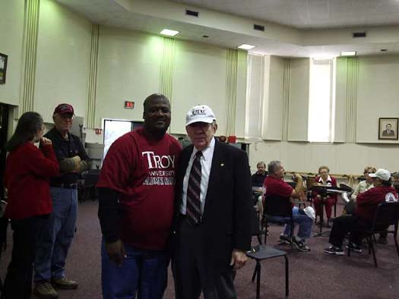

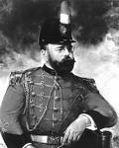

And other great band leaders including:

- Cliff Bainum
- Patrick Conway
- Henry Fillmore
- W. C. Handy
- Karl King
- Archie McAllister
- Paul Yoder
- and others

All band leaders in character are members of the
National High School Band Director’s Hall of Fame.
April 5, 2008

Springer Opera House
Columbus, Georgia

Tickets are $10 each

Proceeds to benefit the High School Band Directors National Association Foundation to benefit school bands and band students in educational need.

April 5, 2008
Springer Opera House

The HSBDNA
Seeks Outstanding High School & Middle School Bands for Honor Concert
In conjunction with the
HSBDNA Band Hall of Fame Induction Ceremony
and the
Sousa Reenactment Concert
Featuring George Corradino & the Bob Barr Community Band

Selected bands will receive :
- Up to $500 for travel reimbursement
- Participation Trophy
- Individual Student Medals
- C D Recording of Performance
- $500 Scholarship (at participating University/College) for one potential Wind Instrumental Music Education Major

Send your audition tape today to:

Dr. Oliver Boone, Director
HSBDNA
P. O. Box 886
Fortson, GA 31808

Deadline is February 15, 2008

www.hsbdna.com or www.cbusmusicfest.org
Dr. Oliver C. Boone, Director
Dr. George R. Corradino, Deputy Director

Divisions of the High School Band Director’s National Association

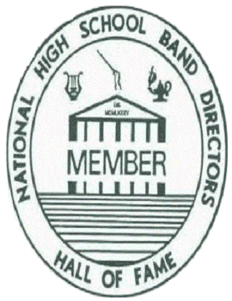
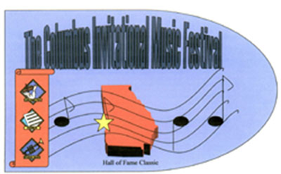
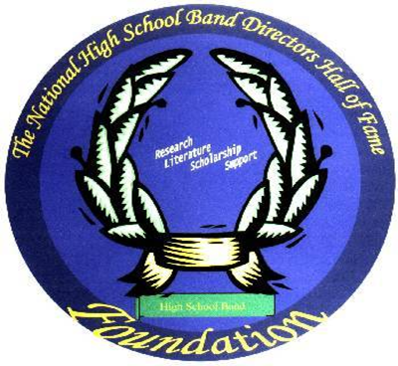

Continuing Education Program
Dr. Oliver C. Boone, Executive Director
Dr. George Corradino, Deputy Director

Board Members

Harold Blankenship
Will Boartfield
Frank Butenschon
Thomas Childers
Vincent Rosse

Governors

Charles Bullard
Chad Deal
James Kusserow
Roland Ventura

HSBDNA is a Non-Profit Organization
501 ( c ) 3 Tax Exempt

Funded by Charitable Donations

