The National High School Marching and Concert Bands
High School Band Director’s National Association
2018-2019
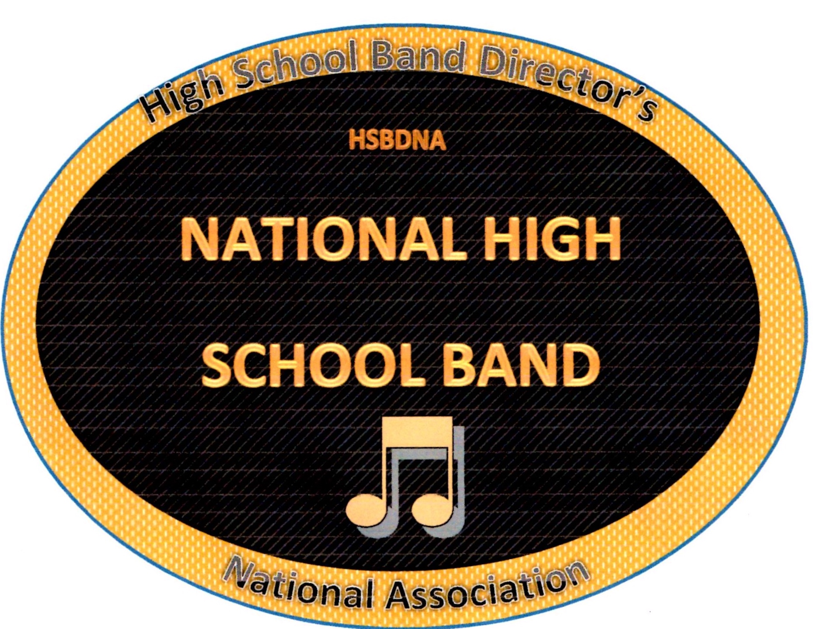

NOMINATION FORM
Student Name __________________________________________________Date _________
School ________________________________________________________
School Address _________________________________________________
Band (Please check) Marching Band Concert Band
Instrument (Please check using menu below)
MARCHING BAND | INSTRUMENT |  | CONCERT BAND | INSTRUMENT
Flute |  |  | Piccolo
Bb Clarinet |  |  | Flute
Eb Alto Saxophone |  |  | Bb Clarinet
Bb Tenor Saxophone |  |  | Bass Clarinet
Mellophone |  |  | Contra Bass
Trumpet/Cornet |  |  | Oboe
Trombone |  |  | Bassoon
Baritone |  |  | Eb Alto Saxophone
Tuba |  |  | Bb Tenor Saxophone
Percussion |  |  | Bari Saxophone
Guard/Majorette |  |  | French Horn
Drum Major |  |  | Trumpet/Cornet
 |  |  | Trombone
 |  |  | Baritone
 |  |  | Tuba
 |  |  | Percussion
Permission Statement
My signature below verifies my nomination for the named student(s) {Nomination Form} to be considered for the HSBDNA National High School Concert and or Marching Band. I verify I am the band director for the named school and understand my application fee of $25.00 maintains my membership into the High School Band Director’s National Association (HSBDNA) for a one year period. Confirmation of the signatures below grants permission to the HSBDNA for the stated students to have their name, picture, director and school posted on the www.hsbdna.org website and the manuscript publication compiling selected members to the HSBDNA National High School Concert and or Marching Band.
Band Director (Print Name) ________________________ Signature _____________________
Principal __________________________ Parent/ Guardian ___________________________
Each student requires their own separate form.

