One More Time
The Legend….My Mentor…My Friend
Dr. John M. Long

By Oliver C, Boone, Ph.D.
They appeared to be frozen. Their feet were spread and the shoulders rigid. Yet the air stood still and the temperature moderate for a 1964 Fall evening in Montgomery, Alabama. They stared out from the end zone of Crampton Bowl waiting for their opportunity. None of them moved. To this wide eyed eight year boy they were amazing to watch. I could not take my eyes off of them. I remember that my Dad and I were wondering if they would move before it was their time to perform. They did not move until the half time started. Then they took over the field and would change my life.
The Robert E. Lee High School Band of Montgomery was under the direction of Mr. John M. Long. The school was opened in 1955 and Mr. Long would serve as the first band director. In the ten years he would lead the Lee Band of Montgomery, he would preserve a legacy. Mr. Long would lead the Lee Band to win in four national competitions. Always demanding music quality and perfection, Mr. Long, would never apologize for being challenging and firm. “Anybody can do it wrong”, he would tell his students and the quality would show. The entire city knew of the success of the Lee Band. Their reputation had spread across the state as well as the nation and I knew someday I had to be a part of the best high school band in the land.
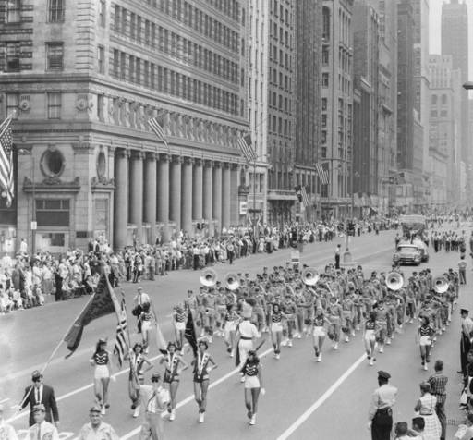
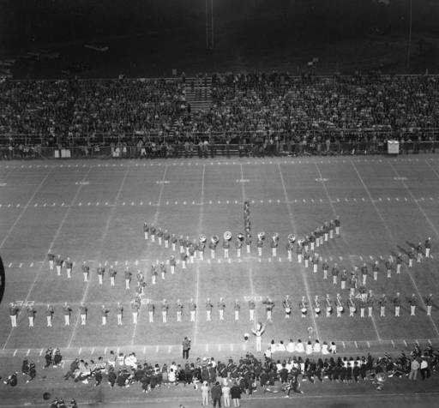

Robert E. Lee High School Band Performs in Montgomery, Alabama Crampton Bowl October 2, 1958 Robert E. Lee Band Performing in the Lions Club Parade in Downtown Chicago, Illinois September 9, 1958

I started Trumpet at Capitol Heights Junior High School under Mr. George Printz in 1968. I was too late to join Mr. Long at Lee. In 1965 he left Montgomery to become the band director of Troy State College. This had not discouraged me as I was hooked….I had to be in the band. After three years of Junior High, I was finally able to join the high school band. My enthusiasm would have to take a back seat as the City of Montgomery School System had established school districts and I lived in the district of the new school, Jefferson Davis. While the Jeff Davis Band had a fantastic director, I was unwavering in my wanting to be in the Lee Band, whether if Mr. Long was there or not. The seed had been planted years before through the eyes of a third grader, and now was my chance. My parents sold their house and moved into the Lee district.
The band director at Lee High School in 1971 was Mr. Thomas Borden. He became the director after Mr. Long had departed for Troy. A former student of Mr. Long, Tom Borden was a magnificent teacher. I stood in awe of him and respected him unquestionably. In 1974, I would make the Alabama All State Band and credit Mr. Borden with the mastery of this accomplishment. Graduation was calling soon and I knew what I wanted to do with my life. Shaped in part by the musicianship of Tom Borden and the pageantry of years long before me, I must seek out the man who had forged the path of that great band I had seen.
I entered Troy State University in the fall of 1974. I recall vividly the first encounter I had with the great man. Mr. Long was now….Dr. Long. His Alma Mater, Jacksonville State University, had decreed the Honorary Doctorate to him in 1971. He had long been making a reputation of superior quality to Troy State University. The Troy State Band had marched in the Presidential Inaugural Parade in 1972 and, of course, I had watched the parade on television while anxiously waiting my turn to be a part of the glory and honor. Troy State University had named Dr. Long as the Dean of Fine Arts and later the Dean of Arts and Sciences and now I had to meet the legend.
I walked into the foyer of his office at Smith Hall on the Troy campus. Expecting to attempt begging the secretary to let me have a word with him, there he was leaning over the desk, talking to his secretary. He quickly stood up and called my name (which he had read from my new student badge). “Oliver, how are you? Welcome to Troy and welcome to the band”. He shook my hand. The moment was magical.
During my years of membership with the Troy State University Band were among the most extraordinary events of my life. Every band rehearsal was not only a practice of music and obtaining perfection, it was also a lesson in life qualities. I listened to Dr. Long’s lessons. I watched his gestures. I admired his emotion. Again I was wide eyed and taking in his knowledge like a sponge takes in water.
His life lessons were not in long and boring speeches but more of short statements about being successful, not only in class but in life as well. They would possess a colorful charm and humor while hitting straight to the point he was making. Dr. Long’s short and brief statements would soon take on a name. Instead of the term colloquialism, they would become known as ‘Longisms’

.
“I was trying to get somewhere today, and I ran into a brick wall” Dr. Long would tell us. “I tried to get around the wall and could not. I tried to go over the wall and could not climb it. I got a running start and tried to knock it down. The wall did not move. Then I found a door and went through”. It would take me several years to completely understand what he meant. Upon the first year of my teaching career as a band director, I would encounter numerous walls. For whatever reason, I could not make that wall move. It was determined to keep me from going forward. Suddenly, a compromise would emerge when I reached out to all parties involved with the wall and sought a door to pass through.

“Everybody is looking for someone to be the head of General Motors. Do you want the responsibility? I say, be the leader….”, Dr. Long would bellow at us while we were in serious quest of air after we had played the entire show for the fourth time…only to be followed by his words…”One more time gang, one more time.” (There were several One More Times)

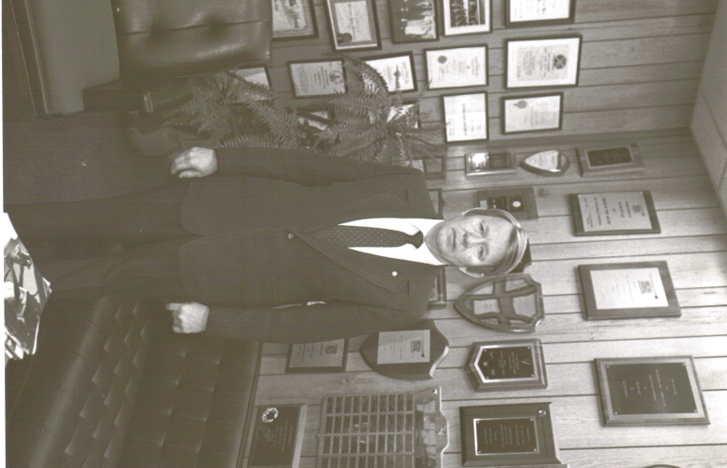
Of the entire favorite ‘Longism’s” I would hear, one would ring true even today….more than forty years after hearing it for the first time. “When you get to be my age your salary will be a $100,000.00”, he would say. (Obviously this got everyone’s attention as most first year teachers were expected to make a tenth of this in their first professional year) Then Dr. Long’s closing comment which was so specifically timed for effectiveness. “But a loaf of bread will cost you ten bucks”.
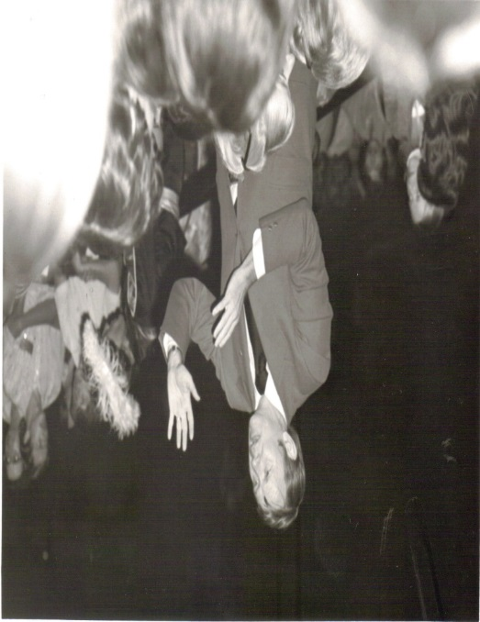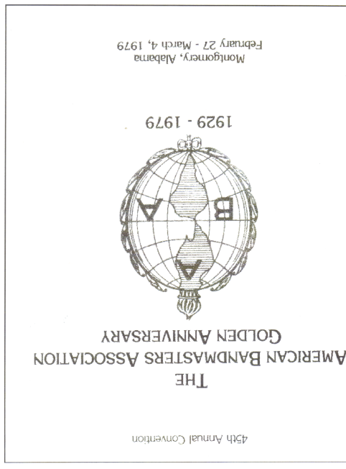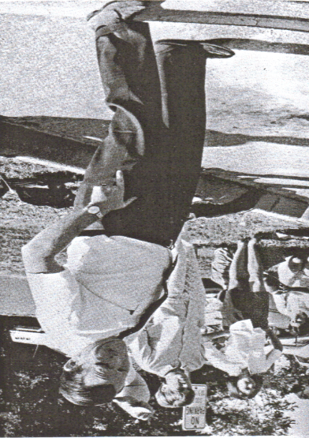
Dr. Long conducting his favorite march, “The Stars and Stripes Forever” Program from the first of two performances for the American Bandmasters Association Always Demanded Perfection

Those brief life lessons, along with the teaching of quality and challenging music, and flavored with the role of being an outstanding role model to literally thousands of young people…..the man is remarkable. During my years of being in his band, Dr. Long had the gift of making you feel ten feet tall…..but never lose focus because there was no crack in the floor small enough to keep you from wanting to crawl in. He demanded perfection while demonstrating his love for each of us.
While at Troy State University, Dr. Long would bring in Visiting Professors of notability to work with the band students. Among these notable professors would include, Dr. Paul Yoder (founding Father of the Japanese Movement); Colonel George Howard (former Conductor of the U.S. Air Force Band); and Sir Vivian Dunn (former Conductor of the British Royal Marines in London). Students were always exposed to playing under the baton of not only these outstanding conductors; but, numerous members of the American Bandmaster’s Association. Dr. Long was a member of the American Bandmasters Association (most prestigious band organization in the world) and would serve as its President. In 1979, the Troy State Band played in the American Bandmaster’s Association Convention in Montgomery, Alabama. What a proud moment it was for me to play under the baton of Dr. William Revelli (Director Emeritus of the famed University of Michigan Band) and Dr. Al Wright (Director of the Purdue University Bands).
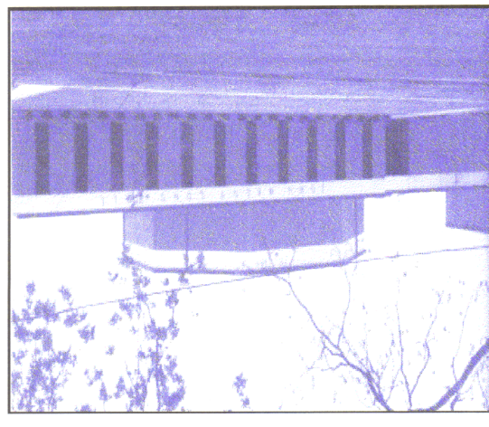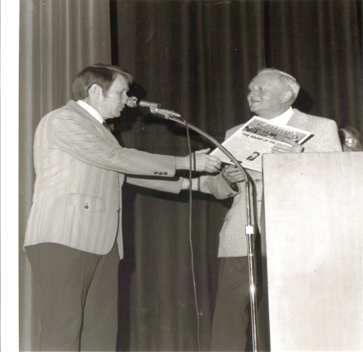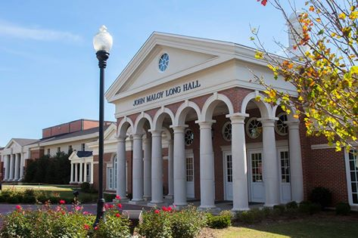
John Maloy Long Hall Band Building (Original) Dr. Long with Dr. Paul Yoder Current John Maloy Long Hall housing John M. Long School of Music
Finally, I had caught up with the legend. I was embraced. I was captivated. I was learning. I was being shaped into a man. In addition to my parents, there have been many people who have provided guidance and influence over my life…….John M. Long holds a strong influence…..and I thank you Sir!
It has been said that a teacher merely lights a candle and passes it on. The flame is passed from one to another…..spreading the message….a message of life and how to model that life to others. Accepting responsibility and leadership while never allowing our feet to leave the ground. As the legend Dr. Long always told us, “If you can put your hand in a bucket, pull it out, and leave a hole….then you are an exception. Otherwise, you are like everybody else”.
Many days have passed since that day I saw those band students of the Lee band standing frozen in the end zone of Crampton Bowl….knowing that someone was watching. I was watching. Others were too. I chased that dream to the finish line only to find that I had obtained those life lessons to shape me not only as a teacher, but a man as well.
Dr. Long, you have passed the candle to others and helped spread the light of band education in our nation. As of this writing, the legend is 93 years old. He telephones me consistently. He always asks how my wife and children are doing. He asks how I am doing. Then he wants to know if there is anything he can do for me…..
I know sir….let’s do it one more time.

Dr. Oliver C. Boone is a professor of music literature. Having enjoyed a multiple year career as a high school band director, he served as a public school principal and is a former Dean of Academics for a collegiate institution. He is the author of “Sixty Years of Sound”, A History of the Troy State University Band 1937-1997. He served as the Captain of the Troy State University Band from 1978-1980

References
Montgomery, Alabama Archives; http:www.archives.alabama.gov/reference/reproduction_order.pdf; 1958; Photo: John E. Scott
“Sixty Years of Sound”, A History of the Troy State University Band 1937-1997; Boone, Oliver; 2012; ISBN 978-0-615-66289-3; Diggypod
Personal Artifacts

