Greater Wyoming Valley Audubon Society
Bird Seed Fundraiser
(Now through September 30, 2022)

Proceeds Benefit the Greater Wyoming Valley Audubon Society and Nature Programs.

Wild Birds Unlimited Nature Shop is happy to support the Greater Wyoming Valley Audubon Society and offer to you the best bird seed you can buy! WBU Seed Blends are designed to attract the broadest assortment of birds to your bird feeders. There is no filler in our bird seed blends to waste your money…

At Wild Birds Unlimited YOU get what the birds want to eat and the freshest seed you can buy.
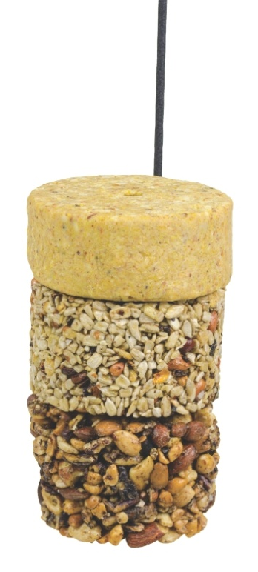
All orders are due by September 30, 2022.

SEED FUNDRAISER - Seed Order Pickup
Friday, October 14 from 10:00 am – 7:00 pm
Saturday, October 15 10 from 10:00 am – 7:00 pm
Sunday, October 16 from 11:00 am – 3:00 pm

WITH A PURCHASE OF $20 OR MORE RECEIVE
FREE FLYING START COMBO
This includes Flying Start Pin Feeder along with 3 stackable
(Naturally Nuts, Nutty for Nuts & No Mess)
A $14.97 Value!

Make checks payable to GWVAS

Please mail or drop off your order form with check at:
Wild Birds Unlimited
50 ½ Dallas Shopping Center
Dallas, PA 18612

Feel free to call Wild Birds Unlimited should you have any questions at 570-675-9900.

Thank You for Supporting GWVAS with your order!

GWVAS Fundraiser Order Form

Name: _____________________________________

Address: ____________________________________

____________________________________

Phone#: ____________________________________

Seed Type | Bag  Size | GWVAS  Price | Number to Pickup | Number on Storage* | Total Quantity | Total Amount
Deluxe LM Seed Blend – Black oil, safflower, striped sunflower, millet (Great for classic style feeders) | 20 lb | $25.99
Choice Blend – Black oil, sunflower chips, peanuts, striped sunflower and safflower (Best for tube feeders) | 20 lb | $30.99
No-Mess-No Millet Blend – Sunflower chips, chopped tree nuts, peanuts (No shells = 100% edible!) | 20 lb | $36.99
Safflower (NOT a favorite of squirrels) | 20 lb | $27.99
Black Oil Sunflower | 20 lb | $24.99
Nyjer/Thistle (loved by all Finches) | 5 lb | $12.99
Add PA Sales Tax 6%
GRAND TOTAL

