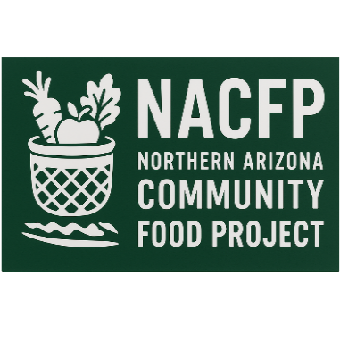

BEYOND ALICE
Building Environments Yielding, Opportunity, Nutrition, and Dignity
Asset Limited Income Constrained, Employed
Core Concept: The Food Insecurity Cycle
Food insecurity is not a single condition, but a cycle:
Deviation → Distress → Behavioral Barriers → Health & Social Outcomes → Time-to-Impact
An analysis of systemic barriers to nutrition experienced by unique populations
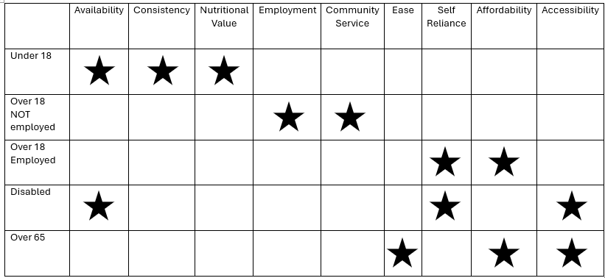

This report presents a behavioral and environmental framework for understanding food insecurity across diverse populations in Southern Apache County.
Evaluation criteria
Deviation (from Norms):
What environmental hurdles to basic nutrition?
Distress:
What emotional stress impedes basic nutrition?
Behavioral Barriers:
What behavior impedes basic nutrition?
Health & Social Outcomes:
What Health & Social Outcomes derive from poor nutrition?
Time-to-Impact
What is the timeline of food insecurity?
Saint Johns, Apache County, AZ
*Under 18 – Availability, Consistency, Nutritional Value
*Over 18 Unemployed – Employment, Community Service
*Over 18 Employed – Affordability, Self-Reliance
*Disabled – Affordability, Accessibility, Self-Reliance
*Over 65 – Affordability, Accessibility, Ease
Under 18 – Availability, Consistency, Nutritional Value

Availability
Deviation (from Norms):
What environmental hurdles to the availability of basic nutrition?
Availability to nutrition is typically impeded by guardians’ finances, transportation and behavior, which is often exacerbated mental health, substance use, incarceration or homelessness.
Distress:
What emotional stress impedes the availability of basic nutrition?
Minors are typically willing to accept nutrition and react positively with little distress to the transaction.

Behavioral Barriers:
What behavior impedes the availability of basic nutrition?
Minors often lack the cognitive framework to evaluate nutritional value, making them more susceptible to the appeal of ultra-processed foods. However, this is not necessarily a hurdle as they will accept nutritional food for reasons not related to aesthetics.

Health & Social Outcomes:
What Health & Social Outcomes derive from the availability of poor nutrition?
Three (3) weeks of malnutrition leads to impairment of decision making, establishing/re-enforcing negative eating habits and Food Grief. Food Grief is a mental health–driven feedback loop condition when a person does not have or expect to acquire proper nutrition -due to lack of consistent nutrition.
Time-to-Impact
What is the timeline for the availability of food?
Minors enrolled in educational systems that provide nutrition are less likely to suffer systemic food insecurity than off-grid, home-schooled or unenrolled minors.

Consistency
Deviation (from Norms):
What are environmental hurdles to the consistency of basic nutrition?
Guardian may have inadequate food preparation skills or equipment to safely keep, prepare and serve nutritious food.
Distress:
What emotional stress impedes the consistency of basic nutrition?
Minors experiencing Food Grief can result in coping mechanisms that can exacerbate emotional distress into deviant behaviors that can include food hording, eating disorders and shame.
Behavioral Barriers:
What behavior impedes the consistency of basic nutrition?
Parental neglect in many forms; hyper-distraction, poor boundary setting with children, substance abuse. Often out of self-preservation these children become the voice of reason in the child-parent relationship.
Health & Social Outcomes:
What Health & Social Outcomes derive from the consistency of poor nutrition?
Children who suffer from Malnutrition experience learning deficit due to poor nutrition. Children who experience Food Grief may develop unhealthy coping mechanisms -this can persist their entire life.
Time-to-Impact
What is the timeline of food consistency ?
The effects of malnutrition take only weeks to manifest and may impact on the child well into adulthood.

Nutritional Value
Deviation (from Norms):
What are the environmental hurdles to acquiring nutritious food?
Children are subject to their guardian’s ability to identify, purchase, prepare and serve healthy food options
Distress:
What emotional stress impedes acquiring basic nutrition?
Fear of environment or food insecurity, intimidated by brands they believe they cannot afford and shame associated with using SNAP or public resources.
Behavioral Barriers:
What behavior impedes acquiring basic nutrition?
Poor eating habits, irregular meal times, picky eating habits
Health & Social Outcomes:
What Health & Social Outcomes derive from poor nutrition?
Cognitive impairment, emotional well-being and physical health are all at risk.

Time-to-Impact
What is the timeline for nutritional food insecurity?
Children who consume ultra-processed food instead of a balanced diet can experience Food Grief and the effects of malnutrition.

Under 18 (Youth)
Children experience food insecurity primarily through dependency on guardians and systems. Barriers are driven by household instability, limited food knowledge, and inconsistent access to nutritious meals. While children are generally willing to accept food, prolonged instability can lead to Food Grief, cognitive impacts, and lifelong unhealthy eating behaviors. Early intervention is critical, as negative effects can emerge within weeks and persist into adulthood.
Actions to Assist
Focus: Availability, Consistency, Nutritional Value
Key Strategy: Stabilize access and normalize healthy nutrition early.
Suggested Actions:
- School & Youth Partnerships
  - Expand in-school and after-school nutrition programs
  - Target off-grid, homeschooled, and unenrolled youth populations
- Guardian Support Programs
  - Offer simple cooking, storage, and meal planning workshops
  - Provide ready-to-prepare meal kits with instructions
- Youth Nutrition Education
  - Hands-on food experiences (taste tests, cooking demos)
  - Normalize whole foods over ultra-processed options
- Consistency Programs
  - Weekly or bi-weekly youth-focused food boxes
  - Backpack programs or youth meal continuity kits
Goal: Prevent early onset of Food Grief and lifelong negative eating patterns

Over 18 Unemployed – Employment, Community Service

Employment
Deviation (from Norms):
What environmental hurdles exist that impede employment to gain basic nutrition?
Lack of jobs, transportation needs, fuel costs, living conditions.
Distress:
What emotional stress impedes employment to gain basic nutrition?
Effects of substance use, low self-esteem feeling socially inadequate due to poverty.
Behavioral Barriers:
What behavior impedes employment to gain basic nutrition?
Poor or no work history, social media distraction, lack of social skills.
Health & Social Outcomes:
What Health & Social Outcomes derive from poor nutrition due to unemployment?
Food Grief, Over-reliance on assistance programs, stifled upward mobility,
Time-to-Impact
What is the timeline for food insecurity from unemployment?
Almost immediately unless a person has adequate savings or a safety net.

Community Service
Deviation (from Norms):
What environmental hurdles affect one’s ability to perform community service to obtain basic nutrition?
Lack of community service opportunity, transportation, lack of direction by role models.
Distress:
What emotional stress impedes one’s ability to perform community service to obtain basic nutrition?
Divorce or life altering events, limited perspectives,
Behavioral Barriers:
What behavior impedes one’s ability to perform community service to obtain basic nutrition?
Reduced engagement, low motivation, or learned dependency patterns, social media distraction, substance use, disinterest.
Health & Social Outcomes:
What Health & Social Outcomes derive from one’s inability to perform community service to obtain basic nutrition?
Social Isolation, entitlement, depression
Time-to-Impact
What are the time constraint limitations to one’s ability to perform community service in order to obtain food security?
There are no time-based limitations to one’s ability to serve themselves while helping others to gain nutritional resources.
Over 18 – Unemployed
Unemployed adults face food insecurity through lack of income, transportation barriers, and limited opportunity access. Emotional stress, low self-esteem, and life disruptions can reduce engagement in employment or community-based solutions. Without intervention, individuals may experience rapid onset food insecurity, social isolation, and reduced upward mobility, often within a very short timeframe.
Actions to Assist
Focus: Employment, Community Engagement
Key Strategy: Reconnect individuals to purpose, opportunity, and food access simultaneously.
Suggested Actions:
- Work-for-Food / Volunteer Programs
  - Structured opportunities tied to pantry, garden, or logistics work
  - Build routine, skills, and dignity
- Transportation Support
  - Gas vouchers, ride coordination, or mobile distribution points
- Skill-Building Pathways
  - Light workforce development (basic job readiness, soft skills)
  - Partner with local employers or county programs
- Community Engagement Tracks
  - Clear entry points into helping (sorting, distribution, outreach)
Goal: Reduce isolation and create pathways from food assistance to self-sufficiency

Over 18 Employed

Affordability
Deviation (from Norms):
What environmental hurdles are there to obtain affordable basic nutrition?
Prices of food, transportation, homelessness
Distress:
What emotional stress impedes having affordable basic nutrition?
Stresses related to cost of living, transportation and fuel expense to acquire food and loss of buying power.
Behavioral Barriers:
What behavior impedes having affordable basic nutrition?
Habitual Tobacco, Alcohol or Substance abuse expenses often come before nutritional expenses which stems from inadequate budgeting of personal resources.
Health & Social Outcomes:
What Health & Social Outcomes derive from having affordable poor nutrition?
Those who experience Food Grief are subject to inadequate nutrition in this condition their analytical judgement becomes less reliable, and formation of unhealthy coping mechanisms can lead to lifetime of malnutrition.
Time-to-Impact
What is the timeline of Health & Social Outcomes in food insecurity?
The negative effects of malnutrition begin to show within weeks, erratic behavior, hopelessness and Food Grief appear by the third week of inadequate nutrition.

Self-Reliance
Deviation (from Norms):
What environmental hurdles to self-reliance in basic nutrition?
Inadequate living and food preparation conditions.
Distress:
What emotional stress impedes self-reliance in basic nutrition?
Those experiencing malnutrition are susceptible to mood swings, psychological deviance and cyclical depression.
Behavioral Barriers:
What behavior impedes self-reliance in basic nutrition?
Inadequate personal time accountability, substance abuse, irresponsible spending habits. Wasteful grocery purchases.
Health & Social Outcomes:
What Health & Social Outcomes derive from poor nutritional self-reliance?
Depression, malnutrition, Food Grief, personal malaise.
Time-to-Impact
What is the timeline of no self-reliance in food insecurity?
Unfortunately, a person may not be nutritionally self-reliant for large portions of their life.

Over 18 – Employed (ALICE Population)
Working adults experiencing ALICE conditions face food insecurity due to affordability gaps despite employment. Rising costs, transportation expenses, and competing financial priorities strain food budgets. Over time, this leads to nutritional trade-offs, reduced self-reliance, and Food Grief, where individuals normalize instability. Effects develop quickly and can become cyclical without structural support.
Actions to Assist
Focus: Affordability, Self-Reliance
Key Strategy: Close the gap between income and cost of living.
Suggested Actions:
- Supplemental Food Programs
  - Flexible pantry access for working households
  - Evening and weekend distribution times
- Cost-Reduction Initiatives
  - Bulk purchasing programs
  - SNAP-eligible mercantile (Navapache concept)
- Budget & Resource Optimization
  - Light-touch financial literacy (meal planning, cost-per-meal strategies)
  - Stretch your food dollar guides
- Prepared Food Options
  - Ready-to-eat or low-prep meals for time-constrained workers
Goal: Prevent working individuals from falling into long-term instability

Disabled

Affordability
Deviation (from Norms):
What environmental hurdles are there to having affordable basic nutrition?
Physical health limitations, inadequate transportation, generational malnutrition, inadequate resources to prep, serve and store nutrition.
Distress:
What emotional stress impedes having affordable basic nutrition?
Depression, financial obligations, health problems.
Behavioral Barriers:
What behavior impedes having affordable basic nutrition?
Substance Use, Poor eating habits, physical limitations due to health, wasteful use of financial resources for nutrition.
Health & Social Outcomes:
What Health & Social Outcomes derive from having affordable poor nutrition?
Death, hospitalization, desperation, poor decision making, risky alliances.
Time-to-Impact
What is the timeline of Health & Social Outcomes in food insecurity?
Unfortunately, a disabled person may not be nutritionally self-reliant for large portions of their life.

Self-Reliance
Deviation (from Norms):
What environmental hurdles to self-reliance in basic nutrition?
Inadequate resources for long-term food stability, physical health limitation, isolation, transportation resources,
Distress:
What emotional stress impedes self-reliance in basic nutrition?
Physical limitations due to health can lead to a feeling of hopelessness
Behavioral Barriers:
What behavior impedes self-reliance in basic nutrition?
Physical limitations due to health,
Health & Social Outcomes:
What Health & Social Outcomes derive from poor nutritional self-reliance?
Food Grief, malnutrition, physical wasting
Time-to-Impact
What is the timeline of no self-reliance in food insecurity?
Time frames for self-reliance are often directly related to mobility

*Accessibility
Deviation (from Norms):
What environmental hurdles impede regular accessibility to basic nutrition?
Limited transportation, systemic barriers to gain access to SNAP or other food assistance, high grocery prices.
Distress:
What emotional stress impedes regular accessibility to basic nutrition?
Hopelessness and “giving up”, psychosis, mental health
Behavioral Barriers:
What behavior impedes regular accessibility to basic nutrition?
Poor Mobility, limited food-prep ability, exacerbated mental health conditions
Health & Social Outcomes:
What Health & Social Outcomes derive regular accessibility to poor nutrition?
Food Grief, Wasting, Malnutrition, Social Isolation, Death
Time-to-Impact
What is the timeline poor accessibility of food insecurity?
Unfortunately, a disabled person may not be nutritionally self-reliant for large portions of their life.
Disabled Individuals
Disabled individuals face compounded barriers including physical limitations, transportation challenges, and long-term economic constraints. Food access is often tied to mobility and support systems, making consistent nutrition difficult. This population is at high risk for chronic food insecurity, malnutrition, and long-term dependency, with limited pathways to self-reliance without sustained assistance.
Actions to Assist
Focus: Affordability, Accessibility, Long-Term Stability
Key Strategy: Bring food access to the individual and reduce barriers to use.

Suggested Actions:
- Home Delivery Programs
  - Scheduled delivery for mobility-limited individuals
  - Priority routes based on need
- Accessibility-Focused Food Design
  - Easy-open packaging
  - Low-prep or no-prep food options
- Case Management Partnerships
  - Coordinate with healthcare providers, social workers, and caregivers
- Long-Term Food Stability Kits
  - Shelf-stable, nutritionally balanced food packages
Goal: Ensure consistent nutrition regardless of physical limitations

Over 65

Affordability
Deviation (from Norms):
What environmental hurdles are there to having affordable basic nutrition?
Rising food prices, transportation expenses, high fuel costs, inability to prepare, serve and store whole food.
Distress:
What emotional stress impedes having affordable basic nutrition?
Dementia. Mental Health, loneliness.
Behavioral Barriers:
What behavior impedes having affordable basic nutrition?
Substance use, isolation, poor spending habits,
Health & Social Outcomes:
What Health & Social Outcomes derive from having affordable poor nutrition?
Food Grief, Wasting, Malnutrition, Social Isolation, Death
Time-to-Impact
What is the timeline of Health & Social Outcomes in food insecurity?
As years go by, seniors on fixed incomes become more food insecure due to affordability as rising living expenses reduce buying power.

Accessibility
Deviation (from Norms):
What environmental hurdles are used to regular accessibility to basic nutrition?
Transportation, food prices, low-cost economical sizes of food go to waste before used, homelessness
Distress:
What emotional stress impedes regular accessibility to basic nutrition?
Food Grief, helplessness, confusion
Behavioral Barriers:
What behavior impedes regular accessibility to basic nutrition?
Substance use, alcohol abuse, isolation, mobility related procrastination
Health & Social Outcomes:
What Health & Social Outcomes derive regular accessibility to poor nutrition?
Food Grief, Wasting, Malnutrition, Social Isolation, Death
Time-to-Impact
What is the timeline poor accessibility of food insecurity?
Food Instability timeline can stem from issues related to transportation, financial status and socialization.

Ease
Deviation (from Norms):
What environmental hurdles to ease of making basic nutrition?
Lack of appropriate kitchen tools, cost of utilities, rising cost of food, ultra-processed food dominance in the low-cost food market.
Distress:
What emotional stress impedes ease of making basic nutrition?
Confusion, Inadequacy, embarrassment, loneliness, physical exhaustion and malaise.
Behavioral Barriers:
What behavior impedes ease of making basic nutrition?
Physical performance due to disease or aging, Substance use, too much sleep, isolation.
Health & Social Outcomes:
What Health & Social Outcomes derive from ease access to poor nutritional options?
Food Grief, Wasting, Malnutrition, Social Isolation, Death
Time-to-Impact
What is the timeline for ease in acquiring/preparing food ?
The timeline associated with the ease of acquiring or preparing healthy food is directly related to an aging person’s physical and financial limitations.
Over 65 (Seniors)
Seniors experience food insecurity through fixed incomes, rising costs, and declining physical ability to acquire and prepare food. Isolation, cognitive decline, and reduced mobility further limit access. Over time, these factors contribute to increasing vulnerability, malnutrition, and social isolation, with food insecurity worsening progressively as financial and physical capacity declines.
Actions to Assist
Focus: Affordability, Accessibility, Ease
Key Strategy: Simplify food access and reduce physical and cognitive burden.
Suggested Actions:
- Senior Delivery & Pickup Programs
  - Priority access times or designated senior days
  - Home delivery for isolated individuals
- Ease-of-Use Food Programs
  - Pre-portioned meals
  - Simple, low-effort meal kits
- Social Nutrition Programs
  - Community meals or small gathering events
  - Reduce isolation while providing food
- Nutrition + Health Coordination
  - Align food offerings with common senior health needs
Goal: Maintain dignity, independence, and nutritional stability as capacity declines

Barriers across all populations to nutrition
- Transportation limitations
- Rising food and fuel costs
- Mental health challenges
- Substance use
- Limited food preparation resources
- Social isolation

Cross-Cutting Solutions (All Populations)
Key Strategy: Address the shared barriers that drive food insecurity across groups.
Suggested Actions:
- Transportation Solutions
  - Mobile pantry routes
  - Distribution hubs across rural areas
- Food Preparation Infrastructure
  - Community kitchens
  - Access to tools (slow cookers, storage containers, etc.)
- Mental Health & Community Integration
  - Reduce stigma around receiving food
  - Build community-based participation models
- Produce Rescue & Supply Expansion
  - Continue and expand programs like Borderlands Produce Rescue
  - Increase volume and consistency of fresh food

- Data & Feedback Loops
  - Continue surveys and tracking
  - Adjust programs based on real-time community input
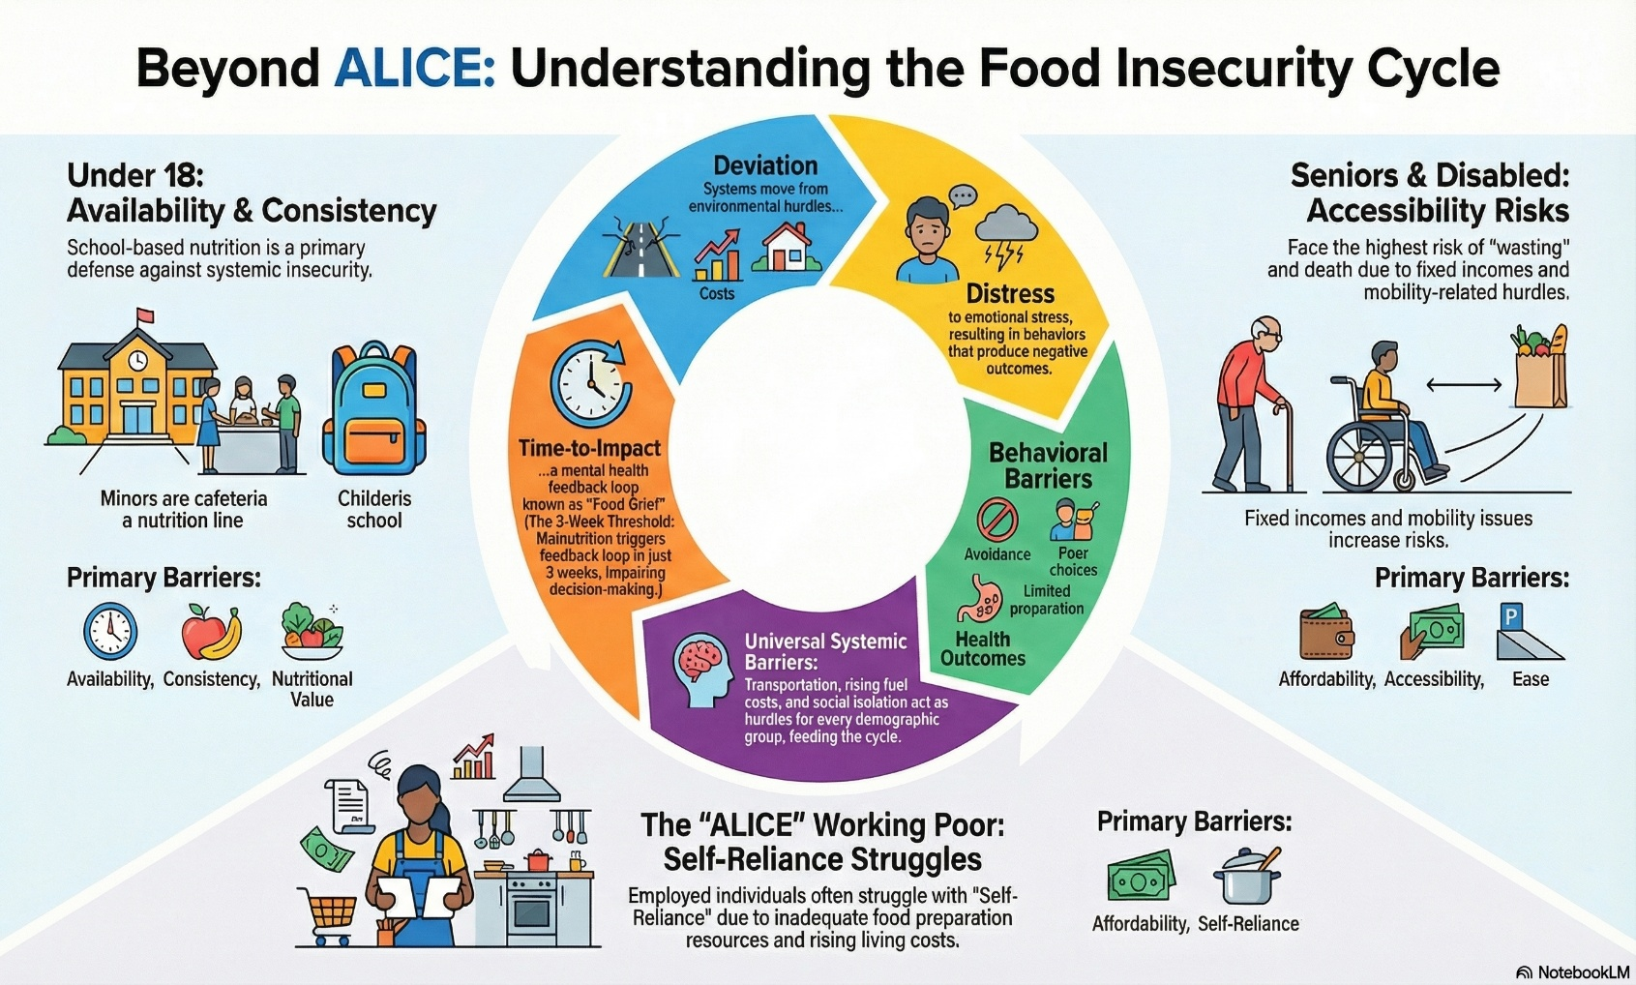

We understand and share a commitment to promote social mobility; we must acknowledge unequivocally that delaying food access until individuals achieve it only amplifies their struggle. Providing stable food support is not a trade-off -it’s the crucial foundation from which people can grow. When we feed people today, we empower them to move forward tomorrow.

