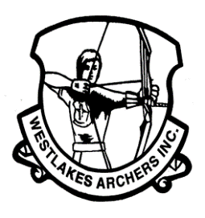
WESTLAKES ARCHERS INC
FIELD QRE 2026
24 Target Marked WA Field
on Sunday, February 1, 2026

By entering the event you are agreeing to be bound by the Constitution and Rules of Archery Australia Inc.

EVENT: 2026 Westlakes Archers 24 Target Marked WA Field
(3 arrows to be shot at each target…all arrows score).

LOCATION: Fassifern Oval, 51 Miller Road, Fassifern, 2283.

TIME: 8:00am - 9:00am Practice
8.30am - 9.00am Registration
9.15am Muster
9.30am First arrow shot.
DIVISIONS:
  - Open Female/Male Compound/Recurve/Longbow/ Freestyle/Barebow
  - 50+ Female/Male Compound/Recurve/Longbow/ Freestyle/Barebow
  - 60+ Female/Male Compound/Recurve/Longbow/ Freestyle/Barebow
  - 70+ Female/Male Compound/Recurve/Longbow/ Freestyle/Barebow
  - Under 21 Female/Male Compound/Recurve/Longbow/ Freestyle/Barebow
  - Under 18 Female/Male Compound/Recurve/Longbow/ Freestyle/Barebow
  - Under 16 Female/Male Compound/Recurve/Longbow/ Freestyle/Barebow
  - Under 14 Female/Male Compound/Recurve/Longbow/ Freestyle/Barebow
COST: $25 for all.

CLOSING DATE: 25 January, 2026
(late entries accepted on application with the Secretary)

NOTE: No camo clothing. The canteen will be open all day.
Sausage on a bun $3; Chicken burger $5
Lunches are to be ordered when signing on.
CROSSBOW archers must show a current NSW permit at registration.
Bow weight must be under 60lb.
ENTRIES: Via Assemble https://account.archery.assemblesports.io/c/club/WAI/finder?id=3004068
non-AA members Contact the Secretary.

FOR MORE INFORMATION: Secretary: V O’Brien (mobile) 0438 430 988
email: secretary@westlakesarchers.com.au

NOTE: Following the QRE, there will be an Equipment Buy and Sell
- an opportunity to sell all that excess archery equipment you have hanging around
- an opportunity to make some money
- an opportunity to buy a piece of archery equipment you have been looking for or didn’t even realise you want.

