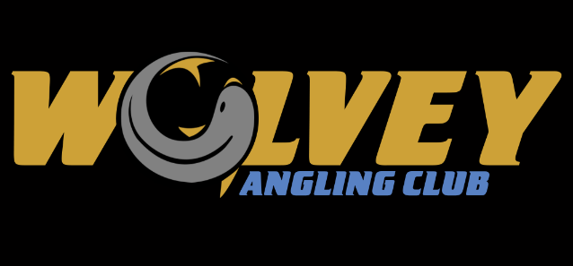

***ARE YOU LOOKING FOR A LOCAL FISHING CLUB?***

**WHO ARE WE & WHAT ARE WE ABOUT?**

Formerly known as The Blue Pig, known records show that Wolvey Angling Club, as it is now, came into existence in 2001.

We are a club that prides ourselves on having fun whilst fishing. To us the banter & friendship between our members is very important.

Our aim is always to keep costs as low as possible with a small yearly membership fee, currently £20, optional “pools” at matches of just £10. We want to make it as affordable as possible to get out on the bank.

We fish 20 matches per club year starting early April, ending late October. Our only stipulation is that peg fees are paid in advance, this could be every 5 matches, half-yearly or in one lump sum, this is in place only to minimise any financial losses to the club as we have paid deposits to venues to cover bookings.

At the end of the year, we have a presentation evening which is part subsidised by the club. We also try to have ad hoc matches during the winter months just to keep that connection between members going.

For further info you can find us on Facebook or email:

**wolveyac@gmail.com**