- STEP 1: Intent to file.
https://www.vba.va.gov/pubs/forms/VBA-21-0966-ARE.pdf
This is what you fill out before filing with the VA. This will give you one year to gather/ request medical records, personal affidavits/ statements from former military personnel, other relevant documents.
When you submit this, you will start the ‘clock ticking’ which is what you want to do. If you file this form on 01Jan2020 and your 526EZ form (below) is submitted on 01Dec2020 and your file is approved, then you would be backpaid for those approved items back to 01 Jan. If you don’t submit it and you are approved, then you only get backpaid to 01Dec. (if you only get a 10% rating, then you would get backpaid 11 months at $142, so an additional $1,562 for 5 minutes of your time.)
The online version is https://www.va.gov/disability/how-to-file-claim/?from=explore.va.gov

- Step 2: Request your military records
https://vetrecs.archives.gov/VeteranRequest/home.html
or
https://www.archives.gov/veterans/military-service-records (there is a blue button that links to the above link) this shows more of the options you may want

- Step 3: Full VA form 21-526ez
https://www.vba.va.gov/pubs/forms/VBA-21-526EZ-ARE.pdf
This is the hard copy version. On page 3, section 4, you will find the address to mail, fax and the online version. Tthe hard copy version is the slowest to be reviewed, so it is best to do it on line, which is here:
https://www.va.gov/disability/file-disability-claim-form-21-526ez/introduction
When you submit your file, one practice that seems to work well: Have a summary page, ideally in an excel spreadsheet form that says what your issue is, what pages of your med records pertain to this issue… and do put page numbers on your COPIES of medical records your are submitting. DO NOT send originals. If you are doing this online, scan the pages in groups of 10-25 page batches.

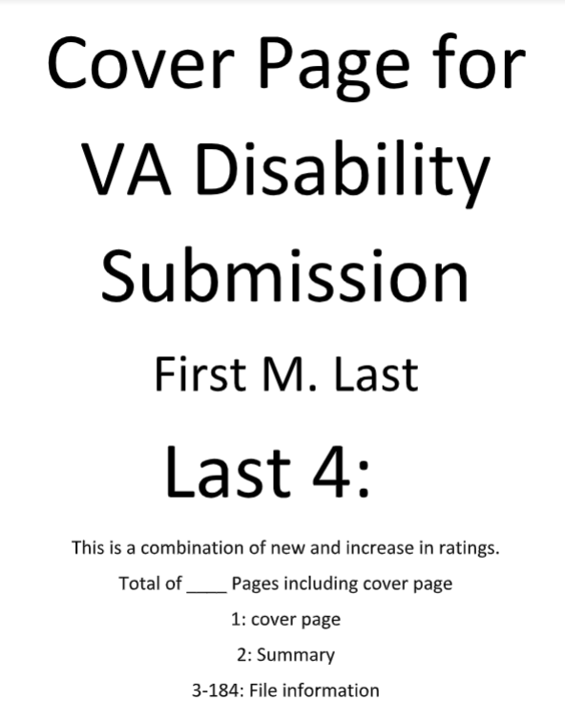
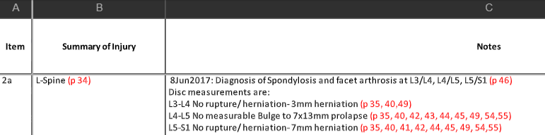
- Various additional forms:
Aid & Attendance/ Nursing home/ Care Provider- VBA-21-0779
https://www.vba.va.gov/pubs/forms/VBA-21-0779-ARE.pdf
Survivor of a Veteran Dependency form- VBA-21P-534EZ
https://www.vba.va.gov/pubs/forms/VBA-21P-534EZ-ARE.pdf
Right to Appeal- VA form 4107
https://www.va.gov/vaforms/va/pdf/VA4107.pdf
Notice of Disagreement: 21-0958
https://www.va.gov/decision-reviews/?from=explore.va.gov
VA Property tax exemptions by state (note that this is a private website & not a GOV site, so there may be changes in your state):
https://www.veteransunited.com/futurehomeowners/veteran-property-tax-exemptions-by-state/
Compensation rates:
https://www.va.gov/disability/compensation-rates/veteran-rates/
CFR 38 Ratings and categories- this is a government site and navigating it is very challenging. Each sub section will need to be downloaded and read as a word doc.
https://www.govinfo.gov/content/pkg/CFR-2018-title38-vol1/xml/CFR-2018-title38-vol1-part4.xml#seqnum4.71a

- My Health eVet portal. This site may state that the Vet to go to a VA hospital or Outpatient Clinic to do the full registration.
https://www.myhealth.va.gov/mhv-portal-web/web/myhealthevet/user-registration

